CNX VINYL / POY RECORDS
What It Takes to Build a Top-Notch Vinyl Plant
Business plan for a full-service vinyl, cassette and CD manufacturing plant in the Chiang Mai region, Northern Thailand
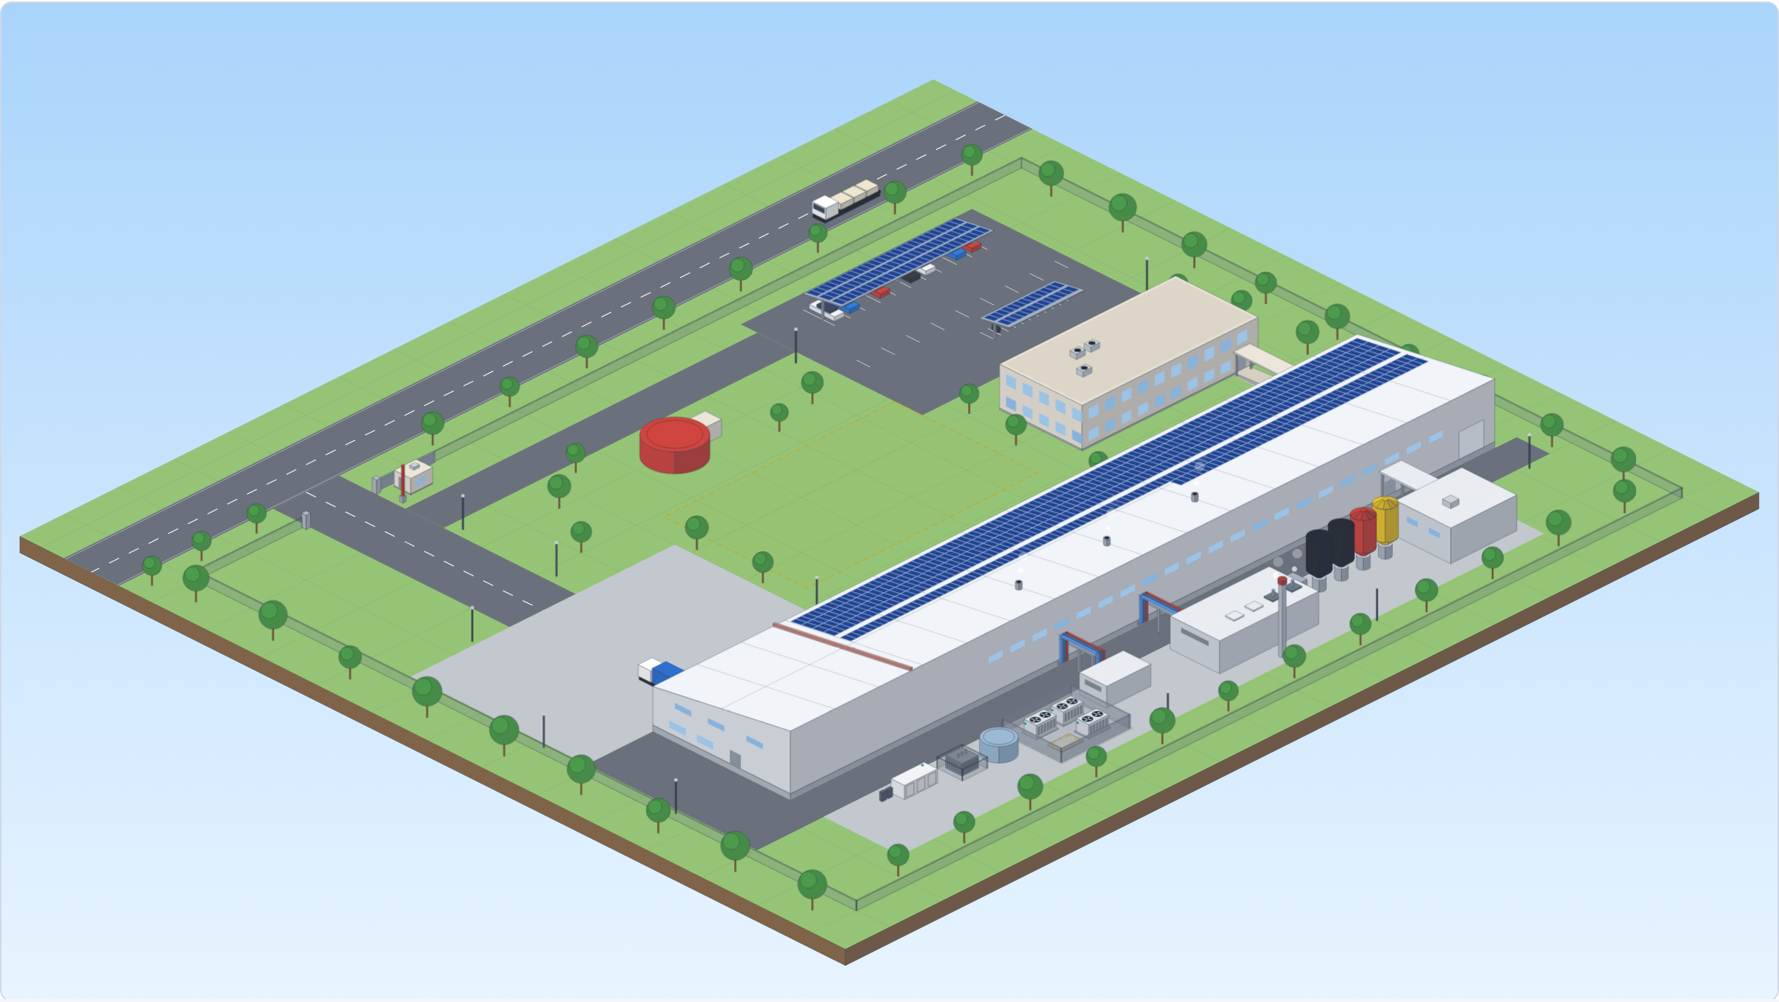
Prepared for: the project's lead investor
Prepared by: Simona Meesaiyati (Project Lead) and Alexander Grabowski (Technical Consultant), supported by buildfor.life, with Ploy Printing (Chiang Mai) as packaging partner and strategic co-investor
Version: Draft 0.3, October 2026: Plan B, ~225M THB
Confidential. All figures in USD and THB at 1 USD = 33 THB (August 2026). Vendor quotes are snapshots at their file dates, not commitments. Every number in this plan is labelled as quoted, researched, or estimated; see section 2. This version is Plan B: the whole chain, cutting and galvanics included, with five presses at launch and everything in, at ~225M THB (~224M). A second version, Plan A (~180M THB), launches with three presses and six cost levers. The plan price includes the ramp-up reserve and carries no contingency. Cover picture: the plant as the plant and business plan calculator draws this plan (schematic, Payap scenario layout, section 6.2). Draft 0.3 replaces draft 0.2 (October 2026), which described a single launch plant priced with a contingency.

Contents
Table of contents: open in Word and press F9 (or accept the update prompt) to populate.

1. Executive summary
CNX Vinyl (label name Poy Records) is a planned record manufacturing plant for the Chiang Mai region of Northern Thailand. Its premise is simple: a label or artist in Asia-Pacific should be able to send an audio file to one place and receive finished, packaged, fully traceable records at their door, without shipping a fragile lacquer disc across the world and without waiting for metal stampers to come back from Europe. Today that customer presses in Europe, the United States or Japan. The one Thai pressing shop we have seen presses only: it buys its stampers abroad, runs without climate control, and cannot economically serve runs under 300 units.
This document explains, for a reader who is not a vinyl specialist, what a top-notch plant consists of, why each part matters, what it costs, what it can earn, how long it takes, and what could go wrong. It is built from the project's planning repository and vendor documents, and it keeps the honest parts: where a number is an estimate, it says so; where the evidence is thin, it says that too.
What changed since the earlier drafts. In October 2026 the plan moved from a phased entry (one press at launch, stampers bought in from the UK, cutting bought in from Europe) to a launch plant that has the whole chain from the first day, bought in one capital round and commissioned in sequence. There are no bridge stampers and no outsourced cutting in the plan any more. Draft 0.3 prices that plant in two versions, both including the ramp-up reserve and neither carrying a contingency: Plan A (~180M THB), the launch plant's three presses with six cost levers, and Plan B (~225M THB), five presses with everything in. This document is Plan B, and every section below is written for it; a short table after the numbers compares the two versions.

What we will build
- The complete vinyl chain under one roof: mastering, lacquer cutting, galvanics (growing the nickel stampers), stamper preparation, pressing, finishing, packaging with our Chiang Mai print partner Ploy Printing, and fulfilment including direct-to-fan dropshipping.
- Five presses at launch: two Newbilt Duplex systems (each two semi-automatic presses with a main and a colour extruder, for colour, splatter and short runs) and one Newbilt Classic fully automatic press for long standard runs. Special prints are the focus (60 % and more of the records) and run only on the Duplex systems; with four semi-automatic presses they no longer set the pace, so the five presses make about 1.0 to 1.5 million records a year on two shifts (1.25 million in the central case; estimates). The press hall keeps room for more Duplex systems and Classics as an option, not part of the investment.
- The metal path in-house: a Sillitoe SDMS cutting room, a Pheenix Alpha galvanics line with zero-discharge water treatment, and the Sibert stamper-prep line. The father and the mother of every side are archived, so represses start from our own metal.
- A modular utility plant: a boiler hall and a chiller compound built once for four modules each, with two 500 kg/h boiler modules (B-1, B-2) and three 250 kW chiller modules (CH-1 to CH-3) installed at launch; further presses add modules, not rooms. The steam fuel (electric or biomass) is still open.
- Cassette duplication and CD-R duplication in-house from launch. Full CD replication (injection-moulded discs) is a separate, much larger decision, outside the totals; both CD routes are set out in section 4.10 for the investor to decide.
- A purpose-built ~1,500 m² plant on long-term leased land, with a detached utility yard, owned rooftop solar with a battery and room for a second building.
- Commissioned in sequence: the cutting room and galvanics first (the presses need their stampers), then Duplex system 1, then the Classic, then Duplex system 2. That puts galvanics, the hardest skill to hire, on the path to the first paying release. Sibert, the stamper-prep supplier in the plan, advised after the Haarlem trade show to get presses, boilers, operators and feedback loops right first; the whole chain at launch was decided anyway, and that advice is carried as a risk (sections 11.2 and 13).
- Everything in, no cost levers: owned rooftop solar and battery (and with them the BOI solar measure), the full metrology stack from launch, the visitor corridor and public tours from the start, a bought overhead crane, cassette and CD-R duplication, and Thai-supplied boilers and compressor.

What makes it top-notch
Four things separate this plant from a pressing shop, and they are the reason it can charge export-grade prices in a region that currently has none:
1. Traceability from audio file to shipment. Every lacquer, father, mother, stamper, press cycle, compound lot and carton lot gets an identity that knows its parents; a pressed record is identified by its stamper, press, cycle time and side. The plant runs ERPNext as its only system of record (orders, invoices, stock, job cards, batches, inspections, metal-part genealogy); machine data (press cycles, instrument files, audio captures) sits beside it, keyed to the same ERPNext names. A customer sees their order's full chain; a complaint resolves to one stamper, one press, one shift and one material lot. The father and the mother of every side are archived: a mother gives about ten stamper sets and a father five to ten mothers (industry rules of thumb), so a repress starts from the archived mother and a worn mother is regrown from the father without a new cut. At Making Vinyl Europe in Haarlem this was what the industry responded to most.
2. Metrology and layered quality control. The nickel parts are measured without contact (laser confocal, wide-area profiler, XRF thickness) and logged per serial, which is ahead of current industry practice. Every pressed record passes 100% inline optical inspection, every press cycle is logged, and sampled records are compared automatically against the source master.
3. Efficiency designed in. Heat is recovered before energy is generated: in order, a flue-gas economiser if the boiler is fired, as much condensate back to the feed tank as possible, then a heat pump that lifts the presses' ~60 °C cooling return into boiler feedwater. The main roof carries ~247 kWp of solar (about 335 to 360 MWh a year, a quarter to a third of mature two-shift use; a second building's roof would take the total to ~498 kWp), with a 271 kWh battery for ride-through, both owned by the plant. Cooling runs as a closed loop, no process water is discharged, galvanics rinse water goes through a zero-discharge evaporator, and 20% of the feedstock is in-house regrind. Boilers and chillers come in identical modules, so spares and service are one routine. At reported northern fuel prices biomass heat costs a quarter to a tenth of electric steam; the fuel choice is open.
4. Climate control as product quality. The whole plant runs at 20 to 26 °C, 35 to 60% relative humidity, with particulate filtration sized for Northern Thailand's burning season. Moisture and dust are the two classic causes of noisy records; the plant we visited has neither control.

The numbers
Capacity | ~1.0M to 1.5M records/yr at 60 % specials, central case 1.25M (4 semi-automatic presses + 1 Classic, 2 shifts; the four semi-automatic presses carry the specials, so the Duplex does not set the pace; estimate; the press fleet calculator gives ~1.5M at our planning rates). Full hall as a later option: ~2.9M to 4.4M
Site | ~1,500 m² main building plus a ~379 m² utility yard built for four boiler and four chiller modules, on leased land (~4 rai minimum, 6 to 8 rai with expansion); second building as expansion
Investment, Plan B | ~THB 224M (~USD 6.79M), rounded to ~225M THB: the plan investment, ~THB 209.2M (~USD 6.34M) at the midpoint with everything in, plus a ramp-up reserve of ~THB 10M to 20M (staff and overheads before volume covers them). From the low to the high end of every block: ~THB 162M to 286M. Estimates: no quote yet for the Classic, the galvanics line (priced at OMS's reference plus 20 %), the EX 35 or the building
Not in the plan price | No contingency (at the 15 % used in the cost documents, ~THB 31M at the midpoint): quotes that land high are funded outside the plan or by scope steps (section 8). Also not in it: the central hydraulic plant (not yet costed), the archive's mobile shelving (to quote), CD replication, financing costs, currency moves, and Thai duty and import VAT (the blocks assume BOI promotion)
Land lease | Not negotiated; the plan carries an estimated THB 0.3M to 1.0M per year (USD 9k to 30k), section 6.1
Operating result, mature year | Central case at 60 % specials: revenue ~USD 6.05M (~THB 200M), EBITDA ~USD 3.14M (~THB 104M), operating profit ~USD 2.63M (~THB 87M); break-even on operating profit at ~0.22M records a year. The adverse case only just covers depreciation: EBITDA ~USD 0.83M, operating profit ~USD 0.02M. All of it needs the records to sell: ~1.25M a year in the central case, ~0.75M of them specials, and no market evidence shows that demand yet. Utilisation and price decide the outcome, not upside (section 9)
Payback | ~2.2 years on the plan price in the central case (1.6 to 2.8 from the low to the high end of the price); ~0.8 year in the favourable case, ~10.5 years in the adverse case (EBITDA, mature year, ramp-up reserve included; estimates)
First paying release | Open. The August 2026 calendar gives Q4 2028 to mid-2029 (27 to 33 months from the start of phase 0), but it was drawn for a one-press launch. Commissioning the cutting room and galvanics before the presses is not yet in it, and the lathe, galvanics line and stamper-prep build times are not on file, so the date stays open until those vendors quote. Plan B commissions its second Duplex system last, after the Classic. Ordering machinery before the BOI certificate, if allowed, could still pull it forward by 6 to 9 months (section 10)
People | ~15 to 25 across shifts at volume (estimate); two shifts need press, finishing, galvanics, QC and maintenance staff whether the plant runs three presses or five, so Plan B's five presses run on the same direct crews (13 to 19 direct production staff in the revenue model) and spread them over more records
The ask | ~THB 224M (~USD 6.79M), the ~225M THB plan, released in tranches against milestones (section 8), starting with phase 0 (~THB 1.3M to 2.6M). BOI caps debt-to-equity at 3:1, so at least a quarter is equity: ~THB 56M (arithmetic, before financing costs)

Two versions of this plan
This plan comes in two versions, built from the same documents and the same machine choices. This document is Plan B. The other version, Plan A (~180M THB), launches with three presses (one Duplex system and the Classic), takes six cost levers and keeps the second Duplex as a growth step from revenue. Both carry the ramp-up reserve and neither carries a contingency. What decides between them is demand: Plan B's central case needs about 70 % more records sold than Plan A's (1.25 against 0.74 million a year), and the market validation gate (section 3.2) is the evidence for that. Section 8 sets the two side by side.
 | Plan A | Plan B
Plan price (ramp-up reserve in, no contingency) | ~THB 177M (~USD 5.35M); ~127M to 226M from the low to the high end | ~THB 224M (~USD 6.79M); ~162M to 286M from the low to the high end
Presses | 3: one Duplex system (2 semi-automatic) and one Classic | 5: two Duplex systems (4 semi-automatic) and one Classic
Records a year at 60 % specials | ~0.58M to 0.90M (central 0.74M) | ~1.0M to 1.5M (central 1.25M)
EBITDA, central case | ~USD 1.73M (~THB 57M) | ~USD 3.14M (~THB 104M)
Operating profit, central case | ~USD 1.34M (~THB 44M) | ~USD 2.63M (~THB 87M)
Payback on the plan price, central case | ~3.1 years (2.2 to 4.0) | ~2.2 years (1.6 to 2.8)
Adverse case | Loses money: EBITDA ~USD 0.23M, operating loss ~USD 0.39M | Just covers depreciation: EBITDA ~USD 0.83M, operating profit ~USD 0.02M
What Plan A gives up, what Plan B needs | At launch: solar through a PPA (very likely without the BOI solar measure), no confocal or profiler, no visitor corridor or tours, no cassette or CD-R, a rented crane; Chinese-made boilers and compressor | ~1.25M records sold a year, ~0.75M of them specials, against 0.74M for Plan A; no market evidence of that demand yet
Estimates: mature year at 60 % specials, from the revenue model; payback counted on the whole plan price including the reserve. Central EBITDA margins of ~47 % (A) and ~52 % (B) are far above the 15 to 25 % pressing plants earn; read the adverse case as the honest one.

Where we are, and what we ask
The project is at the planning stage. Industry outreach has run for several years. Alexander and Simona attended Making Vinyl Europe in Haarlem (30 September to 2 October 2026): most people they talked to were strongly interested in the full-traceability approach, and for Sibert it was the reason to engage at all. Since the show Sibert has confirmed a USD 250k budget for its three stamper-prep machines; Pheenix Alpha's CEO has offered a call, reference clients and a factory visit (the next Europe trip is planned for February 2027); OMS has sent reference prices for a galvanics wet room; and SST in Frankfurt, which already cuts Poy Records' lacquers, has offered help. This is supplier-side evidence, not buyer price validation.
Vendor quotes exist for the pressing line (2024, expired), utilities have been costed with Thai suppliers, and a parametric building model has produced quantities for a construction price request. Site: a leased parcel in Mueang Chi, Lamphun, is the working candidate the design is tested against; Payap University in Chiang Mai has offered land on lease and joint student programmes, but the point it gave fails zoning (zoned very high density residential, where record pressing is not permitted; checked October 2026), and its other plots are not yet checked. Nothing has been re-sited and nothing has been ordered.
Three gates run now and in parallel: market validation (buyer prices from regional labels; none yet); the BOI investment promotion track with a registered consultant; and land: zoning, lease terms and a soil test. Nothing large is spent until its gate clears.
What the investor is asked to fund now
• Phase 0 (next 3 to 6 months): ~USD 40k to 80k (~THB 1.3M to 2.6M) for the BOI consultant, Thai legal work on the lease and zoning, a soil boring test, and the requests that settle most of the investment band: the Newbilt re-quote for both Duplex systems (with an EX 35 price) and the Classic, a Pheenix quote for the galvanics line, the building price request with the soil test, and metrology distributor quotes.
• Then the Plan B round, ~THB 224M (~USD 6.79M), rounded to ~225M THB, including the ramp-up reserve and without contingency, released in tranches against milestones: BOI certificate and lease signed, long-lead orders (lathe, galvanics, stamper prep, both Duplex systems and the Classic, boiler and chiller modules), building contract, fit-out, commissioning in sequence (section 8). From the low to the high end of every block the plan runs from ~THB 162M to 286M; quotes that land high are funded outside the plan or by scope steps.
• Decisions needed from the investor: which version to fund, Plan A or Plan B (demand decides first, from market validation; then the Classic, Pheenix and EX 35 quotes, the solar PPA offer and the building quote); the equity/debt mix (BOI requires debt-to-equity of at most 3:1, so at least ~THB 56M of Plan B's ~224M is equity); CD replication, yes or no (it must be in the BOI application from the start); and the steam fuel, electric or biomass.
• Co-investment: Ploy Printing, the Chiang Mai print and packaging house that will produce the plant's jackets and sleeves, has expressed the intention to invest alongside the lead investor. Terms are not yet discussed; the intended structure is described in section 12.

2. How to read the numbers
Two versions. This business plan comes in two versions, built from the same documents: Plan A (~180M THB), the launch plant's three presses with six cost levers, and Plan B (~225M THB), five presses with everything in. Both plan prices include the ramp-up reserve and neither carries a contingency. This document is Plan B (~225M THB). Chapters that do not depend on the choice read the same in both; where the plans differ, this version gives its own figures, and sections 1 and 8 compare the two.
Every figure in this plan carries one of three confidence levels. Where a table does not say, the basis column or caption does.
Label | Meaning | Examples
Quoted | A vendor document exists, in its original currency: a quote, a budget confirmation or a published list price. Quotes may have expired and need re-confirmation. | Newbilt pressing line (EUR 200,500, June 2024, expired); Sibert's USD 250k budget confirmation for the stamper-prep line (October 2026); Sillitoe SDMS list price USD 125k (ex tax and shipping); OMS reference prices for a galvanics wet room; Newbilt service rates
Researched | Published or market data gathered by the team, including one set of real Thai invoices. | Record Industry's online price calculator (October 2026); Thai pressing invoices (August 2026); the PEA electricity tariff; vendor flyers and datasheets; reported biomass fuel prices; BOI measures
Estimate | Engineering ratio or industry norm with no vendor confirmation. Treat as plus or minus 30 to 50%. | Building cost per m²; the Pheenix galvanics line (no Pheenix price on file; priced at OMS's reference plus 20 %) and the Newbilt Classic (no price on file); the cutting room beyond the lathe; metrology stack; land lease; all cassette and CD figures

Currency: USD and THB at 1 USD = 33 THB (5 August 2026). Vendor quotes issued in EUR or GBP are kept in their currency next to their source and converted at 1 EUR = 1.155 USD and 1 GBP = 1.35 USD. Currency exposure is real and is discussed in section 8.5.
Deliberately not in this plan: a contingency in the plan price (section 8); a financing structure or terms (to be agreed with the investor); a signed customer; a signed lease; firm quotes for the Classic, the galvanics line, the metrology stack or the building; a price for the central hydraulic plant; and a year-by-year cash model. Each of these is a named next step in section 14.

3. The opportunity

3.1 The product
A vinyl record is made by cutting the audio into a soft lacquer disc, growing a set of nickel metal parts from that lacquer by electroplating (the 'stampers'), and pressing hot PVC between two stampers under about 150 tonnes of force with steam heating and water cooling. The record is then trimmed, sleeved, put into a printed jacket, shrink-wrapped and shipped. Each of these steps has its own equipment, skills and failure modes, and most plants in the world do only some of them, sending the rest out to specialists, often on other continents.
Demand for vinyl has grown for well over a decade from a small base. The 2021 to 2022 boom pushed lead times at European and US plants to six to nine months; they have since normalised to roughly 10 to 16 weeks for a standard black LP, and global capacity has been added. Demand is cyclical and this plan does not assume it only rises; it assumes the plant can sell what it presses, which is the single assumption most worth testing (section 3.3).

3.2 Where regional labels press today
Labels and artists in Southeast Asia, Australia and much of East Asia ship their masters to Europe, the United States or Japan, wait in those plants' queues, and pay freight and time zones on top. We know of no industrial-grade, climate-controlled, full-service plant in the region. That is the gap. It is also the plan's biggest assumption: that enough regional customers will pay for a closer, faster, more accountable plant at a price that works. That pricing power is unproven. The Haarlem trade show produced strong supplier interest but no buyer prices, and the market validation gate exists to test it before capital is committed. Plan B makes the assumption heavier: its central case sells ~1.25 million records a year, ~0.75 million of them special editions, against 0.74 million for the three-press Plan A.

3.3 What the market shows: two price points
Two sets of real prices now exist: invoices from the one Thai pressing shop we have seen, and the published calculator of a European plant. Neither is used to re-base the financial model, which keeps its assumed price until buyers have been asked. Together they bracket that assumption.

The Thai market: one buyer, one plant
In August 2026 the team compared real invoices from ResurRec in Bangkok (with whom a collaboration is also under discussion), and toured its plant. This is one buyer, one plant, one afternoon, but it is the only domestic market evidence so far.
Item | THB | USD | Note
Audio mastering | 5,000 to 20,000 per song | 150 to 605 | Market range from several engineers
Stamper set (father, mother, silvering) | up to 22,000 per title | up to 665 | Residual between a full-service and a pressing-only invoice; an upper bound that also carries cutting, test pressings and margin
All-in per 12-inch record at 300 units | 650 to 950 | 19.70 to 28.80 | Includes a printed jacket; discounts of 5% at 500, 15% at 1,000 to 3,000, 30% above 3,000, with 2 to 4 weeks added lead time above 3,000
Minimum run | 150 units, 'rarely accepted' |  | Sub-300 runs are effectively unavailable in Thailand
Researched: buy-side invoices and published discount ladder, August 2026.
What the tour showed: the shop operates from a small non-industrial premises; it does not plate (stampers are bought in from abroad and resold); there is no temperature, humidity or particulate control on the pressing floor; and it runs two Newbilt presses, a Classic fully automatic and one semi-automatic, about 190 to 210 records an hour at nameplate. That is a real capital fleet. Plan B's five presses (four semi-automatic at 60 to 80 records an hour each plus the Classic at ~128, 368 to 448 records an hour at nameplate, planned for two shifts) out-press it on paper, which the one-press launch of draft 0.1 did not. Neither figure is measured output: their shifts and order book were not observed.

A European plant: Record Industry's calculator
Record Industry (Haarlem, Netherlands) publishes an online calculator. For a 12-inch 140 g black LP cut from a digital master, with stampers, five test pressings, printed labels, a white paper inner sleeve, a printed 3 mm jacket and shrink wrap, ex Dutch VAT and ex freight (checked October 2026):
Copies | Order total | Per copy | Per copy, USD | Per copy, THB
200 | EUR 1,494.68 | EUR 7.47 | 8.63 | ~285
300 | EUR 1,721.22 | EUR 5.74 | 6.63 | ~219
500 | EUR 2,098.12 | EUR 4.20 | 4.85 | ~160
1,000 | EUR 3,169.78 | EUR 3.17 | 3.66 | ~121
Researched: Record Industry online calculator, October 2026; converted at 1 EUR = 1.155 USD and 1 USD = 33 THB.
Its per-title items (set-up, small-run charge, cutting, stampers, test pressings) come to about EUR 580 to 600 (~THB 22,000 to 23,000), at the low end of our per-title assumption. Black pressing with labels and a paper inner sleeve comes to about USD 2.43 a copy at 300 (2.09 at 1,000). The Thai price at 300 copies is about 3 to 4.3 times this plant's ex-works price, before the freight, Thai import duty and VAT a Thai buyer pays on an import. Our own artist ordering demo's price list comes to about 343 THB a copy at 300 with vinyl mastering: above the European ex-works price and well below the Thai market. These price levels stay open until buyers have been asked (roadmap item 1).
Four readings follow, each with its caveat:
- Our assumed price sits between the two markets. The plan prices a record at USD 3.76 to 5.27 blended at 60 % specials (124 to 174 THB; 3.50 to 4.60 at a standard-heavy mix). The Thai market pays 535 to 780 THB on a comparable scope, several times more, even after allowing 100 to 150 THB for the jacket. A European plant's published price for black pressing with labels and an inner sleeve (~USD 2.43 at 300) is below our assumption, though our blend also carries colour work and assembly. Two caveats: a sole domestic supplier can hold an import-parity price that a second entrant compresses, and against Europe our assumption is not conservative. We keep it until buyer prices exist.
- The floor of the market is unserved. Runs under 300 are uneconomic for a shop whose per-title cost is an imported stamper plus outsourced mastering. In-house cutting and plating collapse that fixed cost, which makes short runs viable for CNX in a way they structurally are not for the incumbent. The artist platform (section 4.8) is the channel for them.
- Lead time degrades with run size, probably because of metalwork. Three thousand units is about two days of pressing on their fleet, yet they add two to four weeks. A stamper lasts 1,000 to 2,000 pressings, so a 3,000-unit run needs two or three sets, each an overseas order. Jacket printing or floor space could produce the same symptom, and the cause should be confirmed before it is treated as a structural weakness.
- The gap we close is capability, not only capacity. No plating, no climate control, no metrology, no traceability. The incumbent sells commercially from that room today, which bounds how much the Thai market currently pays for the difference. Our bet is on export-grade customers and on regional labels who currently ship to Europe.
Investor takeaway
CNX should not fight a price war at 200-unit runs against an operator with low rent and no climate-control load. It competes on what a non-plating, unconditioned shop cannot offer at any run size: export-grade quality control and traceability, titles that need plating, consistent output through the burning season, a repress in two to three weeks from an archived mother, and short runs. A collaboration with the incumbent is under discussion; supplying stampers into its presses is one plausible shape for it, and is not in the revenue model.

3.4 Cassettes and CDs
The investor has asked for cassette and CD capability on the site. Both fit the same customer: the independent label that presses 300 to 2,000 records also orders 100 to 500 cassettes and a short run of CDs for the same release, and prefers one supplier, one artwork approval and one shipment. Cassette sales have grown from a very low base in the US and UK over the last decade; volumes are small and the equipment market is mostly refurbished, but the format is a natural add-on with modest capital. CDs remain a large format in Asia (Japan and Korea in particular), but industrial CD replication is an established, price-competitive business with existing capacity across the region. Sections 4.9 and 4.10 lay out both formats and the two very different CD routes; cassette and CD-R duplication are in Plan B from launch.

4. Anatomy of a top-notch plant: the full chain
The chain from audio file to delivered record has nine stages and three points where the artist or label must approve before work continues. Every stage records its events in ERPNext and its machine data in the plant's data store, and the instruments behind every check are specified in section 5. The chart on the next page shows the whole chain; the table after it is the checklist of what a top-notch plant needs and where this plan puts each item.

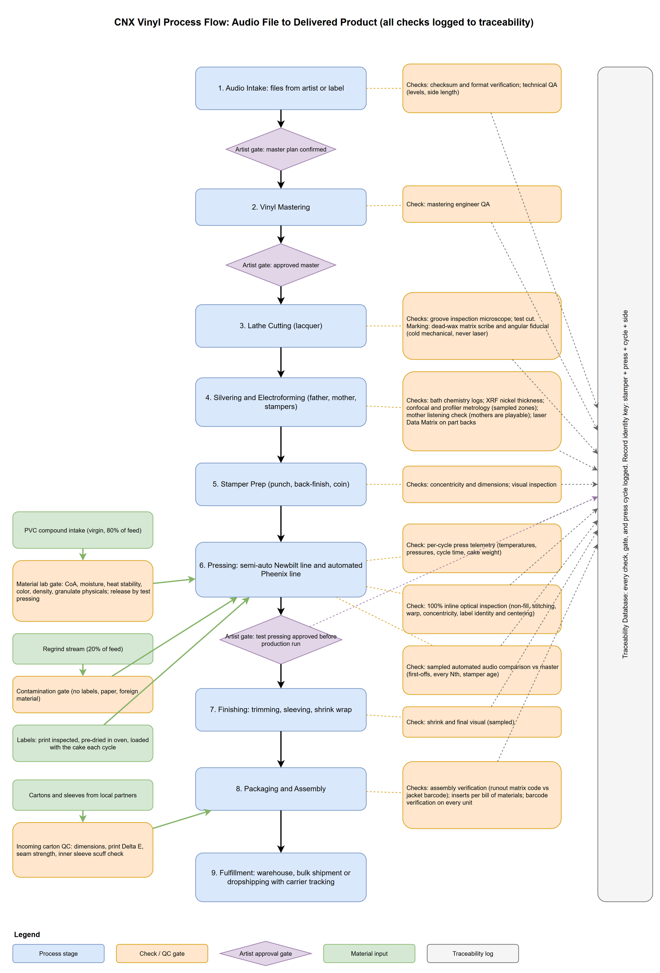
Figure 1. Process flow from audio file to delivered product, with every check and the three artist approval gates. Source: project repository.

4.0 The checklist
What a top-notch plant needs | Why it matters | This plan | When
A quiet, vibration-free cutting room with a modern lathe | The groove is born here; every defect propagates to every record | Sillitoe SDMS complete cutting system in-house; Agnew Type 612 as the other candidate | At launch, commissioned first
In-house galvanics with zero-discharge water | The regional bottleneck; enables represses in days and short runs | Pheenix Alpha line (PASU, PPPU, one PDPU, PMPB); evaporator-based zero discharge and DI water in a treatment building next to it | At launch, commissioned first
Stamper preparation machines | Turns a raw nickel shell into a press-ready part | Sibert back-finisher, punch, coiner (USD 250k budget confirmed) | At launch, with galvanics
A mixed press fleet | Semi-automatic for colour and short runs, automatic for long runs | Two Newbilt Duplex systems (4 presses, each system with main + colour extruder) and one Newbilt Classic | At launch, second Duplex system commissioned last; full hall as an option
Steam, cooling and compressed air engineered locally | The largest energy loads; efficiency lives here | Boiler hall and chiller compound for four modules each; 2 x 500 kg/h boilers and 3 x 250 kW chillers; heat recovery designed in | At launch; modules added with presses
Whole-plant climate and particulate control | Moisture and dust are the two classic record defects | 20 to 26 °C, 35 to 60% RH, filtration for the burning season, tighter in clean zones | At launch
Metrology for the metal parts | Data-backed accept/reject before a stamper is mounted | Laser confocal, wide-area profiler, XRF thickness, inline vision | At launch, full stack
Layered QC for every record | Catch defects at line speed without playing every record | 100% optical inspection, per-cycle telemetry, sampled audio comparison | At launch
Traceability from file to shipment | Complaints resolve backwards; customers see their order; machine data access is a purchasing condition | ERPNext as the only system of record, machine data keyed to it, customer portal | At launch (v1 before the machines arrive)
A materials lab | PVC lots differ; a bad lot is a noisy run | Per-lot gate: moisture, heat stability, colour, density, granulate; release by test pressing | At launch (day-one tier)
A packaging partner and packaging QC | Jackets are the path that slips; the wrong record in the right jacket is the classic error | Ploy Printing (Chiang Mai) for jackets, sleeves, J-cards; matrix code scanned against jacket barcode | At launch
An archive for fathers and mothers | Irreplaceable metal; repress economics | Father and mother of every side; fire-rated, climate-controlled room, clean-agent suppression, mobile shelving (to quote) | At launch
Renewable energy and closed-loop water | Cost, resilience, brand, BOI tax value | ~247 kWp roof PV and 271 kWh battery (owned), closed cooling loop, zero process discharge | At launch
Trained people and a safety program | Steam at 10 bar, hydraulics at 180 bar, plating chemistry | Vendor commissioning training, in-house program, PPE, clean rooms | At launch; galvanics hiring first
An ordering platform for every customer | Short runs need a channel; transparency is the brand | Itemised price calculator, upload checks, fan-funded campaigns (section 4.8) | Calculator early; campaigns after first releases ship
Cassette and CD lines | Same customers, one order, one shipment | In-house cassette duplication; CD-R duplication; CD replication as a separate option | At launch (replication only if chosen)

4.1 Mastering and lacquer cutting
What happens. A mastering engineer prepares the audio for vinyl (levels, side length, low-frequency handling), then a cutting lathe drives a heated stylus into a lacquer-coated aluminium disc, cutting the groove in real time. The lacquer is soft nitrocellulose: heat- and shock-sensitive, and it wants plating within one to three days. Lacquers do not travel well, which is the reason to cut and plate under the same roof.
What it needs. A disk mastering lathe and stereo cutter head, matched cutting amplifiers, a mastering console and chain, monitoring, pitch and depth automation, vacuum for platter hold-down and chip suction, a groove inspection microscope, and a low-vibration, temperature-controlled room away from the presses and compressor. Consumables are lacquer blanks and styli.
Who supplies it. The plan is a Sillitoe Disk Mastering System (SDMS) from Sillitoe Audio Technology (Australia), a complete cutting system rather than a bare lathe: direct-drive turntable with a vacuum platter for 7- to 14-inch disks, a feedback cutterhead, a 350 W per channel cutting amplifier, vacuum and a groove microscope in the box. Its Space / Time Control software computes a virtual groove from the audio before anything is cut and drives pitch, depth and head lift automatically (vendor claim: no capacity tests or dry runs). It also exports a cue sheet, an open-format groove file and stylus hours, which the cutting record in ERPNext can attach instead of manual entry. The weaknesses: it is a closed system (the head works only with Sillitoe's amplifier and is factory calibrated), the install base is small, and service depends on one small company, so a spare cutterhead and support terms belong in the quote. Agnew Analog (Greece) and its Type 612 lathe, billed as the first all-new lacquer lathe since the 1960s, is the other candidate: bespoke, unpublished price, long build times, with amplifiers and automation sourced around it. Used lathes and complete used studios exist too, through contacts OMS passed on; any of them is compared as a whole room.
Cost and people. The cutting-room block is an estimated USD 200k to 350k (THB 6.6M to 11.6M): the SDMS at its published list price of USD 125k (ex tax and shipping, built to order), plus a spare cutterhead and support, the mastering console and chain, monitoring and the room build-out, all estimates. A cutting engineer earns about 50,000 THB a month base (team figure). Mastering is labour-bound: an engineer masters perhaps two to four songs a day, which caps the title-services line (section 9). Payap University wants joint student programmes in mastering and lathe cutting, a possible future source of trained people. SST in Frankfurt, which already cuts Poy Records' lacquers, stays a contact for overflow or a slipping commissioning, not part of the plan.

4.2 Galvanics: silvering and electroforming
What happens. The lacquer is cleaned and sprayed with a conductive silver layer, then electroplated with nickel to grow a negative metal copy, the 'father'. From the father a positive 'mother' is grown (playable), and from the mother the working 'stampers' that go into the press. This three-step process means a fresh stamper can be grown from an archived mother in a day or two; a cheaper one-step stamper is single-use and a repress restarts at cutting. The plant keeps the father and the mother of every side in its archive, so a worn mother is regrown from the father without a recut.
Why it is the key to the region. We have found no plating capability in Thailand; the one plant we have seen buys its stampers abroad (a desk check of Thai electroforming capacity is still to be done). Every title it presses therefore waits on an overseas order, which is the most plausible cause of its lead-time penalty on larger runs and its inability to take small ones. Bringing cutting and plating in-house takes an estimated 1.5 to 5 weeks out of the lead time and USD 175 to 665 per title out of the cost.
What it needs. A lacquer cleaning and silvering station, a low-stress nickel pre-plate, production electroforming cells for the three generations, a passivation and cleaning bench, a clean room with controlled access, fume extraction, DI water, and a closed-loop rinse-water treatment and metal recovery system. The chemistry (silver nitrate, nickel salts) sets the safety and permitting requirements: decontamination procedures, PPE, locked chemical storage, eyewash and emergency shower, and hazardous-substance registration. Because galvanics is now in the plant from launch, the site's zoning and the first factory licence have to allow electroplating from the start.
Who supplies it. The plan is a Pheenix Alpha line (Sweden): the PASU automatic silvering unit, the PPPU pre-plating unit (four masters at once), one PDPU dual plating unit (two cells, up to 200 A each) and the PMPB passivation and cleaning bench. The plating units are PLC-controlled with recipes and a network connection (the protocol is not stated; data access is a purchasing condition). Digital Matrix / Plating Power (New York), the long-standing US turnkey vendor, is the second turnkey candidate. OMS (Optical Media Services, Baarlo, Netherlands), named by Sibert, is the third candidate and the price reference: EUR 224,000 for a basic and EUR 311,000 for an advanced 4-cell wet room (installation and water treatment extra), 24 and 32 shells in an 8-hour day. No vendor supplies the water treatment: the zero-discharge evaporator and DI water come from an industrial water vendor (an imported core unit with Thai integration), in a small treatment building next to the galvanics room (proposed).
How much line the plant needs. Pheenix publishes no cycle times. Published plating practice gives about 15 to 30 minutes for pre-plate, ~75 minutes for a father, about an hour for a mother and ~45 minutes for a stamper (silvering and bench times are estimates). With loading and rinsing, a cell turns a part in about 1 to 1.5 hours, so one PDPU makes 20 to 32 parts in a two-shift day against 8 to 20 parts a working day for Plan B's five presses. One PDPU covers the demand; a second would buy redundancy, not capacity. By OMS's rule of thumb (one person runs about 20 stampers a day) that is one galvanics operator per shift.
Cost and risk. Pheenix has not quoted, so the plan prices its line at OMS's reference plus 20 %: OMS's 4-cell wet room with the EUR 10,000 know-how transfer (nobody on the team has run a plating room), EUR 234,000 to 321,000, times 1.2 gives EUR 280,800 to 385,200, ~USD 324k to 445k (THB 10.7M to 14.7M; an estimate, replacing the earlier estimate of USD 320k to 650k). The zero-discharge and DI water plant adds an estimated USD 97k to 258k and its building USD 52k to 87k. Galvanics is the hardest skill to hire and it is now on the path to the first release, because the presses need its stampers. Sibert advised getting each main step right and earning some return before every manufacturing step is in place; that advice and the plan's answer to it are in sections 11.2 and 13. Stamper Discs (UK), a trade stamper service, stays a contact for overflow or a slipping commissioning, not part of the plan.

4.3 Stamper preparation
A raw electroformed shell is not yet a stamper. It is back-finished flat, centre-punched to the groove, and formed ('coined') to the mould. Sibert Instruments (UK, in this niche since the early 1970s) makes the three machines, run in that order: the VSF back-finisher, the VSP punch and the VSC coiner, which forms the centre hole and the edge and punches the outer diameter to size. Sibert confirmed in October 2026 that USD 250k covers all three (a budget confirmation, with an itemised quotation to follow when we go ahead); its engineer's time, spare parts, shipping and travel are extra and sit in the freight and spares lines. The machines run on single-phase power and compressed air, weigh 200, 250 and 1,000 kg, and stand in a row about 5.0 x 0.8 m. They list no data interface, and centring on the punch is manual under x100 optics, so the concentricity check after it stays and feeds the traceability record. Sibert also builds a fully automatic punch (VSPa) and has offered to carry some of its features across to the VSP; which ones is a question for the quotation. The coiner needs tooling per mould type, which the press vendor has to specify. The back-finisher's water carries nickel fines and goes to the galvanics treatment, never the drain. Stamper prep is planned in one clean zone with galvanics.

4.4 Pressing
What happens. An extruder melts PVC compound into a 'patty', which is placed with two labels between two stampers in a steam-heated mould. The press closes at about 150 tonnes, the mould is then water-cooled, and the record is ejected and trimmed. A cycle takes about 28 seconds on the automatic Classic; on a semi-automatic press an operator handles the patty and the record, which is slower but is exactly what colour, splatter and special editions need. The labels are pressed into the record, not glued on afterwards: they are pre-dried in an oven (moisture in a label causes bubbles) and loaded with the patty every cycle, and the label lot is logged per cycle.
The fleet: all Newbilt, semi-automatic first. The semi-automatic side carries most of the volume: splatter, marble and other colour effects, special editions and small runs are where an operator working the mould is an advantage rather than a cost, and the colour extruder on the Duplex adds the second colour strand. The Classic takes the long standard runs. Classic and Duplex share mould inserts, so the plant runs one mould family, one set of spares and one service relationship; the cost is a single-vendor dependency.
Machine | Role | Basis | Cost
Newbilt Duplex system 1 (Alsdorf, Germany) | Two HRP 12 hydraulic presses (~150 t), EX 50 main extruder and EX 35 colour extruder, 12-inch book moulds for 140/180 g, trimmer, label dry oven, shrink wrapper, PVC grinder, label punch, spindles and plates; one operator's cell | Quoted: EUR 200,500 (~USD 232k) for the Single 2.1 system incl. sea freight, June 2024, plus the quoted second press and extruder (~USD 115k); expired, re-quote required with build time | USD 350k to 370k (THB 11.6M to 12.2M)
Newbilt Duplex system 2 | Two more HRP 12 presses with an EX 50 main and an EX 35 colour extruder, on the same central hydraulics; commissioned after the Classic | Estimate on the 2024 quote: two presses at the quoted ~USD 115k per press and extruder set, plus a hydraulic unit and the EX 35; no EX 35 price on file | USD 230k to 300k (THB 7.6M to 9.9M)
Newbilt Classic | Fully automatic press with built-in extruder, automatic patty, label and record handling; 28 s cycle, ~128 records/h at 180 g; Siemens safety PLC with OPC UA; vendor-claimed 95% yield and uptime | Estimate: placeholder band; no Newbilt price on file | USD 290k to 460k (THB 9.6M to 15.2M)

The Pheenix Alpha AD12 automatic press left the plan in October 2026 and stays the comparison if the Classic re-quote disappoints.
What Newbilt deliberately excludes, and what is engineered and sourced locally: steam and cooling. At Newbilt's per-machine figures the five presses draw about 750 to 900 kg/h of steam at 10 bar / 180 °C and up to ~650 kW of cooling with extruders and hydraulics on a hot afternoon (estimates; the Classic is counted as one press and extruder until Newbilt states its own figures). They are met by two 500 kg/h boiler modules (B-1, B-2) and three 250 kW chiller modules (CH-1 to CH-3), in a boiler hall and an open chiller compound built for four modules each; the fourth positions are reserve and growth. The presses share one central hydraulic plant and one compressed-air plant through ring mains with a valved tee at every press position, so a new press is connected without stopping the others; the standby pump set, accumulators and ring main are not yet costed. These are the largest energy systems in the plant and the reason the efficiency architecture in section 5.4 is ours to design.
Site requirements. Roughly 200 m² of production floor per Duplex system and an estimated 50 to 75 m² for the Classic, saturated steam, compressed air and cooling circuits, and side rooms for materials and finished goods. A press weighs 1,350 kg on under one square metre, so the floor slab must carry several tonnes per square metre and is a building-selection criterion; the floor must be flat, non-slip and solvent-resistant.
Stage | Fleet | Rough output per year
Plan B at launch | 2 Duplex systems (4 semi-automatic) + 1 Classic, 2 shifts | ~1.0 to 1.5 million records at 60 % specials (central case 1.25 million)
Full hall (option) | 5 Duplex systems + 4 Classics, the press hall laid out for Duplex (special pressings first, ~73/27 by floor); a utility phase of its own | ~2.9 to 4.4 million records at 60 % specials (estimate)
Basis: semi-automatic 60 to 80 records/h assumed; Classic ~128/h (vendor flyer); 16 h/day, 300 days/yr, 60 to 70% overall equipment effectiveness; specials (60 % and more) only on the Duplex systems. The five presses are 368 to 448 records/h at nameplate; the four semi-automatic presses (240 to 320/h) carry the specials, so at 60 % the Duplex does not limit the output; the press fleet calculator at the team's planning rates gives ~1.5 million. The full hall is in neither the revenue model nor the investment.
On the 60 to 70% effectiveness figure. Newbilt publishes 95% yield and 95% uptime for the Classic. We have not adjusted the plan on that basis, deliberately: a vendor's machine uptime excludes stamper and mould changes, colour changeovers, compound lot changes, first-article QC and breaks, which are exactly the losses that dominate a short-run boutique plant. It would also apply only to the Classic, because the semi-automatic rate already includes operator handling. Newbilt is being asked for the basis of its figures as part of the re-quote; if they hold, they argue for a higher effectiveness on the Classic only.

4.5 Finishing, packaging and fulfilment
After pressing, records are trimmed inline, sleeved, assembled into jackets, shrink-wrapped and packed; edge trim and rejected records go back through the label punch and grinder as regrind. Jackets, sleeves, inserts, J-cards and CD packaging come from Ploy Printing (Ploy Karnpim Limited Partnership, Pa Daet, Mueang Chiang Mai), an established print house with offset, digital, risograph, UV inkjet and latex inkjet presses and vinyl packaging production. That keeps a labour-intensive, freight-heavy item within the province, gives the plant a partner who already knows record packaging, and, because Ploy Printing intends to co-invest (section 12), aligns the two businesses on the same schedule and quality. Risograph and UV print also open boutique packaging options (spot colours, special stocks, printed shells and J-cards) that suit the short-run and colour-vinyl market the semi-automatic line serves. Two points matter commercially:
- Packaging is the path that slips. Printed jackets need 10 to 20 working days from approved artwork. The metal path and the packaging path run in parallel and converge at assembly; when a label delivers artwork late, jackets become the critical path and every day saved on metalwork is wasted. Artwork deadline is therefore contracted as a fourth approval gate, and the ordering platform checks artwork against our templates at upload (section 4.8).
- The wrong record in the right jacket is the classic error, and a misprinted barcode is a rejected delivery at the distributor. Each jacket is scanned against the runout matrix code of the record going into it, and every unit's barcode is verified.
Fulfilment covers bulk pallet delivery to labels and distributors, and dropshipping single parcels directly to end customers on behalf of labels and artists (one parcel per fan for a fan-funded campaign), with carrier tracking recorded per shipment. Dropshipping fees are charged per parcel and are not in the revenue model.

4.6 Materials: PVC compound
Records are pressed from a vinyl chloride / vinyl acetate copolymer compound, about 150 to 160 g per 12-inch record. The plant runs an 80% virgin / 20% regrind feed: trimmings and rejects go through an in-house grinder and back to the extruder, so scrap is feedstock, not landfill. The current supplier list is European (Netherlands, UK, Italy, France, Germany) with one US option; the preference is a qualified Thai or regional compound if it meets record specifications, which cuts freight, cost and footprint. The incumbent's floor was stacked with sacks marked 'Made in Thailand', a lead worth following. Special designs will run in tens of colours, so the plan keeps a racked colour store, with outdoor silos proposed for black and the standard colours. Every incoming lot passes the material lab gate in section 5.3 before it is released to a press.

4.7 The order, end to end: what a customer is promised
A defensible lead time is not the sum of process steps: it carries queue and buffer, and it is quoted from the last customer approval, because a plant cannot be held to a clock the customer keeps stopping. With cutting and plating in-house from the start, there is no external metal block in any of these quotes. The plan's quotable lead times, from test-pressing approval:
Order type | Quoted lead time | Basis
New title, full service (cutting, plating and pressing in-house) | 7 to 9 weeks | Stage sum of 11.5 to 22 plant days plus queue and buffer; Record Industry (NL) quotes 9 to 11 weeks after test-pressing and artwork approval; EU/US plants are reported at 10 to 16 weeks
Customer supplies jackets | 1 to 2 weeks less | Removes the print path
Repress from an archived mother, no changes | 2 to 3 weeks | Grow a stamper from the mother (1 to 2 days), prep, press, finish: about 7 to 11 working days in the plant; the highest-margin order the plant will take
Rush slot | Premium, capped per month | Only credible with reserved capacity
Estimate: planning figures from the stage table; no order has run through this plant.
Draft 0.1 quoted 10 to 14 weeks for the launch, when stampers were to come from the UK; that row is gone. The figures above are still planning numbers: the first months will run slower while the reject rate settles, which is why fan-funded campaigns open only after the first releases have shipped and lead times are measured.
Lead time is a capacity decision, not a process decision. A plant running at 90% quotes 16 weeks with the same equipment that quotes 6 weeks at 50%. Any turnaround promise to the market is a promise to hold spare capacity, and the revenue model in section 9 is built on that basis.

4.8 The artist platform: ordering and fan-funded pressing
Short runs need a channel, and the plant's transparency needs a front door. The artist platform is a web service where anyone who wants records made, from a bedroom artist to a label, configures a record and gets a transparent, itemised offer: what every line costs, which costs are per title and which per copy, how the price per copy falls with quantity, and when it ships. Two clickable demos of it exist, one detailed and one built for investors.
- Calculator and uploads. Format, weight, colour, labels, jacket with a 3 or 5 mm spine, extras, mastering and test pressings, priced from one price list that also drives the invoice in ERPNext. The master files are checked within minutes (format, sample rate, clipping, side length against the format); artwork is checked against downloadable jacket and label templates (size, spine, bleed, resolution, colour) and can be delivered as PDF, Illustrator (AI) or image files.
- Fan-funded campaigns. The artist sets a fan price and shares a campaign page; fans pre-order their copy. The goal is the larger of a minimum campaign run (100 copies as the planning figure) and the artist's break-even. Fans pay into a ring-fenced account that is never working capital, and are refunded automatically if the goal is missed; CNX is the seller of record. The rule comes from Qrates, a crowdfunded pressing platform whose service was suspended with funded projects caught in the wind-down. A Thai legal opinion comes before the first campaign.
- Timing. The calculator goes public early with indicative prices and an interest list but no payments: every configuration is a data point on the run sizes people actually want, which is the open question in market validation. Campaigns open only after the first paying releases have shipped and lead times are measured; no fan money is taken against a plant that has not yet delivered.
In the platform's illustration, a fan price of 1,200 THB breaks even at about 41 copies, so the 100-copy minimum sets the goal (an example, not a recommendation). The public side is an estimated USD 40k to 90k, inside the software block of the investment; it runs on the plant's own server fleet, with a payment provider as the only outside service. Its name is undecided (under CNX Vinyl, Poy Records or a brand of its own).

4.9 Cassette duplication
What happens. A studio master is duplicated onto tape either in real time on a bank of decks, or at high speed on a loop-bin duplicator that copies a running master loop onto reels of blank tape ('pancakes') many times faster than real time. The tape is then loaded into empty cassette shells ('C-0s') by a loader that cuts to length and splices, shells are printed or labelled, J-cards are printed and folded, and the cassette is boxed and shrink-wrapped.
 | Tier A: real-time bank | Tier B: professional high-speed line
Equipment | 10 to 20 duplicating decks, a cassette loader, shell printer or label printer, shrink wrapper | Loop-bin high-speed duplicator (typically refurbished 1980s to 1990s Lyrec, Gauss or similar, or a current Chinese-built unit), 2 to 3 loaders, pad printer for on-shell print, imprinter, shrink wrapper
Throughput | ~100 to 300 cassettes per day | ~1,000 to 3,000 cassettes per day
Space | ~30 to 40 m² | ~60 to 80 m², climate-controlled (tape and PVC are both humidity-sensitive)
Staff | 1, part time | 1 to 2
Capital | USD 15k to 40k | USD 40k to 150k
Quality | Adequate for short runs; audio quality is master-limited | Industry standard; chrome or ferric tape
Estimate. The professional cassette equipment market is largely refurbished; new high-speed lines are rare. Prices to be confirmed with two or three vendors.
Supply chain. Blank tape pancakes and C-0 shells come from a handful of suppliers worldwide (National Audio Company in the US is the largest tape source; shell moulders exist in China and should be sought in Thailand). Supply risk is real and the plan is to hold stock. Positioning: cassettes are a boutique add-on for the same indie customers, with shells in colours that match the record. Effect on the plan: in Plan B from launch, starting at tier A or a small tier B; cassette and CD-R together are one estimated block of USD 55k to 190k in the investment; schedule-neutral; fits inside the building programme; the activity goes into the BOI application. Plan A, the other version, moves both to after launch as one of its cost levers.

4.10 CD: two very different routes (investor decision)
'CD manufacturing' can mean two things that differ by two orders of magnitude in capital, and the investor is asked to choose.
 | Route 1: CD-R duplication | Route 2: CD replication
What it is | Blank recordable discs are burned and printed by robotic duplicators. The result is a CD-R, playable in almost all players, with full-colour on-disc print. | Discs are injection-moulded from polycarbonate against a nickel stamper (made by glass mastering and electroforming), metallised, lacquered, and printed. The result is a 'pressed' CD identical to major-label product.
Equipment | 2 to 4 robotic autoloader duplicators with inkjet or thermal print (Rimage, Microboards, Primera or Epson class); packaging printed by Ploy Printing; shrink wrapper | Laser beam recorder for glass mastering (or outsourced glass masters), electroforming line, one or two injection-moulding lines with inline metalliser, lacquer coater and scanner, screen or offset disc printer, packaging automation, ISO 7/8 clean room
Throughput | ~200 to 800 discs per day per unit | ~10,000 to 30,000 discs per day per line
Space | ~20 to 40 m² | ~300 to 600 m² plus clean room; realistically the second building
Capital | USD 15k to 40k | USD 1.5M to 4.0M (new-build lines); used lines from closed plants can halve that at higher risk
Staff | Shared with cassette line | 6 to 10 across shifts, including a process engineer
Market fit | Short runs of 50 to 500 for indie releases, merch and promo; same customers as vinyl and cassette | Volume runs of 1,000+; competes with established replicators in Japan, Taiwan, Malaysia and elsewhere on thin margins
Regulatory | No separate BOI activity expected (confirm) | Separate BOI activity code, must be in the application from the start; larger factory licence scope
Effect on timeline | None | Substantial: a second commissioning programme and a bigger building; would push first CD output well past first vinyl
Synergy | Shares packaging, fulfilment, artwork approval, traceability | Shares the electroforming skill set and the clean-room discipline of the vinyl galvanics room, but not the equipment
Estimate throughout. Route 2 figures are order-of-magnitude and would need a dedicated feasibility study.
Recommendation. Route 1 is in Plan B from launch: it is cheap, schedule-neutral, and serves the plant's customers. Treat Route 2 as a separate project with its own market study, because CD replication is a mature, competitive, declining business outside Asia's strongholds and would add USD 1.5M to 4.0M and a second building to a plan whose vinyl economics do not depend on it. If the investor wants Route 2, the decision must be taken before the BOI application is filed (section 7), and the second building should be designed for it. This plan's totals include Route 1 only; Route 2 is shown as a separate line.

5. What makes it top-notch: traceability, metrology, QC and efficiency
A pressing plant makes records. A top-notch plant knows, for every record it has ever made, exactly how it was made, can prove it to the customer, and wastes as little energy, water and material as the physics allows. This section is the heart of the plan, because these four capabilities are what a regional customer cannot buy today and what justifies export-grade pricing. None of it is exotic: the instruments exist, the data interfaces exist, and the engineering is well understood. What is unusual is putting all of it in one plant from the start rather than bolting it on later. The plan makes that possible: with the cutting room and galvanics in-house from the first release, the whole chain from lacquer to box runs through our own floor, with no bought-in stamper whose history we cannot see.

5.1 Traceability: every record knows its history
Every step of production is logged continuously, so that every record is traceable end to end for the customer. This is a fixed requirement and the core specification for the plant's software. The identity of a record is stamper + press + cycle timestamp + side, and everything else hangs off that key.
It is also the part of the plan the industry responds to. At Making Vinyl Europe 2026 in Haarlem most people the team talked to were strongly interested in full traceability. For Sibert's representative it was one of the reasons to talk to a newcomer at all: without it he would have advised strongly against the plan, and seeing buildfor.life's software and data work told him the project comes from the right direction. That is supplier feedback, not buyer price validation, which is still open; but it shows where a newcomer's credibility comes from, and why the data side leads in every supplier and investor conversation.
Stage | What is recorded
Audio intake | File received, checksums, versions, who handled it, approval trail; the files themselves sit in an encrypted, access-logged client vault
Mastering | Session log, engineer, settings, the artist's approvals at the master-plan and master gates
Cutting | Lacquer serial, lathe parameters and the Sillitoe lathe's own session files (cue sheet, groove export, stylus hours), microscope check, dead-wax scribe
Galvanics | Silvering and plating bath IDs, rectifier current and ampere-hours, bath chemistry, father/mother/stamper genealogy (which stamper came from which mother from which father); all in-house from launch
Stamper preparation | Back-finish, punch and coin as station check-ins (the Sibert machines have no data interface); the punched centre slug kept as the stamper's test coupon
Pressing | Press, operator, shift, stamper serials, per-cycle temperatures, pressures and cycle time, PVC compound lot and virgin/regrind mix, label lot
Quality control | Optical result for every record, audio score for every sampled record, test-pressing approval, reject counts and reasons
Finishing and packaging | Trimming, sleeving, carton and sleeve lots; every unit's dead-wax code checked against its jacket barcode
Fulfilment | Warehouse location, shipment or dropshipping consignment, carrier tracking per end customer
Archive | Father and mother of every side, with box and shelf position

How it is built: one system of record, machine data beside it
ERPNext is the plant's only system of record (decided October 2026). ERPNext is an open-source ERP with no licence fee. Every record of the business and of production lives in it: customers, prices, orders and the three artist approval gates, invoices and payments, stock and compound lots, work orders and job cards, quality inspections, and the serial number of every lacquer, father, mother and stamper with its parent. What the project builds are tools and interfaces that read and write ERPNext: station kiosks, the customer portal, the artist platform, instrument adapters and reports. None of them keeps business records of its own, so a trace and an invoice always point at the same order.
Machine data stays beside it, keyed to it. What machines produce at machine speed (per-cycle press rows, the optical result of every record, audio captures, instrument raw files, 1 Hz time series of temperatures, energy and water) is too much for an ERP. It lives in a machine-data store on the plant's core server, every row carrying the ERPNext job card, batch and serial number it belongs to; ERPNext receives totals and verdicts per run, lot and shipment. Rows are written once and never changed (append-only, each event carrying the hash of the one before), and corrections are new entries that reference the old, so the record a customer sees can be trusted.
It runs on a fleet B4L already operates. Every plant server is a NixOS machine declared in B4L's existing fleet repository (its clan), so a failed machine is rebuilt from the repository instead of by hand, and the plant reuses the fleet's mesh network, DNS, monitoring and backups instead of building them again. The factory application (cnx-factory, its own repository) uses the Rust web stack B4L already runs for its other tools. Vendor instrument PCs stay appliances that export into this estate and host nothing of ours. The plant runs without the internet: a WAN outage stops only the customer portal, off-site backup and remote support, which catch up when it returns.
Machine data access is a purchasing condition. Every equipment RFQ carries a data clause: for the presses, OPC UA (or Siemens S7) read access licensed and enabled, the full tag list with the cycle counter as a tag, and no vendor cloud agent as a warranty condition; for the boilers, chillers and compressor, Modbus with the register map delivered; for the air conditioning, BACnet or Modbus read access to the building management system. The question is free before a purchase order and expensive after it.
- Log at the source. Machine data comes from the machine, never from transcription; manual steps get a badge tap and a scan at a station kiosk, not paperwork.
- Counters, not clocks. Every press cycle carries the press's own cycle counter and every measurement the serial of the part it was read from; wall-clock time is recorded, but two systems are never joined on it.
- Environment attached. Temperature, humidity and particulates of every zone are logged on the same timeline, and each press cycle carries a snapshot of them.
- Operators see it first. Every live value is shown at the station where it can change the next cycle before it becomes a report. Sibert's advice after Haarlem was exactly this: feedback loops the staff use to improve production decide whether a plant succeeds.
- Kept as long as it matters. Logs for the life of the customer relationship; genealogy for as long as the archive holds the metal.
Identity travels with the product. The matrix code scribed into the lacquer's dead wax propagates through father, mother and stamper to every pressed record. A small angular fiducial scribed beside it makes each part's rotation camera-readable at any stage, and lets the packing station read the code on a finished record and match it to the jacket barcode. Nickel parts additionally get a laser-marked serial on the back, as the optical-disc industry marked its stampers; lacquers are never lasered (nitrocellulose is flammable) and records are never lasered (burning PVC releases hydrochloric acid).
The metal archive. Decided in October 2026: the father and the mother of every side are archived. As a rule of thumb a mother yields about ten stamper sets and a father five to ten mothers, so a worn mother is regrown from the father without recutting the lacquer, and a repress years later starts from metal the plant already holds. The archive room gets mobile shelving (section 6.2); every box and shelf position has an address, and each part's serial number in ERPNext carries its location, so a repress order says which box to pull.
Why this is a product feature, not an internal file
• Customers see their order. A per-order portal reads the customer's own records and machine data, without exposing anyone else's: progress through the three gates, copies pressed so far, the compound lot's lab certificate, the listening checks. The investor demo shows the per-copy version, a 'record passport' reached from the code on the sleeve (IDs simulated). Labels ask about pre-release security and provenance before they send masters; this answers both.
• A complaint resolves backwards. One noisy record resolves to its stamper, press, cycle, operator, compound lot and packaging lot, and from the stamper back through mother and father to the lacquer and the approved master. Root cause takes minutes, not a week of guessing.
• Stampers retire on data. Audio scores trending down against a stamper's play count become an automatic retirement signal instead of a customer complaint.
• Represses start from the shelf. The archive location of every father and mother sits on its serial number, so a repress is a regrow, not a recut.

Cost and build. The factory software is estimated at USD 60k to 170k, the ERPNext implementation (configuration with Thai tax through Ecosoft's Thai localisation, the integration, packaging for NixOS) at USD 15k to 50k, and the artist platform's public side at USD 40k to 90k: the 115k to 310k software block in section 8 (estimates). No vendor sells a turnkey version; it is a development project. Version 1 (intake, gates, genealogy, press runs and cycles, the compound lot gate, packaging scan, shipments) goes live during commissioning, and the network, servers and edge collectors go in before the machinery arrives, so vendor engineers plug into a finished network and the first test pressings are already in the system. Running it needs one automation and IT engineer from the build onward. Open design work: whether the semi-automatic HRP 12 presses expose PLC data or need the priced sensor fallback (asked in the Newbilt re-quote); how a press hands its cycle counter to the vision system; reading the scribed dead-wax code with a camera on black and coloured vinyl (tested with samples first); retention and PDPA handling for operator-linked records; Thai payroll and BOI raw-material reporting in ERPNext.

5.2 Metrology: measuring the metal before it presses a single record
A stamper is a 0.2 to 0.3 mm nickel disc carrying a spiral ridge 40 to 80 microns wide and about 28 microns high, 200 to 350 turns per inch. Industry practice, even at respected stamper houses, is to check its thickness with a hand micrometer at ten points on sacrificial blanks, with nothing logged. A top-notch plant measures the metal without contact, per serial, and makes an accept or reject decision on data before the next plating generation or the press mounting.
Instrument | What it measures | How it is used | When
XRF thickness gauge (Fischer or Bowman class) | Nickel deposit thickness, non-destructive | Per serial, read on the outer land zones; replaces the ten-point micrometer. Target total thickness variation 10 to 20 microns | At launch
Inline machine vision | Cosmetic defects | 100% of parts, fast | At launch
3D laser confocal microscope (Keyence VK-X class) | Groove cross-section, wall roughness, micro-defects; 20 nm vertical, ~120 nm lateral resolution, non-contact | Sampled radial zones (lead-in, outer, mid, inner) on fathers, mothers and stampers; the full spiral is not feasible and not needed. The optical-disc industry verified its nickel stampers with this instrument class | At launch
Wide-area optical profiler (Keyence VR-6000 class) | Form, flatness, gross defects; 0.1 micron height resolution, ~1 s per field, HDR mode for mirror-bright nickel | Fast whole-part mapping | At launch
Stylus profilometer | Traceable reference | Calibrates the optical instruments | With the optical instruments

Hardness comes free with the punch. The Sibert punch leaves one centre slug per stamper. Marked with the part serial, it is a per-stamper coupon for hardness and thickness, logged against the plating bath, as the optical-disc industry measured stamper hardness on the punched centre rather than on the part. A fresh nickel bath plates soft at first, which changes how stampers punch and finish, so this is the cheapest bath check the plant has. The structure of that industry's stamper specification (thickness, flatness, hardness, back roughness, centre hole, eccentricity, burr, visual defects) is the model for the acceptance specification this plant still has to write.
Integration is real but not turnkey: the instruments export CSV and raw 3D data and support scripting, but there is no off-the-shelf connector to a factory system. A small watcher at the metrology bench stamps each result with the part serial scanned from its back, writes the verdict to the part's quality inspection in ERPNext and the raw file to the machine-data store.
Metrology in Plan B: the full stack at launch
• At launch: the full stack. The metrology and QC block is USD 350k to 810k (11.6M to 26.7M THB, estimate, section 8): XRF, laser confocal, wide-area profiler, inline vision on the presses and the audio station. Every father, mother and stamper is measured before the next plating generation or the press. The block was priced with inline vision on three presses, so the cameras for the second Duplex system are to quote.
• If quotes land high, the laser confocal and the wide-area profiler (USD 180k to 350k, estimate) are the part that can wait and be bought from revenue: thickness and cosmetics would still be measured on every part, and groove geometry judged through the test pressing and the audio station meanwhile, as most plants do today.
• Either way the data path is the same, so later instruments plug in without rework. Distributor quotes for the metrology stack are one of the four requests that settle the budget.

5.3 Quality control: three layers for every record, one gate for every material
Full automated audio checking of every record is physically impossible: a 12-inch record plays for about 40 minutes and a press makes a new one every 25 to 30 seconds, so one press outruns roughly 80 to 95 full-time listening stations. No playback-QC robot exists anywhere. The credible maximum-automation design is layered, and it is described to customers exactly as it is: 100% optical plus per-cycle telemetry plus sampled audio, with human ears approving every test pressing.
Layer | What | Catches | Status
1. 100% inline optical inspection | Darkfield line-scan cameras at the press unloader inspect every record at line speed | Non-fill (dull patches where PVC did not fill the stamper), stitching and flow lines, warp, off-centre spindle holes, surface debris, wrong or off-centre labels. Non-fill and stitching correlate with audible defects, so this is a strong proxy for audio quality | Custom integration of general machine vision (Keyence or Cognex class) on all five presses; no vinyl-specific product exists
2. Press telemetry, every cycle | Mould temperatures, pressures, cycle time, extruder values, yields and drift alerts from the press PLC | Process drift before it becomes a defect; the record-level context for every other check | Proven in the industry (Viryl's ADAPT model). The Classic's Siemens PLC offers OPC UA (vendor statement); for the HRP 12 the re-quote asks, with a sensor fallback priced
3. Automated audio comparison, sampled | Needle-drop capture with automated analysis: spectral-envelope comparison against the source master, click and pop counting, noise floor from lead-in silence, channel balance; score and pass/fail to the record | Wrong master cut into good-looking grooves, EQ and mastering errors, speed and pitch problems; what no camera can see | Buildable from proven parts (Stamper Discs' Fonograph approach, iZotope-class algorithms); first of its kind as a whole; at launch

Sampling rule for layer 3: every test pressing and first-off per stamper, plus pulled samples densifying as the stamper ages (a stamper lasts roughly 1,000 to 2,000 records; the industry rule of thumb is a spot-play around every 50th).

The materials lab
Every incoming compound lot passes a gate before it reaches a press, and its lot ID follows every record pressed from it. Per lot, in-house from day one, on benchtop instruments with data export: certificate of analysis against the agreed specification, moisture (the most common cause of noisy surfaces), heat stability (PVC degradation releases hydrochloric acid and shows as discoloration and noise), density, colour and gloss, granulate size and dust, specks on pressed test plaques. In a climate of 60 to 90% ambient humidity a moisture result is only comparable if the sample is taken sealed and conditioned the same way every time, so sample conditioning is part of the method. New lots, and especially new suppliers, are released only by a test pressing on a production press. This day-one tier is estimated at USD 55k to 150k and is in the launch investment. The mature tier (torque rheometry, DSC, FTIR, ~USD 120k to 240k) is deferred: Payap University's Faculty of Pharmacy and Chiang Mai University's science faculties are the places to ask for contract testing in between (which instruments they hold is unconfirmed). Supplier qualification uses an external lab for K-value, stabiliser identification (legacy lead rejected) and heavy metals for export. The in-house regrind stream has its own contamination gate. This protocol is how Thai and regional compounds are qualified against the European references.

Packaging QC
Incoming cartons and sleeves are checked per delivery: dimensions (records must fit without force; spine width per title), board grammage, print quality against the customer-approved proof (spectrophotometer Delta E for colour-critical jobs), lamination and seam strength, inner sleeve scuff risk. At assembly a camera reads the scribed dead-wax code (a handheld scanner cannot read it reliably on black vinyl) and checks it against the jacket barcode, so a record in the wrong jacket is caught systematically rather than being unlikely, and every unit's barcode is verified. Results go back to Ploy Printing per packaging lot.

5.4 Efficiency: recover before you generate
The pressing machinery is a modest electrical load: 32 kVA connected for a full Duplex line. The real demand sits in the utilities around it. At launch the five presses need 750 to 900 kg/h of saturated steam at 10 bar / 180 °C and ~652.5 kW of cooling at a hot-afternoon peak, on a utility backbone with rooms for four boiler and four chiller modules. On top comes whole-plant air conditioning in a tropical climate. Newbilt excludes steam and cooling from its scope, so these systems are ours to design, and the design rests on one observation: the steam's job is to heat the moulds and the cooling water's job is to remove that same heat again. Roughly 98% of the press cooling load is heat the steam put into the moulds, and the press cooling return leaves at about 60 °C. That warm return, the condensate and a fired boiler's flue gas are heat the plant reuses before it generates anything new.

Utilities: backbone once, modules with the presses
Everything that is cheap to oversize now and costly to change in a running plant is built once, for the five-press fleet: the boiler hall and the chiller compound with room for four modules each, the steam main and condensate return, the cooling mains, the heat-exchanger frame and tanks, and hydraulic and compressed-air ring mains with a valved, capped tee at every press position. The machines that make steam and cold water come in identical modules: at launch two 500 kg/h boilers (B-1, B-2) for the 750 to 900 kg/h peak and three 250 kW air-cooled chillers rated at 40 °C ambient (CH-1 to CH-3) for ~652.5 kW, sequenced lead and lag by one controller; the boilers and the compressor come from Thai suppliers (below). Five presses on two boilers leave no spare: a third module (B-3) is an RFQ option outside the plan price, and without it a boiler fault costs about two presses until it is fixed; one chiller out leaves ~77% of the cooling peak. Identical modules mean one set of spares and one service routine, N+1 later is one more module rather than a redesign, and the plant never runs one oversized boiler at poor part load. Four boilers carry about eight presses with one in reserve; four 250 kW chillers carry the five-press fleet with the fourth in reserve, and pads for the next chiller frame up (about 350 kW, estimate) are a priced option in the chiller RFQ. The central hydraulic plant around the Newbilt aggregates (standby pump set, accumulator station, ring main) is not costed yet; a Thai hydraulic power unit builder quotes it.
Measure | What it does | Effect
1. Flue-gas economizer (fired boilers) | Recovers stack heat into the boiler feedwater; the first measure to investigate on a biomass or LPG bank (an electric boiler has no flue gas) | Outlet and stack temperatures are vendor figures; rice-husk ash is abrasive, so the RFQ asks for cleaning, wear protection and a bypass
2. Condensate return | As much clean, hot condensate back to the feed tank as possible | Less water, treatment and fuel. Steam and cooling water share the mould channels, so the condensate is only as clean as the cooling loop: a conductivity sensor diverts off-spec condensate
3. Feedwater heat pump, if it pays | Lifts the ~60 °C press return into feedwater at 90 to 95 °C, cutting the boiler's work and the chiller's load at once | With condensate return, roughly 10 to 15% of steam energy. With most condensate returned the remaining feed-tank load is small, so it may not pay; the press return profile Newbilt is asked for decides
Waste heat for low-grade loads | The label dry oven and the air conditioning's dehumidification reheat run on recovered press heat | Displaces fresh electricity in two continuous loads
Steam accumulator | Presses draw steam in bursts; an accumulator (a Newbilt option) lets the boilers ride the peaks | Steadier firing; whether a modular bank needs it is a re-quote question
Closed loop, air-cooled chillers | The press returns drain open into a vented warm tank and go back through a plate heat exchanger to the chillers; no open 'dirty water' loop as in the reference schematic, and no cooling tower | No process water discharged; the largest water draw of the earlier water-cooled concept (tower evaporation) is gone
Regrind loop | In-house grinder returns trimmings and rejects to the extruder at 20% of the feed | Scrap is feedstock, not landfill; ~20% less virgin compound

Three things were checked and ruled out. Heat pumps cannot make the final 10 bar / 180 °C steam (commercial units top out around 120 to 165 °C, and core utility reliability is the wrong place to pioneer). Ground-source heat exchange does not work in Thailand (the ground sits at 28 to 30 °C, too cold for process heat and warmer than the cooling loop wants). Solar-thermal feedwater preheat only reaches the 60 to 90 °C the heat recovery already gives for free, concentrating collectors need strong direct sun that northern haze does not give, and the roof earns more as PV. The boiler only does the final lift, from already-hot feedwater.

The grid tariff, and what it decides
The plant is on PEA's time-of-use tariff 3.2.2 (medium general service at 22 kV; the flat rate is closed to new customers), never a flat kWh price: a demand charge of 132.93 THB per kW of the highest 15-minute demand in peak hours, 4.1839 THB/kWh in the peak window (09:00 to 22:00 on weekdays) and 2.6037 THB/kWh off-peak, plus the Ft fuel adjustment (+0.1623 THB/kWh for September to December 2026; it resets every four months) and reclaimable VAT. Two shifts put about two thirds of process energy into peak hours: a blended ~3.81 THB/kWh before the demand charge. For the five presses, without electric steam, that is roughly 4.5M to 6.8M THB a year before solar, 0.7M to 1.1M of it demand charge (estimates), on an 800 to 1,000 kVA connection. Three design consequences:
- Biomass heat is far cheaper than electric steam (below): the demand charge follows the boiler's full-power draw, and the peak window covers 13 of the 16 production hours.
- The roof gets PV, not solar thermal. Self-consumed PV is worth ~3.7 THB/kWh; it cannot lower the demand charge, because the peak window runs to 22:00, long after sunset.
- The battery is for ride-through, not peak shaving. Charging off-peak and discharging at peak earns ~70k THB a year for the 271 kWh stack, and it can hold demand down by only ~20 kW (~30k THB a year; estimates). Its case is riding through grid dips and outages.

Renewable energy
Rooftop PV | ~247 kWp on the 1,523 m² monopitch roof (425 modules of a generic 580 W placeholder; no module chosen yet), ~335 to 360 MWh a year, ~25 to 35% of mature two-shift use (1,000 to 1,500 MWh). Saves ~1.2M to 1.3M THB a year and pays back in ~4.5 to 7 years at 25,000 to 35,000 THB/kWp (estimates)
Canopies and the second building | ~40 kWp on the parking canopies (construction RFQ; ~54 kWp if fully covered). A phase 2 building's roof adds ~251 kWp, ~498 kWp across both roofs
Battery | 271 kWh Gobel Power LiFePO4 rack (15 stacked 18 kWh packs, 8,000+ cycles), USD 39,900 to 58,000 listed, 50 to 60 day lead. Roughly an hour of the chiller bank's peak draw: ride-through, not off-grid autonomy
Inverters | Deye three-phase hybrid units (30 to 80 kW class), Thai distribution via Solar Nicolo; Deye is a supported protocol on the Gobel battery management
Roof design | Monopitch at 10° falling toward ESE puts the whole roof on one plane at ~98% of ideal yield; at this latitude orientation barely matters (under 2% across a wide azimuth swing). 10° rather than shallower so the rains self-clean burning-season dust
Open checks | Battery rack voltage against the chosen Deye model's window; Gobel safety certifications (not published); EPC warranty on a mixed-vendor DC bus; yield against PVGIS before committing
Owned (this plan) | The plant buys the array and the battery: rooftop PV EPC USD 227k to 318k (7.5M to 10.5M THB) and the battery USD 42k to 62k (1.4M to 2.0M THB), estimates, section 8. Owning them is what the BOI solar measure rewards (section 7). A solar PPA (an installer owns and finances them, the plant buys the power at a price still to quote) would take ~10.7M THB out of the capital round at the midpoint, but very likely gives up that measure

Steam: the open engineering choice
The boilers' fuel is still open; the modular bank works with either. There is no natural gas pipeline in Northern Thailand, so gas means a bulk LPG tank on site with hazardous-storage separation and licensing, and diesel means a fuel tank with price exposure. The two routes without a fossil tank, compared for the same heat (~1,120 to 1,280 MWh a year at about 1.0 million records, the low end of the five presses' range; estimates):
 | Electric boiler bank (~98%) | Biomass boiler bank (~80%)
Price of heat | ~3.9 THB/kWh, plus the demand charge | ~0.5 to 0.9 THB/kWh at 1.35 to 2 THB/kg delivered (reported market prices, October 2026; no supplier quote yet)
Running cost, mature two shifts | ~5.2M to 6.0M THB a year, including 0.8M to 1.0M of extra demand charge for the five-press bank | ~0.6M to 1.2M THB a year of fuel, plus handling and ash
Boiler package, 2 × 500 kg/h | 4.5M to 7M THB (Thai suppliers); the plan's price | ~6M to 10M THB, plus the fuel store
Grid | Peak ~950 to 1,330 kW: PEA Schedule 4, 1,250 to 1,600 kVA | Unchanged, ~800 to 1,000 kVA
Also | Cleanest permitting, no fuel logistics, no stack | Fuel contracts, a dry store sized for the monsoon, ash handling, a 14 m stack and its emissions

Reading it. The electric boiler is the more efficient machine; biomass is by far the cheaper heat. At maturity the fuel saving of ~4.0M to 5.4M THB a year repays the biomass premium in under a year (estimate), so the earlier staged path (start electric, add biomass later) is a permitting and fuel-logistics choice, not a cost one: every year on electric steam costs roughly 1.4M to 5.4M THB more. The site can decide it too: next to the pharmaceutical facility on Payap land a biomass stack would be a hard sell, which favours electric or LPG there (section 6.1).
Fuel. A biomass bank burns roughly 350 to 400 tonnes of air-dry wood a year at about 1.0 million records (~540 to 620 t as fresh chips, which is what the store and the monsoon stock are sized for), up to ~550 t air-dry at 1.5 million (fuel follows records pressed, not presses). Lamphun alone produces more than 900,000 t of farm residues a year (Maejo University), so supply is not the constraint; price is. Reported prices follow diesel, so the fuel contract gets a diesel clause and sources within ~50 km. The local price-setter is Ratch Pathana's biomass buying centre at Pa Sak, Mueang Lamphun, which feeds a 9.6 MW cogeneration plant and competes for the same fuel. The team's own 60 rai of forestry-classified land could supply 80 to 135 t a year as short-rotation coppice once its title is checked; at market prices that is worth only ~0.1M to 0.25M THB a year, so its value is supply security and the story ('records pressed with steam from our own trees'), not the fuel bill. Next step: written quotes from Pa Sak and two or three chip suppliers, priced by moisture, before the boiler decision.
Where the boilers come from. The plan buys the two modules and the compressor from Thai suppliers (4.5M to 7M THB installed for the boilers). Chinese makers with Thai references (ZOZEN, Sitong, Fangkuai, Taiguo) could supply the boilers for roughly 2.8M to 5.5M THB installed, about 1.6M THB less at the midpoint, and with a Chinese compressor brand bought through its Thai office ~1.9M less (estimates from listings, not quotes): a step if quotes land high. The specification is a 1.25 MPa design to ASME Section I with the S stamp; most Chinese packaged electric units are rated 0.4 to 0.8 MPa and cannot deliver 10 bar. An imported boiler must meet TIS, ASME, JIS, EN or an equivalent standard and be verified by a certification body registered with the Department of Industrial Works (DIW), engaged before the order (section 7). No mainland maker has a verified Thai service partner, so a Thai boiler contractor and the certification body are the service layer either way. Chillers and air conditioning, the larger blocks, have not been checked for a Chinese route yet.

Water
Water arriving is still open: no source is confirmed for the candidate site (PWA mains, a licensed deep well, or both), and a water analysis comes before the boiler and chiller RFQs because it decides softener or RO. The earlier demand estimate of ~15 m³ a day (~20 with margin) was over half cooling-tower evaporation and blowdown; the air-cooled chiller bank has no tower, so that figure is now on the safe side until the water balance is redone with the site. Storage is a dedicated ~200 m³ fire reserve plus a ~50 m³ raw-water tank. No process water is discharged: cooling is a closed loop, condensate is returned, galvanics rinse water goes through a zero-discharge evaporator with metal recovery and the DI water plant (USD 97k to 258k, in the launch investment) in a water-treatment building of its own next to galvanics, the stamper back-finisher's spent water and filters take the same route, the workshop has no floor drain, and solvents leave as controlled waste. This is a fixed design requirement, not an aspiration to be traded away during engineering.

Climate control as a product
The whole plant runs under continuous control: 20 to 26 °C, 35 to 60% relative humidity, and particulate filtration (F7 to F9 general, HEPA with positive pressure in the cutting room and galvanics clean room), with sensors logging in every zone. Moisture in PVC compound causes bubbles, non-fill and surface defects and drives cooling rate, hence flatness and warp; airborne particulate embeds in the record surface and is the classic source of clicks and pops. Northern Thailand's burning season (February to April) brings some of the world's worst PM2.5 episodes, so a plant without filtration would press different records in March than in September. This is the plant's largest utility line (THB 7.5M to 15M for ~1,500 m², plus THB 1.2M to 3.4M for the two clean zones, estimates) and it is treated as part of the product, not as overhead. The 35% humidity floor is aggressive for the tropics and drives desiccant cost; if 45% proves acceptable the cost drops materially, and that question is on the RFQ list.
Efficiency in one paragraph, for the investor
Steam and cooling are built once as a backbone and filled with identical modules as presses arrive; heat is recovered from the flue gas, the condensate and the press returns before more is generated; the roof carries PV worth a quarter to a third of mature electricity use, with a battery for ride-through; no process water is discharged; a fifth of the plastic is reclaimed; and biomass steam, if chosen, costs a quarter to a tenth of electric steam. The same choices push the energy line toward its low end, hedge Thai tariff rises, and convert into BOI tax value (section 7). They also make the plant's sustainability story true rather than claimed, which matters to the labels it sells to.

5.5 The software: plant overview, factory console and artist platform
Three pieces of software carry the traceability and the customer promise of this plan into daily work. All three exist today as working demos on the project's test site, run on simulated data: orders, customers, IDs and measurements are invented, while the stages, checks, cycle times and shifts follow the plan. They show investors, vendors and future staff what is being built. The production versions are the development project of section 5.1 (software block USD 115k to 310k, estimate), built on ERPNext as the plant's only system of record.

Plant overview (SCADA)
One screen for the whole plant: the metal path from audio intake through mastering, lathe cutting, the Pheenix Alpha galvanics line and Sibert stamper prep to the stamper rack; the press hall with its presses, extruders, material lab and compound silos; inspection, packaging and fulfilment; and underneath them the utilities (steam, process cooling, compressed air, hydraulics, water treatment, energy and PV, HVAC). The demo animates the launch plant at real cycle times, from real time up to 3600× (a day in 24 seconds); every station opens with its figures and the source of each, and the three artist gates show how many titles wait at each. In the plant the same screen is fed from the machine-data store instead of the simulation: the presses over OPC UA, boilers, chillers and compressor over Modbus (the data clause in every equipment RFQ). Alarms go to the shift's phones and keep working with the internet down.
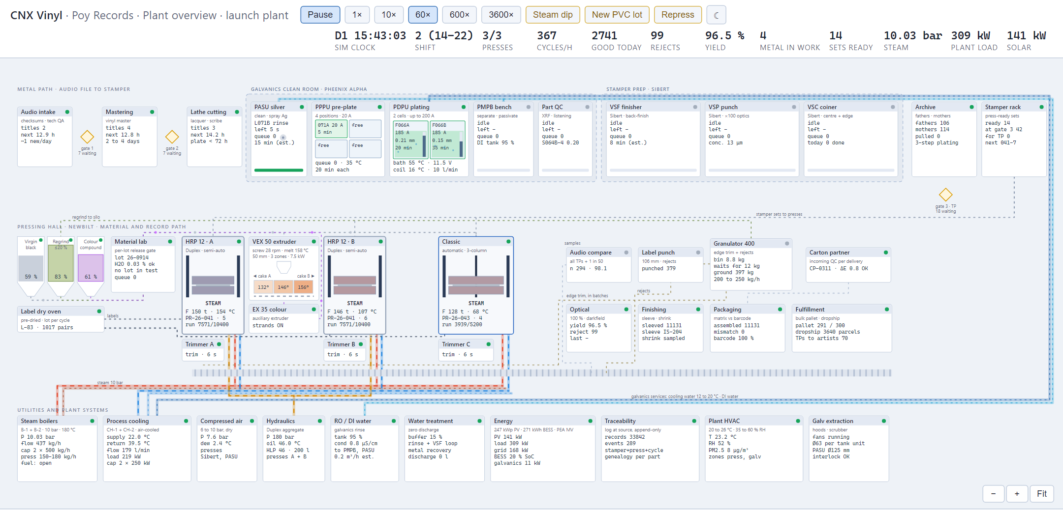
Figure 2. Plant overview (simulated SCADA) of the launch plant, running at 60×: header with shift, presses running, cycles an hour, good records and rejects, metal in work, steam pressure, plant load and solar; metal path on top, press hall and finishing in the middle, utilities below. The demo draws the launch plant (Duplex system 1 and the Classic); Plan B adds the second Duplex system to the same screen. Demo (docs/plant-operation.html), simulated values.

Back office: the factory console on ERPNext
The factory application (working name cnx-factory) is the plant's working interface. It shows the press floor with live counters per press, stamper life and the optical result of every record; work orders per station in kiosk form (badge in, scan what the step asks for, confirm); the material lab gate with lots on hold; stamper metrology and the lacquer, father, mother and stamper genealogy; the hash-chained event log; and the customer portal of the same orders. It keeps no business records of its own: orders, job cards, batches, inspections, metal parts, deliveries and invoices are posted to ERPNext through an outbox, so no press waits for the ERP, and the office works in ERPNext's own desk for purchasing, accounts, stock and planning.
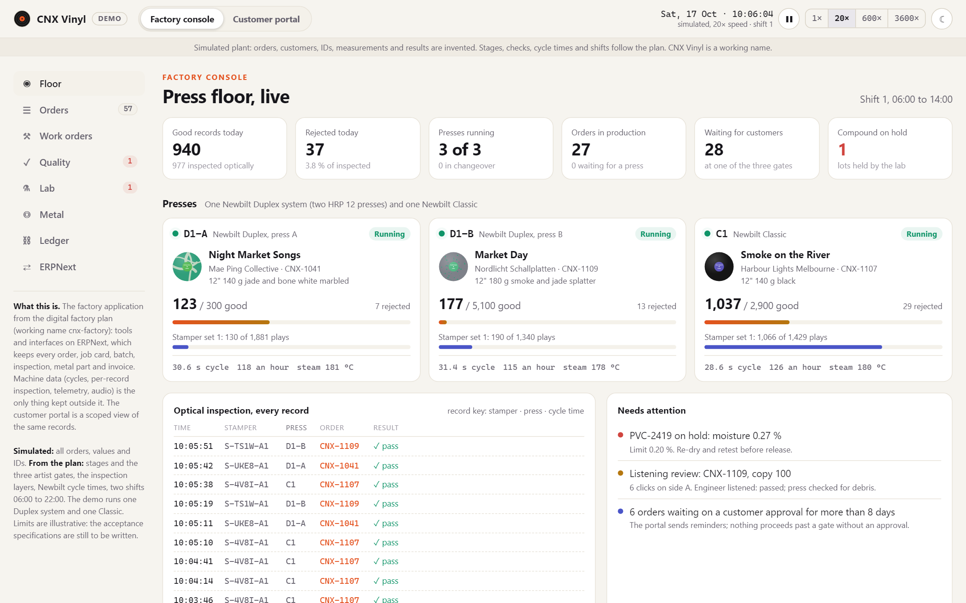
Figure 3. Factory console, press floor: good and rejected records today, presses running, orders in production and waiting at an artist gate, compound on hold; one card per press with its order, progress, stamper set and play count, cycle time and steam temperature; the optical inspection stream keyed by stamper, press and cycle time; what needs attention. Demo (docs/factory-console.html), simulated orders and values; the demo runs one Duplex system and one Classic.
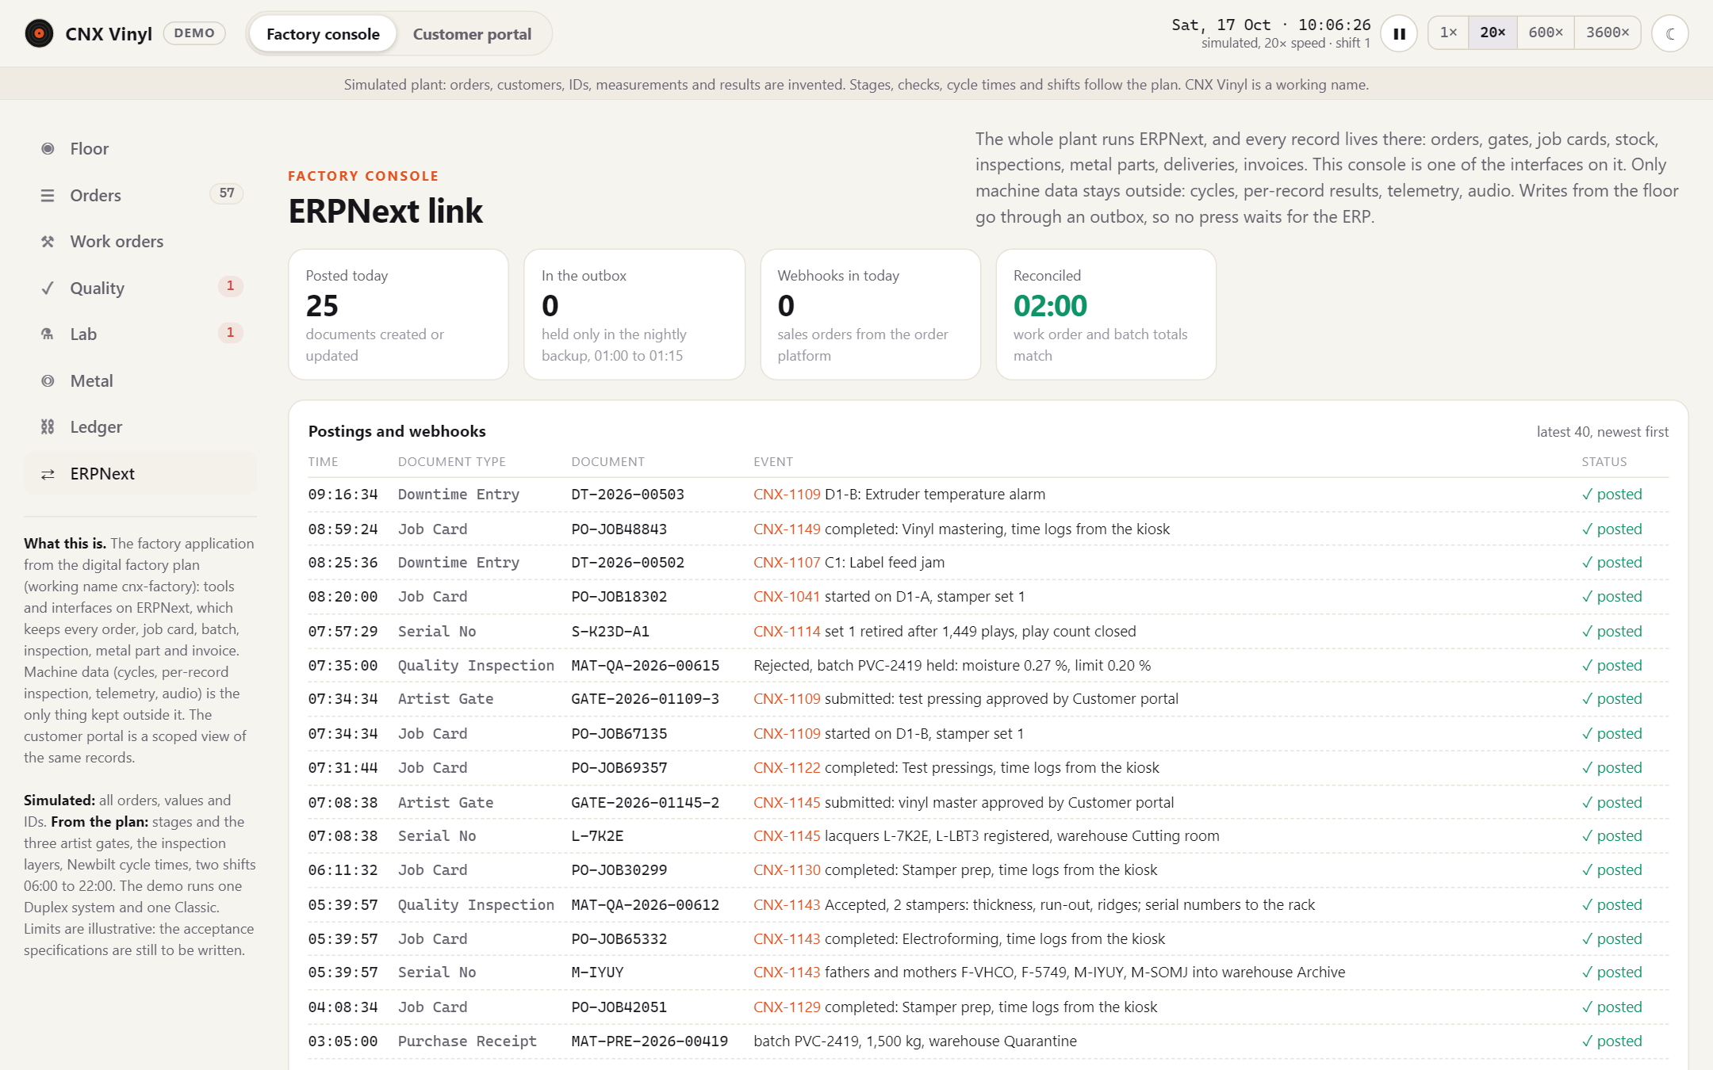
Figure 4. The ERPNext link: every posting the floor makes (job cards, serial numbers of lacquers, fathers, mothers and stampers, quality inspections, artist gates, downtime entries, purchase receipts), its document name in ERPNext and its outbox status. Demo, simulated documents.

Artist platform: order, fund and follow a record
The artist platform is the plant's front door for every customer. The customer configures the record against a to-scale mock-up; uploads music and artwork, which are checked in the browser and never uploaded in the demo (format, sample rate and bit depth, clipping, side length; artwork size, spine, bleed, resolution and colour against downloadable templates); approves the master plan, the first of the three artist gates; and receives an itemised offer with its lead time. In the demo's example a 12-inch black LP with a printed jacket costs 37,836 THB once per title and 343 THB a copy all in at 300 copies (indicative prices, estimates).
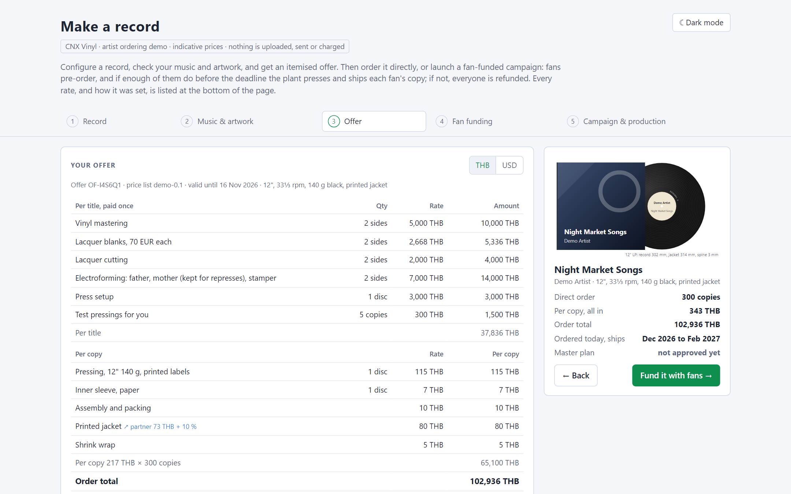
Figure 5. Artist ordering: the itemised offer, per title (mastering, lacquers, cutting, electroforming with the father and mother kept for represses, press setup, test pressings) and per copy (pressing, sleeve, assembly, printed jacket, shrink wrap), with the mock-up and the lead time. Demo (docs/artist-order.html), price list demo-0.1, indicative.
The artist then orders directly or runs a fan-funded campaign: fans pre-order at the artist's price into a ring-fenced account, the plant presses from 100 copies, and if the goal is missed every fan is refunded. At a fan price of 1,200 THB the artist needs 100 fans, breaks even at 41 and keeps ~548 THB a copy at the goal. After delivery each copy has a record passport, reached from the code on its sleeve: the traceability record of that one copy, from the approved master through lacquer, father, mother and stamper to the press cycle and the packing scan. Campaigns go live only after the first paying releases have shipped and lead times are measured. The public side is costed at USD 40k to 90k within the software block (estimate). The platform's name is undecided.
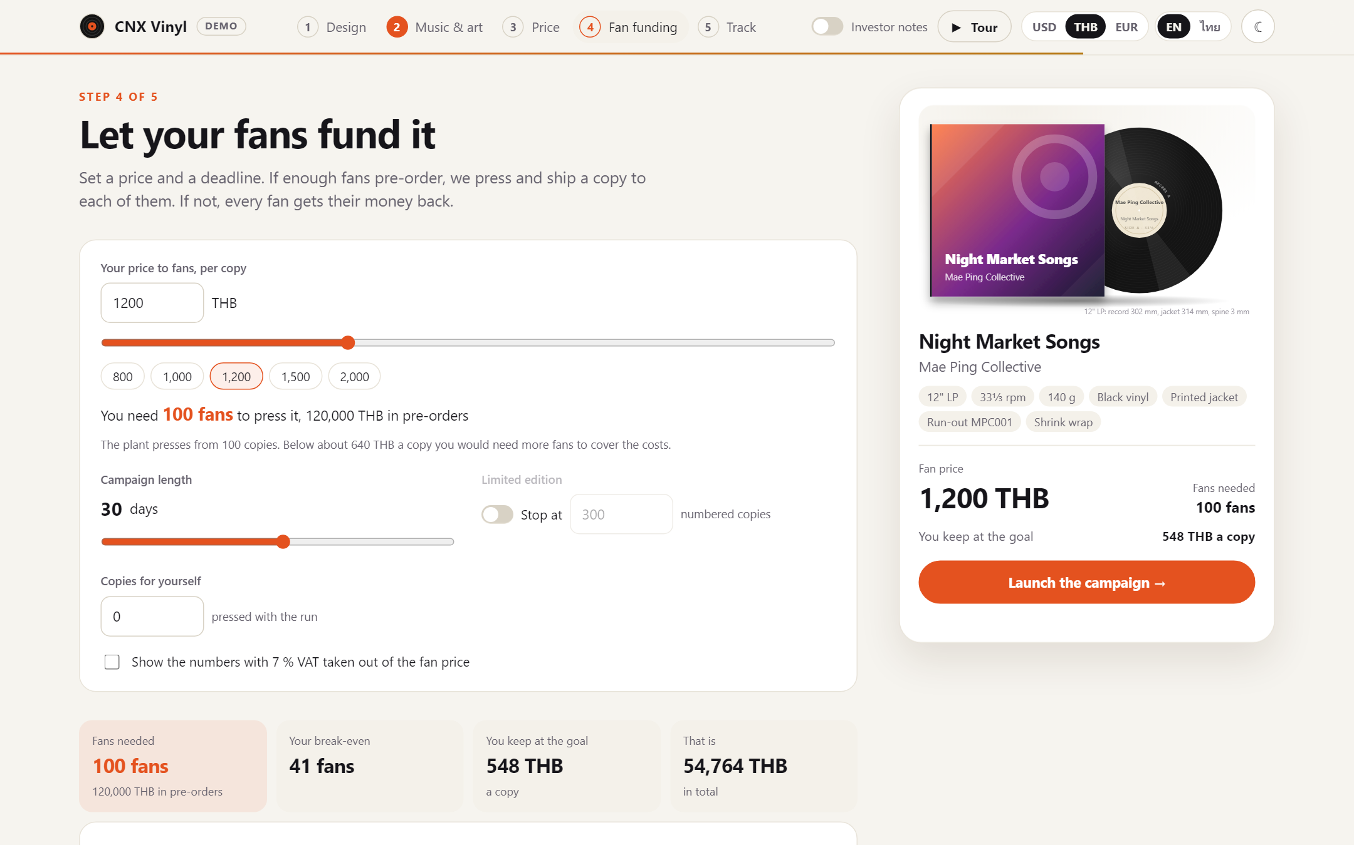
Figure 6. Fan funding in the investor demo of the platform: the artist sets the fan price and the deadline; the fans needed follow from the 100-copy minimum and the break-even, with what the artist keeps. Demo (docs/make-a-record.html), indicative prices.
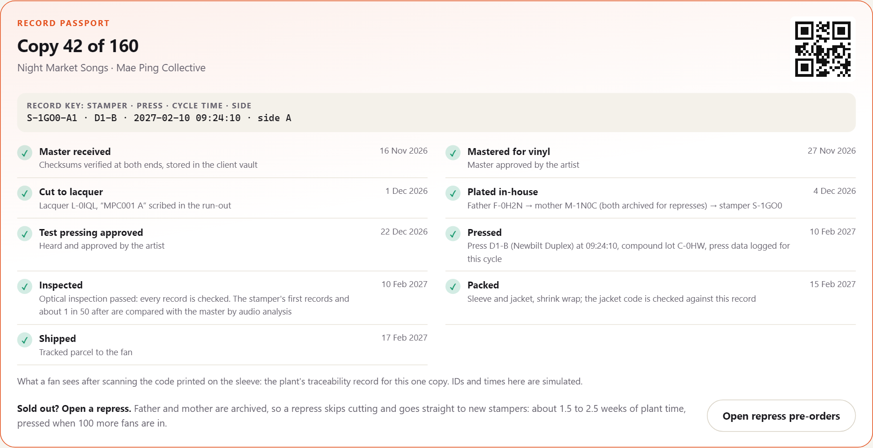
Figure 7. Record passport of one copy: the record key (stamper, press, cycle time, side) and the chain from master to shipment, with the repress path from the archived father and mother. IDs and times are simulated.

6. Site and building

6.1 Land: a long lease, three candidates
The site strategy is a long-term lease of raw land, on which the purpose-built plant is constructed. Compared with buying 6 to 8 rai this keeps ~12M to 32M THB (~0.36M to 0.97M USD, at the 2 to 4 million THB per rai the plan carried for a purchase) out of the capital round, removes land from the balance sheet, and matches how most foreign-invested manufacturing in Thailand holds its site. Three candidates are on file; nothing is signed.
 | Mueang Chi, Lamphun | Northern Region Industrial Estate, Lamphun | Payap University land, Chiang Mai
Status | Working candidate: the massing model, PV roof study and construction RFQ are sited here | Fallback | New lead (October 2026): the university is interested in leasing land to us. The point it gave fails zoning; its other land is not checked yet
Plot | 5-0-66.5 rai on the deed, narrow and skewed | Leased estate plots | Not known yet: boundary, size and title to come
To Chiang Mai old city | ~35 km | Lamphun valley | ~5 km, on the Chiang Mai to Lampang superhighway
Zoning | Unverified (agricultural land): the first check | Industrial estate; licensing through the estate | At the point given: zone ย.7-1, very high density residential; record pressing not permitted (Chiang Mai city plan in force from 25 May 2026)
Galvanics effluent | Ours to permit; zero discharge | Shared central effluent treatment | Lessor's written consent on top of the permit
Neighbours | Agricultural | Industrial | A pharmaceutical facility under construction on the same land

Galvanics now raises the bar for every site. With the electroplating line in the plan, a plot has to permit record pressing with a steam boiler and electroplating from day one, not in a later phase. That favours the industrial estate (licensing through the estate, shared effluent treatment) and makes zoning the first check everywhere else.
Payap University approached the project and is interested in leasing land next to a pharmaceutical facility under construction. The point it gave was checked on the land-use map of the Department of Public Works and Town and Country Planning on 14 October 2026: zone ย.7-1, very high density residential, where factory type 107 (whose definition names gramophone records) is not permitted and type 72 is allowed only for repair, so a record plant cannot get a factory licence there. The same city plan permits type 107 in its low density residential and rural and agricultural zones, so Payap's other land is worth checking before the lead is dropped (the map data is preliminary; the provincial town planning office confirms). Why it is worth the checks: it is ~5 km from the old city, 25 to 30 km nearer the team, customers and the airport than Mueang Chi, which helps tours, the artist platform and hiring; and Payap is a partner, not only a landlord: it wants joint student programmes with us in mastering, lathe cutting, IT and business administration, and its Faculty of Pharmacy has analytical labs that could back the PVC lab. Any Payap plot is checked in this order, before any design work:
1. Zoning: the plot's zone in the Chiang Mai city plan allows a record-pressing factory with a steam boiler and electroplating (the neighbour's pharmaceutical permit proves little).
2. Lease-ability: Chanote title, university council approval, and whether campus land of a private university can be leased commercially; with Thai counsel, together with the lease terms below.
3. The GMP neighbour: a pharmaceutical plant is sensitive to the boiler stack, galvanics extraction, extrusion fumes, noise and trucks; emission and buffer rules go into the lease, not after the first complaint.
4. Flooding: Payap describes the land as low-lying when bought; check the plot against the 2024 flood extents.
5. Plot fit: the building, the detached utility yard and a second building need 6 to 8 rai; the Payap scenario model draws a 150 m square (14.1 rai) with room for the full press hall.
6. Galvanics on a campus: the lessor's written consent; zero discharge becomes a lease condition, not only a commitment.
Nothing is re-sited until a Payap plot passes zoning and lease-ability: the model, the PV study, the RFQ and the plant's network site code stay on Mueang Chi. The lease itself must meet these conditions, which Thai counsel resolves before signature:
- Term and registration. A lease over three years must be registered at the Land Office to be enforceable; the ordinary maximum is 30 years, and for industrial and commercial use the Hire of Immovable Property for Commerce and Industry Act allows up to 50 years for qualifying projects. The plan assumes a registered 30-year lease with a contractual renewal option, and will test the 50-year route with counsel.
- Building ownership. The lease states that the buildings, foundations, tanks and fixed plant belong to the company for the term, what happens to them at expiry, and that the company may mortgage or assign them. Without this, financing the building is difficult.
- Lessor's title and encumbrances. A clean Chanote title, no mortgage that could foreclose over the tenant, consent from any co-owners. A lease of Sor Por Kor or forestry-classified land is not acceptable.
- BOI. BOI's land-ownership privilege for foreign-held promoted companies is simply not used; leasing does not affect the promotion.
- Rent. Not negotiated. The plan carries THB 0.3M to 1.0M a year (USD 9k to 30k) as an estimate for 5 to 8 rai of agricultural land in the Lamphun valley, with the lease deposit and first-year rent in the working-capital block; IEAT plots run higher, and Payap has named no figure.
Land requirements: ~4 rai minimum, 6 to 8 rai comfortable with expansion; truck access and turning, parking, the detached utility yard, a separated battery enclosure, and a medium-voltage connection from PEA (800 to 1,000 kVA for the five-press backbone without electric steam, 1,250 to 1,600 kVA with it).

6.2 The building
The main building is a single-storey steel portal frame (pre-engineered) of 60 × 25 m (1,500 m²), designed from day one for an overhead crane, with a 10° monopitch roof carrying the PV array, low eave 7.0 m, high side ~11.4 m. The floor is a 200 mm slab rated 30 kN/m² (3 t/m², the standard industrial class the presses and racking need) raised 1.2 m above ground, so that two sealed loading docks work at trailer height and the docked trailer acts as the airlock. The envelope is insulated PIR sandwich panel (100 mm roof, 75 mm walls) on a 2.5 m masonry dado, taped and gasketed, because the building is air-conditioned and must be airtight against smoke-season particulate; mineral-wool panels where fire compartmentation (EI 60 or 120) or acoustics require them.
Zone | Area
Semi-automatic press hall (Newbilt Duplex specification) | ~200 m²
Automatic press zone | ~100 to 150 m²
Galvanics clean room, water treatment, chemical storage | ~80 to 150 m²
Mastering and cutting room | ~40 to 60 m²
Stamper preparation | ~30 m²
Packaging and finished-goods warehouse | ~300 to 500 m²
Utility rooms (boiler, compressor, chiller, electrical) | ~100 to 150 m²
Offices, QC and listening room, archive, IT, entrance | ~150 to 200 m²
Maintenance workshop and machine bay (crane-served) | ~100 to 150 m²
Visitor corridor (glazed, ground level) | ~110 to 130 m²
Circulation, walls, miscellaneous | ~150 to 250 m²
Total under roof | ~1,400 to 2,000 m², against 1,500 m² built
Estimates. The boiler and chillers have since moved to the detached utility yard, which frees floor the workshop and corridor take; water treatment is proposed in its own building next to galvanics; cassette and CD-R duplication (~40 to 80 m² and ~20 to 40 m²) are not in the table yet. The press rows size one Duplex system and the Classic; the second Duplex system needs its own bay on top (~110 m² at the calculator's floor figure, estimate). At the lower half of the table everything fits in 1,500 m²; at the upper half, finished goods move to a second building.
Figures 8 to 10 show the plant as the plant and business plan calculator draws it for Plan B (~225M THB). The calculator draws the Payap scenario model (section 6.1): a 128 × 25 m production floor in process order along the glazed visitor corridor, a two-storey office, the detached utility yard and a press hall of ~870 m² laid out for five Duplex bays and four Classic positions, on a 150 × 150 m placeholder plot. The building described above and the zone table are the 60 × 25 m hall for Mueang Chi; which layout is built is decided once a plot passes zoning and lease-ability. The calculator itself is interactive: rotate, zoom, switch floors and tap any object for its figures and their source.
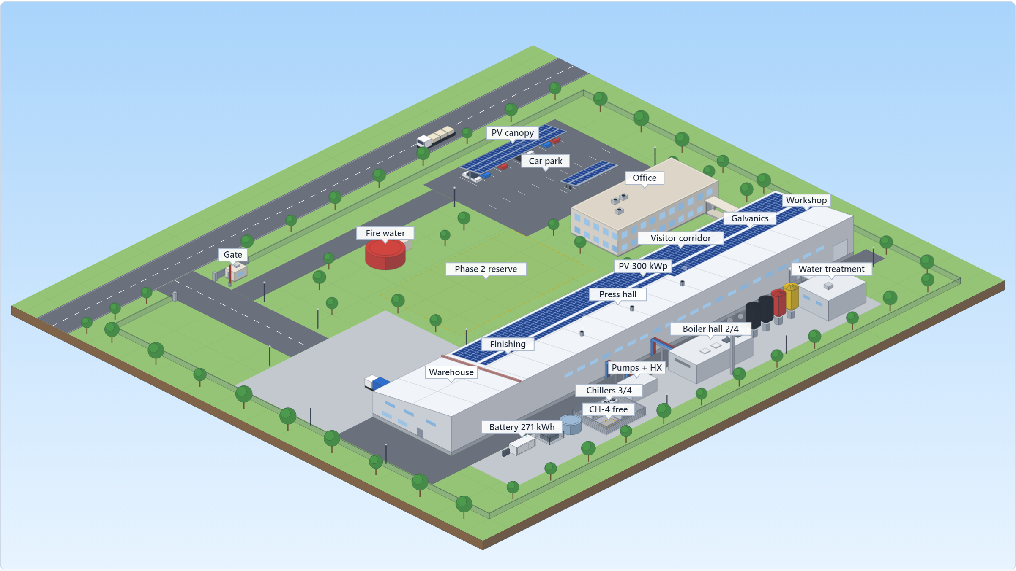
Figure 8. The site from above, Plan B (~225M THB) preset of the plant and business plan calculator: the factory with roof PV and battery, owned, the office, the utility yard (boiler hall and chiller compound built for four modules each, pump and heat-exchanger room, transformer, water treatment, PVC silos), parking with PV canopies and the phase 2 reserve. Schematic render of the Payap scenario model (docs/fleet-calculator.html); positions and envelopes are estimates.
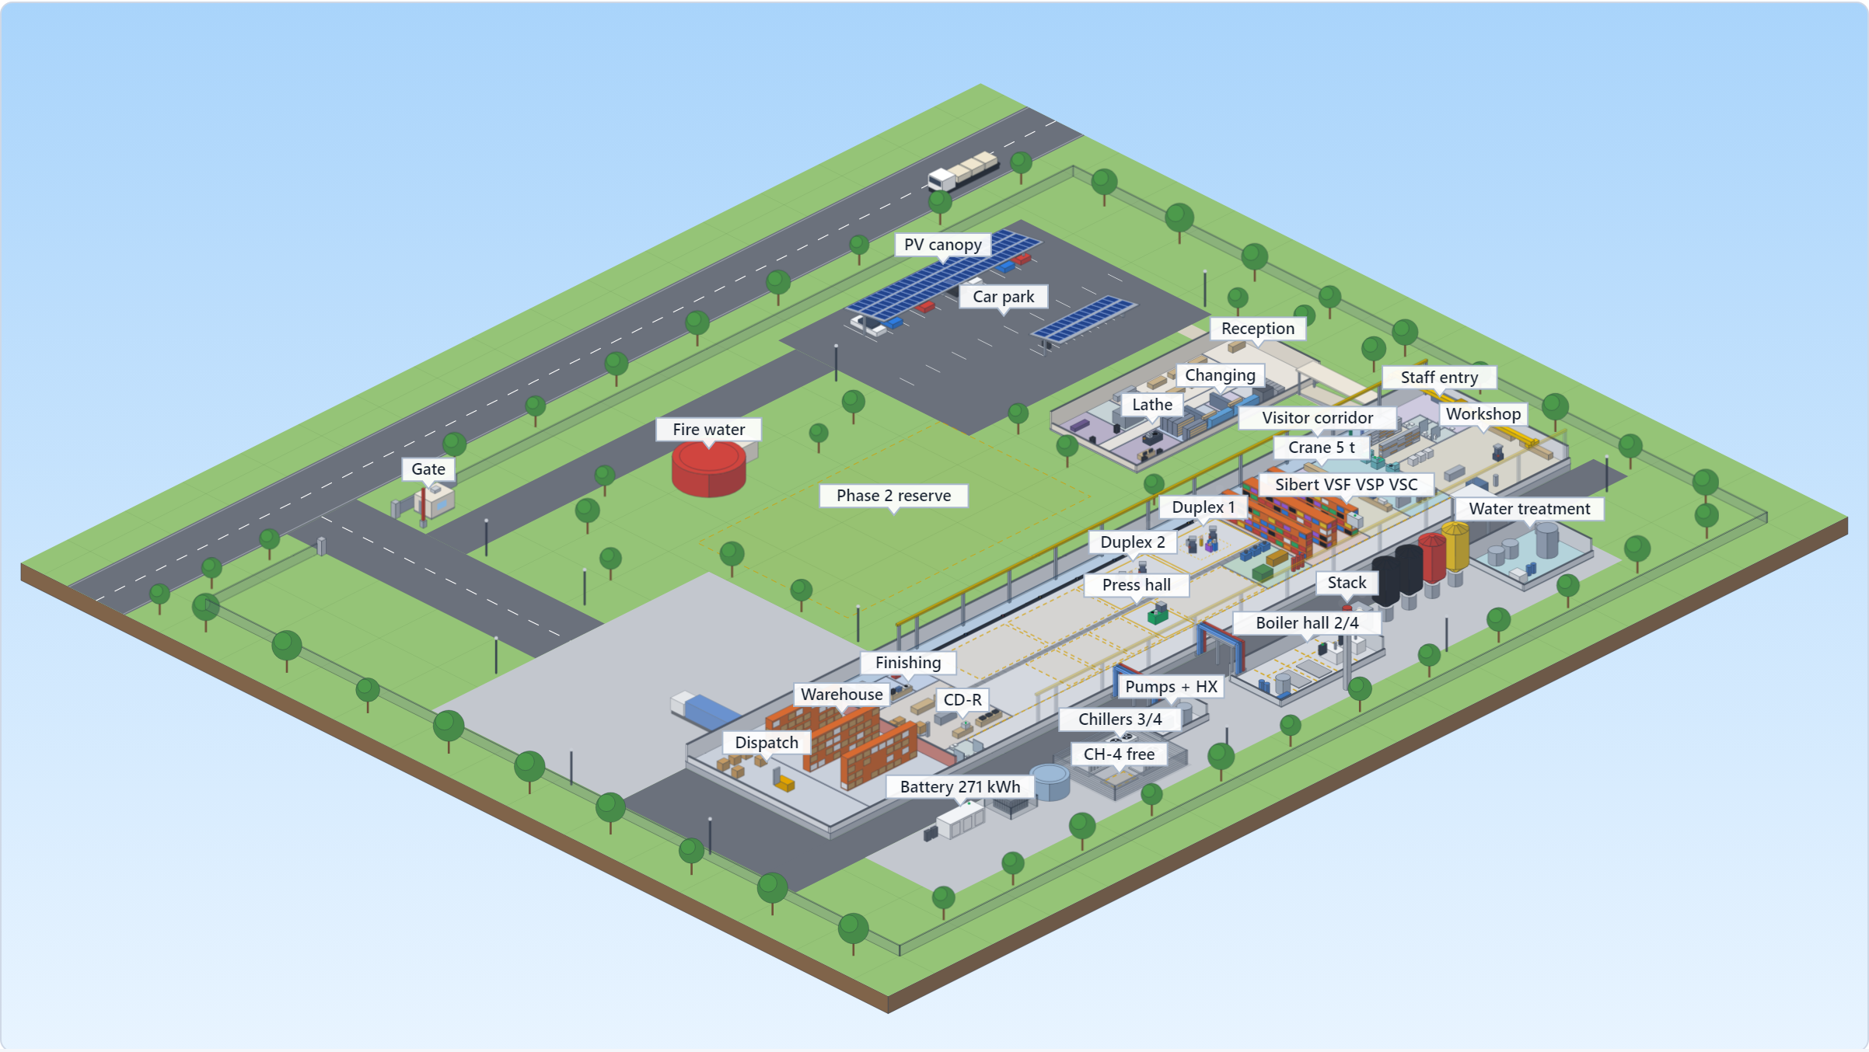
Figure 9. Ground floor with the roofs cut away, Plan B (~225M THB) preset: from the west end the staff entry, workshop, galvanics (PASU, PPPU, PDPU, PMPB), Sibert stamper prep, metrology, PVC lab and colour store, then the press hall, optical inspection, finishing and packaging, the warehouse and dispatch; the office with reception, lathe and cutting room, listening room and archive. With the 5 t crane, the visitor corridor and the cassette and CD-R rooms. Schematic, estimates.
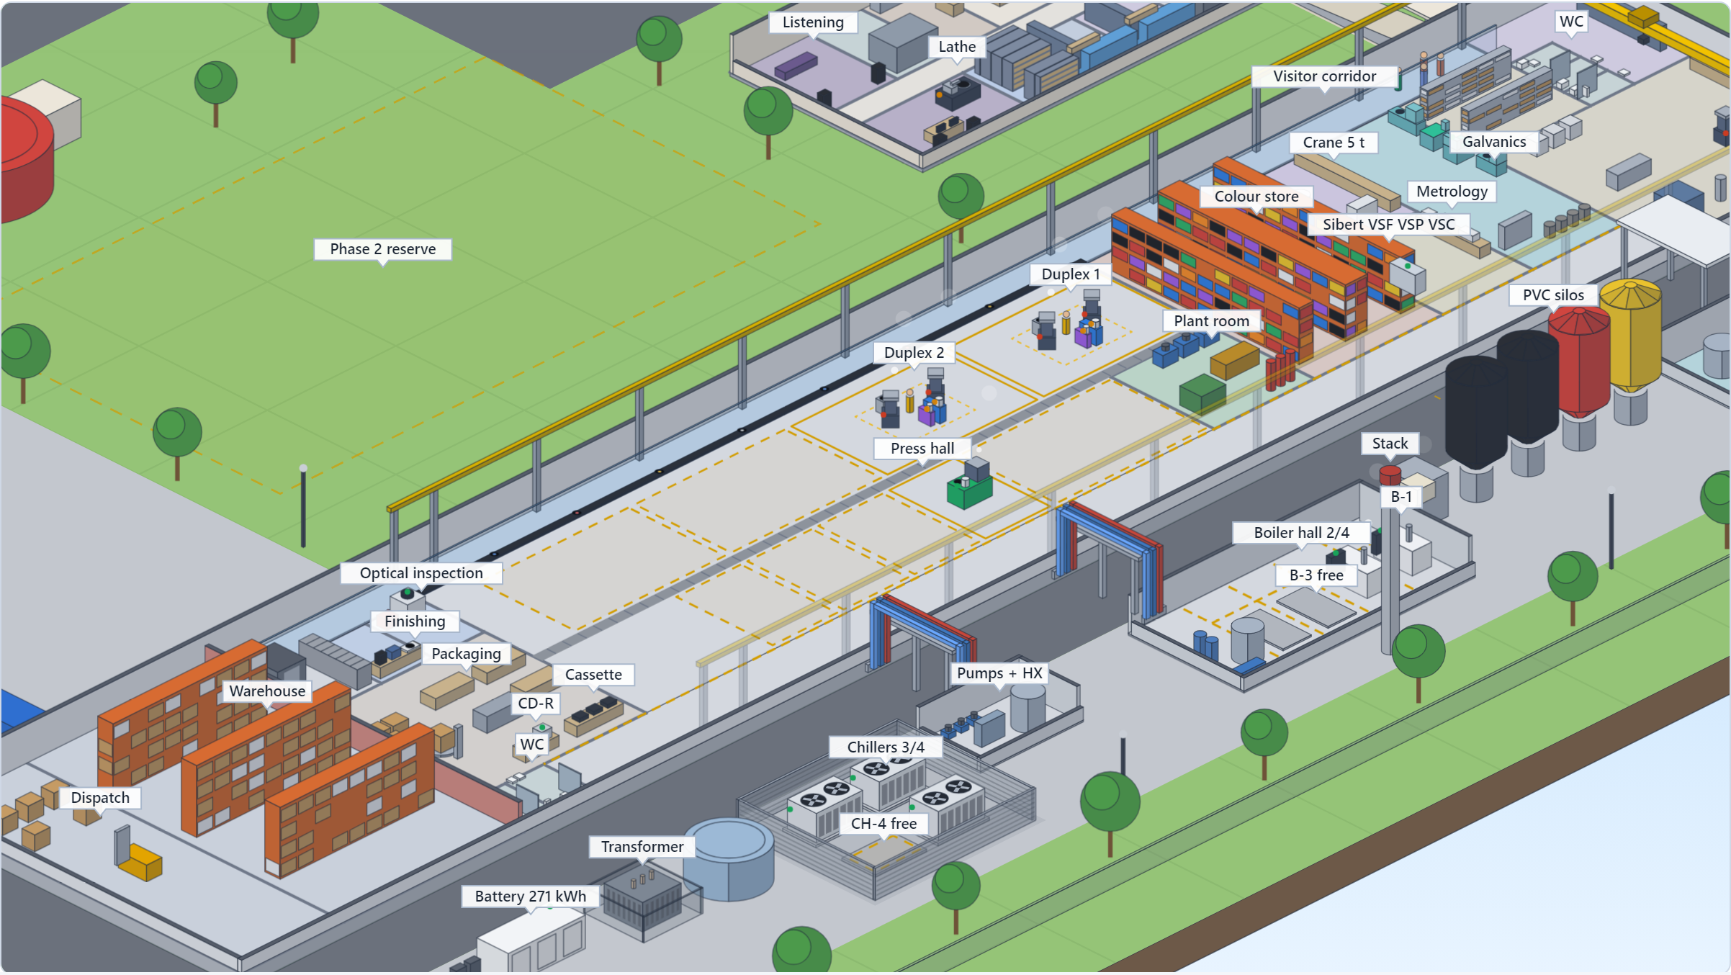
Figure 10. The press hall close up, Plan B (~225M THB) preset: Duplex systems 1 and 2 (four HRP 12 presses with their extruders) and the Classic; the dashed outlines are the free Duplex bays and Classic positions. In the yard, boiler modules B-1 and B-2 (B-3 and B-4 free) and chillers CH-1 to CH-3 (CH-4 free). Schematic, estimates.

Crane, workshop and visitor corridor
- A 5 t overhead crane (single-girder, ~24 m span, inverter drives, radio remote) runs over the whole production compartment, roughly 40 to 48 m of the 60 m, and stops at the fire wall to the finished-goods warehouse. Machines are moved in, out and around without hiring a mobile crane. It shapes the building: a frame designed for crane loads, no full-height cross walls in the crane zone (rooms there are lidded boxes, with removable hatches where heavy kit goes in), and the cutting room kept outside it, away from the frame's vibration. 5 t covers the heaviest known lift (a Newbilt HRP 12 press, 1,350 kg) with margin until Newbilt states the Classic's weight; 3.2 t is the alternative price.
- A machine door of ~4.5 × 5.0 m at the ramp end, opened a few times a year: a truck reverses up the ramp into the machine bay and the crane lifts the machine off the bed inside.
- A maintenance workshop of ~100 to 150 m² beside it, where the crane parks: a service bay for one press-sized machine, benches, a hydraulic hose crimper, a spares store tracked in ERPNext, and a hot-work corner, held at negative pressure so its dust never reaches the presses. Newbilt service comes from Germany and Pheenix from Sweden; spares on the shelf are the uptime lever.
- A glazed visitor corridor at ground level along the car-park wall (~45 to 55 m, ~2.4 m clear), with stations in process order from the cutting-room window to packaging. It has its own filtered air at slight positive pressure and acoustic glazing that brings the 80 to 90 dB(A) near the presses down to roughly 40 to 50 dB(A) (estimates), so a guide talks without a headset and visitors need no PPE; a 1:12 accessible ramp serves the entrance. Tours for artists, labels, investors and schools can run several times a day without stopping production.

Utility yard and water-treatment building
Detached utility yard (decided October 2026) | Size (estimate)
Boiler hall, four 500 kg/h module positions (B-1 and B-2 at launch) | ~162 m² (18 × 9 m), 6.0 m high
Biomass fuel store | 42 m²
Chiller compound, open and screened, four pads (CH-1 to CH-3 at launch) | ~135 m² (12.5 × 10.8 m)
Cooling pump and heat-exchanger room | ~40 m² (8 × 5 m)
Flue stack | 14 m
Yard in all | ~379 m², against 178 m² before the four-module decision
The fired case sets the boiler hall (an electric bank would need about half). No cooling tower: the chillers are air-cooled. The rooms are built once for four modules and the plant goes in one module at a time; the yard sits outside the main building because the boiler must have its own room and biomass deliveries need yard access.
Water treatment gets its own building (proposed, October 2026): ~12 × 10 m directly behind galvanics, holding the zero-discharge effluent treatment, the DI water plant and the chemical store. A buried duct carries the effluent by gravity from the galvanics floor at +1.2 m and brings DI water back, and a covered crossing joins the two doors; the galvanics room keeps only a chemical day store.
The archive room holds the father and mother of every side, about 1,200 to 2,400 parts a year at full capacity, on mobile archive shelving (A-Z Solutions of Vienna as the reference specification, LPI Rack Range in Thailand to quote against it). In the Payap scenario's office a room of about 4 × 5.75 m with four mobile carriages holds ~150 shelf metres, roughly 50,000 parts or 20 years and more of output (estimates). It asks things of the building early: ~11 kN/m² under the shelving block, so the archive stays on the ground slab at the full rating; rails set into the floor screed at fit-out; clean-agent gas suppression; a water-leak sensor along the rails. One open point: with fathers and mothers in one room, one event takes both, so keeping the rarely pulled fathers in a second fire compartment or off site is on the list.

Site works and the second building
On the Mueang Chi parcel the site works are a ~444 m perimeter wall, one 10 m sliding gate with a guard house, 4,387 m² of paving in two classes (1,608 m² heavy-duty for trucks, 2,779 m² general), roofed parking for 10 cars and 30 scooters carrying ~40 kWp of PV, a ring foundation for a 9 m fire-water tank with its pump house and one for a 5 m raw-water tank, a fire ring main and hydrants, stormwater drainage and domestic sanitation. With the buildings, ~6,549 m² or 68% of the modelled plot is sealed, so stormwater attenuation, quite possibly a detention pond, may be a permit condition.
A second building is expansion, not a gap. A 45 × 38 m (1,710 m²) phase 2 building fits the plot's narrowing southern end with a two-bay sawtooth roof carrying ~251 kWp and a 20 m yard between the two for fire separation and shared loading; coverage stays at 39% of the deed area. It is where finished goods move to free production floor, where pressing capacity can double, or where a CD replication line would go if that option is chosen (section 4.10). The press hall is planned for Duplex systems, because the plant focuses on special pressings and specials run only on the Duplex: five Duplex bays and four Classic positions (~73/27 by floor, estimate). This plan installs two Duplex systems and one Classic at launch; growth adds Duplex systems first. Where the second Duplex system stands on the Mueang Chi footprint is not drawn yet; the Payap scenario model draws the five-press fleet.

What the construction RFQ asks
The budget-level construction RFQ, with quantities from the parametric model, asks contractors for: the shell rate per m² at the insulated-panel specification (not a bare shed); heavy-duty and general paving separately; a separate rate for mineral-wool panels at fire-compartment and acoustic walls; the crane package separately (runway and frame premium, machine door, the crane, and the hook height achieved under the 7.0 m eave, with +1.0 m on the eave as an option); the utility yard with floors, pads and plinths for all four positions; a lump sum for the rest of the site works; and the foundation assumption behind all of it. It excludes process machinery, PV, air conditioning, boilers, chillers and tanks, sprinklers, fit-out and the PEA transformer, and asks whether permit drawings for the building permit and the factory licence are included.

What the building costs, and what is not known
Block | USD | THB | Basis
Building ~1,500 m² plus civil and site works | 650k to 1,100k | 21.4M to 36.3M | estimate at 12,000 to 20,000 THB/m² for Thai pre-engineered steel to the insulated-panel specification, plus ~20% site works
Overhead crane, runway, frame premium, machine door | 97k to 227k | 3.2M to 7.5M | estimate
Maintenance workshop and machine bay fit-out | 30k to 76k | 1.0M to 2.5M | estimate; a workshop lathe and CNC mill not priced
Visitor corridor and accessible entrance | 67k to 148k | 2.2M to 4.9M | estimate; building it later would take ~3.6M THB out at the midpoint
Utility yard for four boiler and four chiller modules | 73k to 122k | 2.4M to 4.0M | estimate at the building rate
Water-treatment building next to galvanics | 52k to 87k | 1.7M to 2.9M | estimate at the building rate
Together | ~0.97M to 1.76M | ~32M to 58M | sum of the blocks; the plan carries no contingency (section 8)

The single largest unknown is the ground. The Mueang Chi parcel is likely soft former paddy, and a piled slab can add several hundred to 1,000+ THB/m² across the building, 4,387 m² of paving and a 1,711 m³ fill platform. A soil boring test (THB 30k to 50k, in the phase 0 budget) comes before any real number, and the building RFQ with a soil test is one of the four requests that settle the budget. Also open: the crane's hook height under the 7.0 m eave; the archive's mobile shelving (to quote); the valved branches and feeders for the empty utility positions; and the fire-water volume, which the hydraulic design and the warehouse racking height set. Renting a mobile crane for the installations while the frame, runway and machine door stay crane-ready would take ~3.2M THB out at the midpoint (estimate): a step if quotes land high, not part of the plan.

6.3 Safety, security and the irreplaceable
Worker safety is a founding priority on equal footing with the environmental commitments. The press floor combines hydraulics at ~180 bar, saturated steam at 10 bar / 180 °C and hot PVC; the galvanics room handles silver nitrate, nickel salts and acids. The plan provides vendor-led commissioning training extending into an in-house programme, mandatory PPE per area, and galvanics as a clean room with controlled access, extraction on every plating unit, decontamination procedures, eyewash and emergency shower at the line, and a hard-wired interlock (no extraction, no plating). A machine is lifted only after lockout (power isolated, steam vented, hydraulics depressurised including the accumulator) and with a lift plan; hot work stays in the workshop under a permit; the boilers run under a licensed boiler controller (section 7).
Decided in October 2026: every member of staff, office included, gets group health insurance (inpatient and outpatient) and a yearly check-up on top of social security, plus the occupational checks Thai law requires for risk-factor work (press-floor heat and noise, galvanics chemistry, maintenance) within 30 days of starting and yearly after. Everyone wears the same company workwear (Strauss), with process PPE on top. Planning costs, estimates: ~15,000 THB a head a year for insurance, ~2,500 for the check-up plus ~1,500 for risk-factor tests, and workwear ~USD 9k a year at ~20 staff.
Physical security is zoned: production, galvanics, chemical storage, the metal archive, IT, shipping and the visitor corridor each get badge or biometric access with logs; CCTV at entrances, perimeter, dock, production, chemicals and archive under a PDPA-compliant retention policy. Two things are irreplaceable and get their own protection: the metal archive (a destroyed father means recutting and re-plating a release; fire-rated room, climate control in the tightest monitoring tier, access logging, clean-agent gas suppression because sprinkler water would destroy paper records and corrode the metal) and client audio (pre-release music is a leak target; an isolated, encrypted, access-logged vault, need-to-know access, and a written policy the sales team can show labels).
Fire suppression is zoned, not full-building gas: clean agent only in small sealed high-value rooms (archive, IT, switchrooms, control cabinets), water mist or sprinklers in production and the carton-heavy warehouse, and detection and containment rather than suppression for the battery enclosure. The site carries its own ~200 m³ fire reserve and pump set (electric duty, diesel standby, jockey) because mains flow cannot be assumed; warehouse racking above about 3.7 m changes the sprinkler design and raises that volume, so the racking height is fixed before the fire design. The property insurer is involved before the design is fixed.

7. Regulatory: BOI promotion and licences

7.1 BOI promotion
The project will apply for promotion by the Thailand Board of Investment. In BOI terms vinyl pressing is basic plastic consumer-goods manufacturing (incentive Group B): no corporate income tax holiday on the core activity, but the full non-tax package and machinery duty exemption. The tax value is engineered on top through measures where this project happens to be strong, so the application is pitched on solar, automation and technology content, not on pressing plastic discs. The research behind this dates from July 2026, BOI revises its measures roughly every year, and the exact activity sub-code needs confirmation by a BOI-registered consultant before filing.
What BOI gives | Why it matters here
Machinery import duty exemption | Almost the entire launch equipment list is imported (Germany, Sweden, the UK, Australia, Japan, China). Machinery imported duty-free is also exempt from VAT at import (Revenue Department answer on BOI's FAQ, checked October 2026). The investment blocks assume promotion: without it, ~5% duty on ~2.3M USD of imported machinery (~0.11M USD) plus ~0.17M USD of import VAT, reclaimed only later (estimates for the three-press equipment list; the second Duplex system adds to both).
100% foreign ownership and land privileges | Overrides Foreign Business Act restrictions for the promoted activity. The land-ownership privilege is unused under the lease strategy.
Visas and work permits via the One Stop Service | Foreign commissioning engineers and the technical consultant, without the four-Thai-employees-per-permit rule.
Raw material duty relief | Exemption for export production; up to 90% reduction for domestic sales. Relevant for imported PVC compound until a Thai source is qualified.
Solar and battery measure (Announcement 2/2568, April 2025) | CIT exemption based on the solar investment; PV modules, inverters, battery and battery inverters, and mounting are eligible, capped at THB 12M, 30M or 40M of investment per MW depending on investment type. It rewards a plant-owned array. This plan buys the ~247 kWp array and the 271 kWh battery, so their cost is the base of the exemption (section 5.4).
Smart and Sustainable Industry measure (Announcement 15/2565, refreshed July 2025) | Rewards automation, smart machinery and energy efficiency, typically 3 years of CIT exemption capped around 50% of the qualifying upgrade spend. The automatic Classic, inline inspection, metrology and heat recovery are the natural fit.
R&D merit | At least 1% of revenue in Thai R&D adds 1 to 3 exemption years and can lift the cap. Galvanics process development, recycled-PVC work and the audio-QC system could qualify; whether R&D with Payap University and the joint student programmes count is to be checked.

Requirements: minimum THB 1M investment excluding land and working capital (cleared many times over); debt-to-equity no higher than 3:1 for the life of the privileges, which shapes the financing mix; modern machinery and process; progress reports, annual reports and machinery lists. The plant's asset register and stock ledger in ERPNext are where the record of promoted machinery and raw materials lives, from the first capex invoice.
Process: file via the e-Investment system and present at an analyst meeting. BOI quotes about 40 working days to a decision for projects under THB 200M and 60 to 90 working days for larger tiers; at ~162M to 286M THB with the ramp-up reserve (~224M at the midpoint) the plan sits around that line, so the consultant confirms which applies. In practice it is roughly 4 to 6 months end to end to the certificate; the company is incorporated under it; machinery is imported within a window commonly 30 months from issuance; full operation is due by about 36 months. The Northern Economic Corridor (Chiang Mai, Lamphun, Lampang) is promoted as a creative-economy base, which a music manufacturing story fits; the current area add-ons for Lamphun must be confirmed with BOI directly.

7.2 Factory licence, galvanics and boilers
BOI promotion does not replace the factory licence (Ror.Ngor. 4), hazardous-substance registration for the plating chemistry, wastewater permitting or the boiler rules. Galvanics is in the plant from launch, so the electroplating line, its chemistry and its zero-discharge effluent system are in the first factory licence application, not a later amendment. The earlier plan to keep galvanics out of the first licence to protect the schedule no longer applies. Effluent is the most likely regulatory friction point regardless of BOI, and it now sits on the path to the first paying release:
- The site must permit plating from day one (section 6.1): zoning has to allow a record-pressing factory with a steam boiler and an electroplating line. The industrial estate's licensing and shared effluent treatment are the easiest path; on Mueang Chi the permit is ours; on Payap land the lessor's written consent comes on top.
- Zero discharge is the design, and the application says so: rinse water through the ZLD evaporator with metal recovery, the back-finisher's spent water and filters by the same route, solvents as controlled waste, no process water to the environment. It is the strongest answer the plant can give to the effluent question.
- Permit drawings for the building permit and the factory licence come from a licensed engineer; the construction RFQ asks whether contractors include them (shell prices usually do not), and stormwater attenuation may be a permit condition.
Boilers (DIW rules). The Ministerial Regulation on boilers B.E. 2549 and the Ministry of Industry notification on boiler safety of the same year apply to every module, Thai or imported: a design to TIS or an international standard (ASME, JIS, EN or equivalent) checked and certified by a DIW-registered certification body or licensed engineer; for an imported boiler, verification by a registered certification body and the manufacturer's data report, design and inspection reports filed with DIW; installation drawings checked and an inspection before first use reported to DIW within 30 days; a licensed boiler controller on site; and inspection at least once a year. The relief for small once-through units does not apply at ~10.5 bar (our reading), and the labour-side regulation of 2021 adds licensed-engineer installation and testing and a feedwater standard. The plan's modules come from Thai suppliers to the same ASME specification; a Chinese boiler built to the Chinese GB code would rest on 'or equivalent' with no precedent found. DIW has announced a revision of the boiler, pressure-vessel and refrigeration rules, so they are rechecked before the RFQ, and a certification body is engaged before any boiler order.
Other permits and duties: the same 2021 labour regulation covers the overhead crane (a crane-industry summary puts cranes above 3 t on an engineer inspection every three months; to confirm against the text before the capacity is chosen); hazardous-substance registration and locked, inventoried storage for silver nitrate and nickel salts; the occupational health check-ups (section 6.3); PDPA for CCTV, personnel and operator-linked production data; local fire codes and the building permit during construction; and DIW manifests for used oil and other controlled waste.
Three things to settle before filing
• Zoning before filing. The BOI clocks (the import window and the deadline for full operation) start at the certificate, and the margin on them is consumed by one scenario: filing early and then finding the site does not work. Verify the chosen plot's zoning, including plating, first.
• Scope. Cassette and CD-R duplication go into the application from the start. CD replication would need new activity codes, which cannot be added casually afterwards, so the investor's decision on CD (section 4.10) is needed before the filing date.
• Sequencing. The plan's rule is that no machinery purchase order precedes the certificate, because duty exemption is not retroactive. But the exemption attaches at importation, not at contract signature. If equipment can be ordered with a deposit while the application is in review, provided it clears customs after issuance and is on the approved machinery list, the launch pulls forward by six to nine months. With the lathe, galvanics and Sibert line now on the critical path alongside the presses, this is the first question for the BOI consultant and the only item in the plan worth half a year.

Keep any future label, content or retail arm in a separate entity: media and service activities carry different, sometimes Thai-ownership, conditions and would muddy a clean manufacturing application. Poy Records as a label brand is therefore a separate question from the plant.

8. Investment
This chapter prices Plan B (~225M THB): the launch plant decided in October 2026, with the whole chain from the cutting room to the shrink wrapper, plus the second Duplex system at launch: five presses with everything in, in one capital round and commissioned in sequence. The plan price carries the ramp-up reserve, because that is cash the investor puts in, and no contingency. Blocks marked 'estimate' have no vendor confirmation; the rest trace to quotes, published prices or researched ranges. Treat all figures as budgetary with a wide margin (plus or minus 30 to 50 % on the estimates) until requests for quotation replace them. Exchange rates: 1 USD = 33 THB, 1 EUR = 1.155 USD, 1 GBP = 1.35 USD.
The September 2026 draft of this plan priced a phased entry (one press, bridge stampers, outsourced cutting) and a five-press full vision. Both are superseded, as is the launch-plant budget with a 15 % contingency of the previous draft; they are not repeated here, and the planning repository keeps them for the record.

8.1 Plan B, all blocks
Block | USD | THB | Basis
Phase 0: BOI consultant, legal and lease work, soil test, re-quotes | 40k to 80k | 1.3M to 2.6M | Estimate
Newbilt Duplex system 1 (two HRP 12 presses, EX 50 main and EX 35 colour extruder, trimmer, label oven, shrink wrapper, grinder, label punch) | 350k to 370k | 11.6M to 12.2M | Quoted: 2024 offer EUR 200,500 for the Single 2.1 plus the quoted second press and extruder ~USD 115k; expired, re-quote
Newbilt Duplex system 2 (two HRP 12 presses, EX 50 main and EX 35 colour extruder) | 230k to 300k | 7.6M to 9.9M | Estimate: two presses at the quoted ~115k per press and extruder set, plus hydraulic unit and EX 35; no EX 35 price on file
Newbilt Classic, fully automatic press | 290k to 460k | 9.6M to 15.2M | Placeholder (the old automatic-press band per press); no Newbilt price on file
Pheenix galvanics line (PASU, PPPU, one PDPU, PMPB) | 324k to 445k | 10.7M to 14.7M | OMS's reference plus 20 %: OMS's 4-cell wet room with the EUR 10k know-how transfer, EUR 234k to 321k (letter of 9 October 2026), × 1.2 = EUR 280.8k to 385.2k; no Pheenix price on file
Galvanics water: zero-discharge (ZLD) evaporator and DI water | 97k to 258k | 3.2M to 8.5M | Researched: utilities rows, launch scope
Water-treatment building next to galvanics (~12 × 10 m, proposed) | 52k to 87k | 1.7M to 2.9M | Estimate at the building rate below
Sibert stamper prep: VSF back-finisher, VSP punch, VSC coiner | 250k | 8.3M | Sibert's budget confirmation, 5 October 2026; its time, spares, shipping and travel sit in the freight and working-capital lines
Cutting room: Sillitoe SDMS lathe, spare cutterhead and support, mastering console and chain, monitoring, room build-out | 200k to 350k | 6.6M to 11.6M | SDMS list price USD 125k (ex tax and shipping); the rest estimate
Metrology and QC, full stack: XRF, laser confocal, wide-area profiler, inline vision, audio station | 350k to 810k | 11.6M to 26.7M | Estimate, phaseable; the launch-plant figure, not re-sized for the two extra presses
PVC lab, day-one tier | 55k to 150k | 1.8M to 5.0M | Estimate
Steam, cooling and compressed air: two 500 kg/h boiler modules (priced electric), cooling backbone for four modules (plate heat exchanger, tanks, pumps, mains), three 250 kW chiller modules (CH-1 to CH-3), screw compressor, dryer and receiver | 344k to 548k | 11.4M to 18.1M | Researched: Thai supplier ranges; the two boiler modules carry the five presses' 750 to 900 kg/h
Whole-factory HVAC, clean-room adder for galvanics and the cutting room, softener, loop treatment, racking | 297k to 627k | 9.8M to 20.7M | Researched: utilities rows
Rooftop PV (EPC) and the 271 kWh Gobel battery, owned | 269k to 380k | 8.9M to 12.5M | Researched: utilities rows; owned, so the BOI solar measure applies
Building ~1,500 m² plus civil and site works | 650k to 1,100k | 21.4M to 36.3M | Estimate at 12,000 to 20,000 THB/m² plus ~20 % site works; soil is the main variable
Overhead crane, runway, frame premium, machine door | 97k to 227k | 3.2M to 7.5M | Estimate
Maintenance workshop and machine bay fit-out | 30k to 76k | 1.0M to 2.5M | Estimate
Visitor corridor and accessible entrance | 67k to 148k | 2.2M to 4.9M | Estimate
Utility yard built for four boiler and four chiller modules | 73k to 122k | 2.4M to 4.0M | Estimate
Factory software, ERPNext, artist platform public side | 115k to 310k | 3.8M to 10.2M | Estimate: factory software 60k to 170k, ERPNext implementation 15k to 50k, artist platform 40k to 90k
Cassette duplication and CD-R duplication | 55k to 190k | 1.8M to 6.3M | Estimate, sections 4.8 and 4.9: cassette 40k to 150k, CD-R 15k to 40k
Freight, installation, commissioning, training (Pheenix, Sibert, Sillitoe, Newbilt beyond its quoted 5 days) | 174k to 348k | 5.7M to 11.5M | Estimate: the launch plant's 150k to 300k plus 24k to 48k for the extra machinery
Working capital, PVC stock, spares, lease deposit, first-year rent | 201k to 432k | 6.6M to 14.3M | Estimate, sized for ~1.25M records a year; land is leased, so no land purchase
Subtotal, plan investment | ~4.61M to 8.07M | ~152.2M to 266.3M | Midpoint ~209.2M THB (~6.34M USD)
Ramp-up reserve: staff hired before first revenue, overheads until volume covers them | ~0.30M to 0.61M | 10M to 20M | Estimate; cash the investor puts in, so it is in the plan price
Plan B price | ~4.92M to 8.67M | ~162M to 286M | Midpoint ~224M THB (~6.79M USD): ~225M THB
Contingency: not in the plan price |  |  | For information: at 15 %, ~31M THB at the midpoint
Source: docs/finance/total-investment.md, 'Two plans', and the Plan B preset of the plant and business plan calculator (docs/fleet-calculator.html), whose rows are grouped here; estimates. Further Duplex systems and Classics are growth options: the hall is laid out for five Duplex bays and four Classic positions.
Not in the plan price: a contingency (the blocks are budgetary, so the plan carries no buffer for quotes landing high; at 15 % it would be ~31M THB at the midpoint); CD replication (section 4.10); financing costs; currency moves; the mobile shelving for the father and mother archive (to quote); and the central hydraulic plant around the Newbilt aggregates (standby pump set, accumulator station, ring main), not costed yet, for a Thai hydraulic power unit builder to quote. The blocks are vendor prices without Thai duty or import VAT, so they assume BOI promotion: without it, ~5 % duty on ~2.3M USD of imported machinery (~0.11M USD, the launch plant's estimate) comes on top, plus ~0.17M USD of import VAT paid at the border and reclaimed later (estimates). Plan B's second Duplex system adds ~0.23M to 0.30M USD of imported machinery to that.

8.2 Two versions of this plan
The lead investor asked in October 2026 whether the plant can be built for 180M THB (~5.45M USD), possibly up to 20 % more. The answer is two versions of this plan, built from the same documents, both priced without contingency and with the ramp-up reserve: Plan A keeps every machine of the launch plant and brings it to ~180M THB with six cost levers; Plan B adds the second Duplex system at launch, five presses with everything in, at ~225M THB (Plan A plus 25 %). This document is Plan B (~225M THB). How the two differ (estimates):
Midpoints, estimates | Plan A | Plan B (this plan)
Plan price: ramp-up reserve in, no contingency | ~177M THB (~5.35M USD): ~180M | ~224M THB (~6.79M USD): ~225M
Low to high end of every block | ~127M to 226M THB | ~162M to 286M THB
Presses | 3: Duplex system 1 (two HRP 12) and one Classic | 5: two Duplex systems (four HRP 12) and one Classic
Records a year at 60 % specials | ~0.58 to 0.90M, central 0.74M (Duplex-limited) | ~1.0 to 1.5M, central 1.25M
Revenue, central | 3.65M USD (~120M THB) | 6.05M USD (~200M THB)
EBITDA, central | 1.73M USD | 3.14M USD
Operating profit, adverse case | -0.39M USD: loses money | 0.02M USD: just covers depreciation
Payback on the plan price, central (EBITDA, mature year) | ~3.1 yr (2.2 to 4.0) | ~2.2 yr (1.6 to 2.8)
What it gives up or takes on | Six levers: solar through a PPA (very likely without the BOI solar measure), confocal and profiler from revenue, no tours at first, cassette and CD-R later, a rented crane, Chinese boilers and compressor; the second Duplex waits for revenue | No levers; needs ~1.25M records sold a year, ~0.75M of them specials, which the market data does not show yet; a longer ramp on the same reserve; ~27 % more capital
Estimates: docs/finance/total-investment.md 'Two plans' and docs/finance/revenue-model.md 'Operating pictures of Plan A and Plan B'. Section 9 has this plan's operating picture.
Plan B: the launch plant plus the second Duplex system, no levers. Midpoint values:
Block | USD | THB, midpoint
Launch plant, every block, no contingency | 4.24M to 7.50M | ~193.8M
Second Duplex system: two HRP 12, EX 50 and EX 35 (two presses at the quoted ~115k per press and extruder set, plus hydraulic unit and EX 35; no EX 35 price on file) | 230k to 300k | +8.7M
Third chiller module, CH-3 (250 kW; the two boiler modules carry 750 to 900 kg/h) | 48k to 78k | +2.1M
Freight and installation for the extra machinery | 24k to 48k | +1.2M
Working capital for ~1.25M records a year instead of 0.85M | 64k to 139k | +3.4M
Subtotal | 4.61M to 8.07M | ~209.2M (~6.34M USD)
Ramp-up reserve |  | +10M to 20M
Plan B |  | ~224M THB (~6.79M USD); ~162M to 286M from the low to the high end
Midpoint values without contingency, estimates; docs/finance/total-investment.md 'Two plans'.
Plan B takes none of Plan A's six levers (~32M THB at the midpoint together): it keeps owned solar and battery, and with them the BOI solar measure, the full metrology stack, the visitor corridor from the start, the bought crane, cassette and CD-R, and Thai-supplied utilities.
What decides between Plan A and Plan B
• Demand first. Plan B needs ~1.25 million records sold a year in its central case, about 70 % more than Plan A's 0.74 million, three fifths of them special editions. Market validation (section 14.1, item 1) is the evidence for that, and it is not in yet.
• The quotes. The Newbilt re-quote for the Classic and the EX 35 (in Plan B also the second Duplex system), the Pheenix quote against the OMS reference, the building quote with the soil test, and, for Plan A, the solar PPA offer.
• Neither price carries a contingency. Quotes landing high are funded outside the plan price or by scope steps (section 8.4).
• The second Duplex is commissioned last. If validation does not show the demand, it is the part of Plan B that can still return to a growth step, leaving the three-press launch plant.

Figure 11 is the budget check of the plant and business plan calculator with the Plan B (~225M THB) preset, contingency kept out of the total as in this plan.
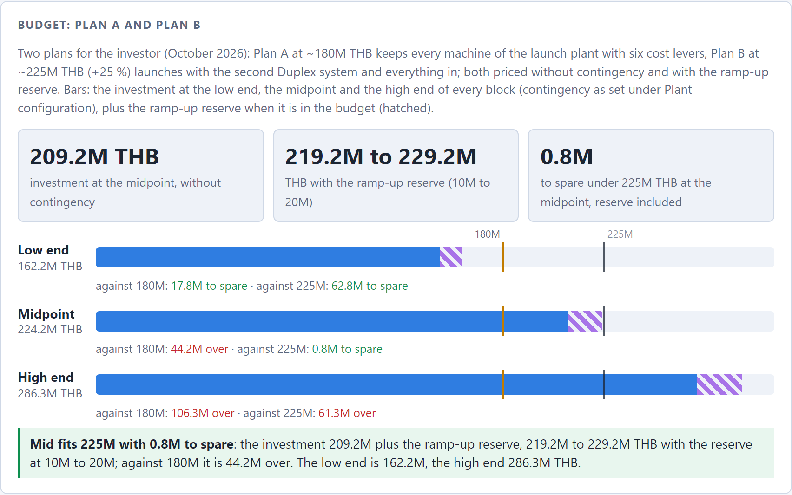
Figure 11. Budget card of the plant and business plan calculator, Plan B preset: 209.2M THB at the midpoint without contingency, 219.2M to 229.2M with the ramp-up reserve of 10M to 20M, inside 225M at the midpoint. Bars: the investment at the low end, the midpoint and the high end of every block, the reserve hatched, against 180M and 225M THB. Calculator figures (docs/fleet-calculator.html), estimates.

8.3 Tranches
The plan is one capital round, but it is not one payment. Capital is released against milestones, so each tranche is spent only once the previous gate has cleared. Because cutting and galvanics are commissioned first and have their own build times, their orders sit in the first long-lead tranche next to the presses. The shares below are estimates for planning the calls on capital, not a payment schedule agreed with any vendor.
Tranche | Trigger | Covers | Approx. share, THB
0 | Now | Phase 0 work (section 14.1) | The Phase 0 block, ~1.3M to 2.6M (1 to 2 %)
1 | BOI certificate issued; lease signed; zoning and soil confirmed; pricing and the demand for ~1.25M records a year validated | Deposits on every long-lead order: Pheenix galvanics line, Sillitoe lathe, Sibert line, both Newbilt Duplex systems and the Classic; building design and permit; first boiler and chiller modules | 20 to 30 % (~42M to 63M)
2 | Building permit; vendor build dates confirmed in writing | Construction, water-treatment building, utility yard, utilities including the third chiller module, balance payments as machines are built | 35 to 45 % (~73M to 94M)
3 | Building watertight; first machinery shipped | Fit-out, HVAC and clean zones, ZLD and DI water, rooftop PV and battery, crane, visitor corridor, the full metrology stack, factory software and ERPNext, cassette and CD-R lines, the launch team | 15 to 20 % (~31M to 42M)
4 | Cutting room and galvanics commissioned; first stampers made | Working capital, PVC stock, spares, first-year rent; the ramp-up reserve (10M to 20M THB, in the plan price) is drawn from here on | 8 to 12 % (~17M to 25M), plus the reserve
Shares of Plan B's investment before the reserve (~209.2M THB at the midpoint); the THB figures are the shares applied to it (arithmetic, estimates).
The second Duplex system is commissioned last (section 11.1). Its order sits with the other long-lead items in tranche 1, and it is the one order that could still be moved to a growth step if the demand case weakens before the round is called.

8.4 What moves the number
- No contingency in the price. Plan B's ~224M THB is the midpoint of every block with the ramp-up reserve and no buffer: at 15 % a contingency would add ~31M THB, and the high end of every block comes to ~286M. Quotes landing above the midpoint are funded outside the plan price or by scope steps; how they are funded is a decision for the investor before commitment (section 14.2).
- The quotes that decide it. The Classic has no Newbilt price (its band is a placeholder borrowed from another vendor's automatic press); the Pheenix line is priced at OMS's reference plus 20 %, without a Pheenix figure; the second Duplex system's EX 35 has no price on file (the first is priced as the expired 2024 quote's second-extruder option); and the building depends on the soil. The Newbilt re-quote, the Pheenix quote, the building request with a soil test and the metrology distributor quotes settle most of the band.
- BOI promotion. The machinery duty and import VAT exemption applies across most of the equipment blocks (~0.11M USD of duty and ~0.17M USD of import VAT cash flow on the launch plant, estimates), and the automation and solar spend converts into corporate income tax exemption headroom. The application precedes every purchase order. Plan B owns its solar array, so it keeps the solar measure.
- The ground. Soft paddy soil under the building, paving and fill platform is the single largest cost variable in the building package, and the cheapest to resolve: a soil boring test costs THB 30k to 50k.
- Chinese suppliers: ~1 %. Plan B prices Thai-supplied utilities. The Chinese route for the boiler modules and the compressor would take ~1.9M THB off at the midpoint (Plan A takes it); chillers and HVAC, the larger blocks, are not checked yet.
- Solar bought, not leased. Plan B owns the array and the battery (8.9M to 12.5M THB). A solar PPA would take ~10.7M THB off the price at the midpoint and add a power price to the energy line instead, very likely without the BOI solar measure.
- Every band narrows only with quotes. The supplier map in the planning repository lists who to ask, and the re-quotes are phase 0 work (section 14).

8.5 Currency exposure
Revenue will be mostly USD and EUR from export customers; the cost base is mostly THB; the equipment is priced in several currencies. Newbilt quotes in EUR, and the Pheenix line is expected in EUR (European vendor, no quote yet; the currency is a stated field in the request; the plan prices it at OMS's EUR reference plus 20 %, EUR 280.8k to 385.2k). Sibert's budget and Sillitoe's list price are in USD (Sibert is a UK company, Sillitoe Australian). None of it is hedged, and the orders will not be placed for roughly a year. In the September draft a 10 % move in EUR/THB was worth USD 25k to 35k on the Duplex line alone; with the second Duplex system, the Classic and the galvanics line also in EUR, the four EUR lines come to ~1.19M to 1.58M USD, so the same move is worth roughly USD 0.12M to 0.16M (estimate).
Operationally, roughly two-thirds of direct cost (labour, energy, local cartons, maintenance) is THB, so a 10 % baht appreciation takes 0.09 to 0.17 USD off the gross margin per record without any operational change, enough to push the adverse case, which only just covers depreciation, under water. Three mitigations are planned: every re-quote states its currency and validity period; decide early whether to quote regional customers in THB; and decide, once the BOI timeline is known, whether to hedge the EUR orders. The hedging decision belongs to the investor.

9. Revenue and operating model
A first-pass economic model of Plan B's five presses in a mature year. Most numbers are estimates from industry pricing norms and the project's own cost research; the point is the shape of the economics and which levers matter, not precision. The price assumption is deliberately held at the conservative Western export level even though the one set of Thai market data (section 3.3) says domestic prices are several times higher: re-basing the whole model on one supplier's price list in a market with one supplier would be worse than leaving it low.

9.1 Pricing assumptions
- Blended pressing price: USD 3.76 to 5.27 per record (THB 124 to 174) at the planned 60 % specials (splatter, marble and colour effects; the plant focuses on special prints, not mono colours): standard USD 3.40 / 3.80 / 4.25 plus a specials premium of 0.60 / 1.15 / 1.70 on 60 % of the records, covering pressing, labels, inner sleeve and assembly into the jacket; deluxe packaging passed through at cost plus margin. At ~20 % specials the same prices blend to 3.50 to 4.60. Western plants charge roughly USD 2.90 to 5.80 for standard black at volume, with premiums of 0.60 to 1.70 for colour and splatter, 180 g and small runs. What specials cost extra (coloured compound, colour-change purge, trim that only goes back into black) is not yet in the direct cost, so the specials gain is an upper bound until the compound quotes arrive.
- Western benchmark, October 2026. Record Industry (Haarlem) publishes its prices online: 300 copies of a black 140 g LP with stampers, test pressings, printed labels, a paper inner sleeve, a printed jacket and shrink wrap come to 1,721 EUR all-in (~219 THB a copy), ex VAT and freight. Its per-title items (set-up, small-run charge, cutting, stampers, test pressings) total about 580 to 600 EUR, the low end of this plan's title assumption; black pressing with printed labels and a paper inner sleeve comes to about 2.43 USD a copy at 300, below the 2.90 to 5.80 range.
- Thai market. The ResurRec invoices of August 2026 come to 650 to 950 THB a copy all-in at 300, about 3 to 4.3 times Record Industry's ex-works price. The artist ordering demo's price list comes to ~343 THB a copy at 300 with vinyl mastering: above the European ex-works price, well below the Thai market. Both price levels stay open until market validation (roadmap item 1).
- Per-title services: USD 580 to 1,730 per title (THB 19k to 57k) for mastering, cutting, stampers and test pressings. The middle of the range is the artist-demo per-title fee of 37,836 THB: mastering 10,000, lacquer 5,336, cutting 4,000, plating 14,000, press set-up 3,000 and tests 1,500. Plan B models 300 to 400 titles a year (375 central); mastering is labour-bound, and the plan staffs one to two engineers, which caps this line.
- Cassettes and CD-Rs are add-on lines in the plant from launch, not in the operating picture. The September draft illustrated them at 20k to 60k cassettes a year at USD 2.50 to 4.00 and 10k to 40k CD-Rs at USD 1.50 to 3.00; estimates with no market data behind them yet.
- Dropshipping fees per parcel and stamper supply to other plants are on top and not modelled.

9.2 Capacity and revenue of Plan B
Five presses make ~1.0 to 1.5 million records a year on two shifts at 60 % specials (estimate). Specials run only on the Duplex systems (the Classic has one built-in extruder), but with two of them the plant is not Duplex-limited: the four semi-automatic presses, 240 to 320 records an hour together, carry the specials, and the Classic (~128 an hour, 28 s cycle, vendor flyer) the rest; at 60 to 70 % effectiveness, 16 hours a day and 300 days a year that is ~1.06 to 1.5 million. The plant and business plan calculator, at the team's planning rates (3 records a minute per Duplex system, 2 per Classic, 65 % effectiveness), gives ~1.5 million. The central case takes 1.25 million.
USD per year | Adverse | Central | Favourable
Records | 1.0M | 1.25M | 1.5M
Blended price, 60 % specials | 3.76 | 4.49 | 5.27
Pressing revenue | ~3.76M | ~5.61M | ~7.91M
Titles × per-title fee | 300 × 580 | 375 × 1,155 | 400 × 1,730
Title-services revenue | ~0.17M | ~0.43M | ~0.69M
Revenue | 3.93M (~130M THB) | 6.05M (~200M THB) | 8.60M (~284M THB)
Estimate. Pressing and title revenue are records × price and titles × fee; the totals are those of docs/finance/revenue-model.md. A pure-volume plant runs at the low per-title end; a boutique-heavy mix pushes titles up and volume down.

9.3 Direct cost per record
Cost element | USD/record | THB/record | Basis
PVC compound | 0.29 to 0.46 | 9.6 to 15.2 | ~150 to 160 g effective virgin at 1.75 to 2.90 USD/kg; regrind loop covers scrap
Labels | 0.03 to 0.09 | 1.1 to 3.0 | Printed pairs, volume
Inner sleeve | 0.09 to 0.17 | 3.0 to 5.7 | Poly-lined
Jacket (standard) | 0.40 to 0.92 | 13.3 to 30.4 | Ploy Printing and local carton partners; largely pass-through
Shrink wrap | 0.02 to 0.03 | 0.8 to 1.1 | Film
Energy | 0.12 to 0.23 | 3.8 to 7.6 | ~1.5 to 2 kWh blended per record at grid/solar mix
Production labour, Plan B | 0.08 to 0.16 | 2.6 to 5.4 | 13 to 19 direct staff, 3.7M to 5.4M THB a year, over 1.0 to 1.5M records (0.13 to 0.28 on three presses)
Stamper amortisation | 0.03 to 0.12 | 1.0 to 4.0 | In-house three-generation set at ~USD 60 to 150 marginal over 1,000 to 2,000 pressings
Maintenance, spares, consumables | 0.12 to 0.23 | 3.8 to 7.6 | Estimate
Reject allowance | 0.12 to 0.17 | 3.8 to 5.7 | 5 to 10 % reject rate carried by good units
Total direct cost, Plan B | ~1.30 to 2.58 | ~43 to 85 | Central 1.94; no extra cost for specials yet
Estimates, docs/finance/revenue-model.md. THB at 33 per USD.
Five presses spread the same crews. Two shifts need the full press, finishing, galvanics, QC and maintenance crews whether the hall holds three presses or five, so the direct payroll stays at 3.7M to 5.4M THB a year (113k to 163k USD), and Plan B spreads it over 1.0 to 1.5 million records: 0.08 / 0.11 / 0.16 USD a record (favourable / central / adverse), against 0.13 / 0.19 / 0.28 on three presses, and a direct cost of 1.30 / 1.94 / 2.58 USD. The build-up, at northern Thai rates loaded ×1.3 for social security, overtime, bonus and PPE:
Role | Heads | THB/month each, loaded
Press and finishing operators | 8 to 12 | ~19,500
Galvanics | 2 to 3 | ~32,500
QC | 1 to 2 | ~26,000
Maintenance | 2 | ~32,500
Direct production payroll | 13 to 19 | ~312,000 to 449,000 a month

Mastering and cutting engineers are title-services labour, not per-record (a cutting engineer earns about 50,000 THB a month base, team figure); admin, sales and logistics sit in overheads. Group health insurance with a yearly check-up (~0.35M THB a year for ~20 staff) and unified workwear (~0.3M THB a year) come on top of the ×1.3 and are not yet in the per-record figure.

9.4 Operating picture of Plan B
Built from the components above. Three scenarios, each internally consistent: adverse pairs low volume with the low price, the high cost, the high capital and the high overheads; favourable does the opposite; central takes midpoints. Cash overheads (admin, sales, insurance, facility running, IT, professional fees, marketing, the land lease) are estimated at USD 0.20M to 0.45M a year and paired high-to-adverse. Depreciation is on this plan's blocks: the high end (8.07M USD) over 10 years (adverse), the midpoint (6.34M USD) over 12.5 years (central) and the low end (4.61M USD) over 15 years (favourable). Payback is counted on the whole plan price including the ramp-up reserve (4.92M / 6.79M / 8.67M USD from the low to the high end).
USD per year, mature | Adverse | Central | Favourable
Records | 1.0M | 1.25M | 1.5M
Blended price, 60 % specials | 3.76 | 4.49 | 5.27
Direct cost | 2.58 | 1.94 | 1.30
Contribution per record | 1.18 | 2.55 | 3.97
Pressing contribution | 1.18M | 3.19M | 5.96M
Title-services contribution | 0.10M | 0.28M | 0.48M
Total contribution | 1.28M | 3.47M | 6.44M
Cash overheads | 0.45M | 0.33M | 0.20M
EBITDA | 0.83M | 3.14M | 6.24M
Depreciation | 0.81M | 0.51M | 0.31M
Operating profit | 0.02M | 2.63M | 5.93M
Revenue | 3.93M (~130M THB) | 6.05M (~200M THB) | 8.60M (~284M THB)
Payback on the plan price (EBITDA, mature year) | ~10.5 yr | ~2.2 yr (1.6 to 2.8 on 4.92M to 8.67M) | ~0.8 yr
Estimates, docs/finance/revenue-model.md 'Operating pictures of Plan A and Plan B (October 2026)'. Title services at 60 to 70 % contribution after lacquers, styli and nickel. Contribution per record and total contribution are the table's own arithmetic.
Reading this table honestly
• Demand comes first. Plan B earns this only if the records sell: its central case needs ~1.25 million records a year, ~0.75 million of them special editions, against 0.74 million for the three-press Plan A. Nothing in the market data so far shows that demand (roadmap item 1, market validation).
• The central case works on ~224M THB. EBITDA ~3.1M USD (~104M THB) and operating profit ~2.6M USD (~87M THB) a year once the plant runs at volume; it breaks even on operating profit at about 0.22 million records a year, under a fifth of its central output. Its central EBITDA is ~1.8 times Plan A's for ~27 % more money. On the earlier ~20 % specials share the five-press table showed EBITDA 2.59M at the same 1.25M records: five presses are not Duplex-limited, so more specials raise the price on the same volume.
• The adverse case only just covers depreciation (~1.0 million records needed, 1.0 million made): more presses spread the same crews, overheads and title services over more records. It stacks the low price, the high cost, the high capital and the high overheads at once. At the central cost and volume the price that covers depreciation is ~2.4 USD (~79 THB) a record (arithmetic on the table), below the low price assumed.
• The central margin is too good to trust yet. A central EBITDA margin of ~52 % is far above the 15 to 25 % pressing plants earn. The direct cost table counts only per-record consumables and direct payroll and leaves out indirect labour (supervision, planning, warehouse), freight, scrap above the reject allowance, sales commissions and the extra cost of specials. Treat the adverse column as the honest one until those lines exist. The plan price carries no contingency either.
• This is a sensitivity, not a forecast. The plant and business plan calculator's Plan B preset, with its own cost build-up (it adds electric steam heat and the cutting engineer, which this table leaves out), gives at 1.25M records and 60 % specials: revenue ~6.09M, EBITDA 3.25M USD, payback 2.0 years on the 209.2M THB investment in a mature year; with a ramp of 35, 70 and 90 % in the first three years and the reserve in year 0, cash payback in year ~3.3, ~32 % IRR and an NPV of ~9.7M USD over ten years, pre-tax and pre-financing (estimates). Not modelled here: cassette and CD-R lines, stamper supply to other plants, dropshipping fees, and the ramp year. BOI tax exemptions shield part of early-year profits where there are any.

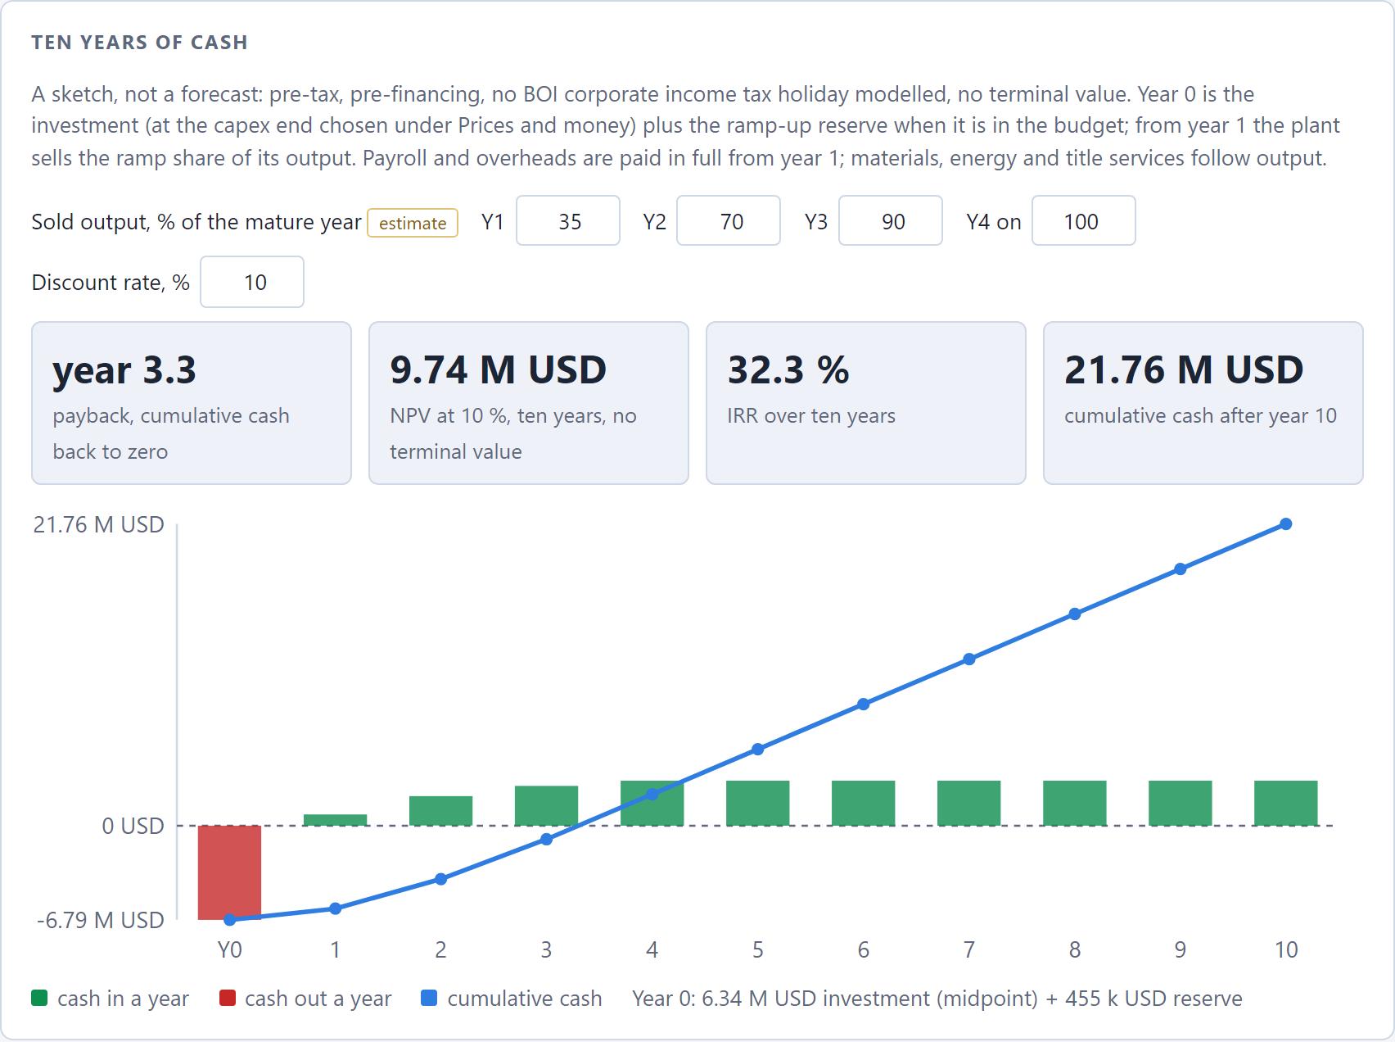
Figure 12. Ten years of cash in the plant and business plan calculator, Plan B preset: cash payback in year ~3.3, IRR ~32 %, NPV ~9.7M USD at 10 %. Year 0 is the midpoint investment plus the ramp-up reserve; years 1 to 3 sell 35, 70 and 90 % of the mature year's output. Pre-tax, pre-financing, no BOI tax holiday, no terminal value. The calculator's own cost build-up and faster Duplex planning rate, not the table above (docs/fleet-calculator.html); a sketch, not a forecast, estimates.

9.5 The ramp
The table above is a mature year. Plan B does not start there. It is commissioned in sequence: first the cutting room and galvanics (the presses need their stampers), then Duplex system 1, the Classic, and Duplex system 2 last. Early production runs slower and rejects more than any of these figures while the process settles, and the crews of a two-shift plant are on the payroll before the volume is. Plan B's ramp is longer: it has to sell ~1.25 million records a year, not 0.74 million, before it reaches the table above. The ramp-up reserve is the same ~10M to 20M THB estimate as for Plan A (inside the plan price); it carries staff hired before first revenue and overheads until volume covers them, and with break-even at ~0.22 million records a slower ramp costs payback time more than solvency (our reading). Fan-funded campaigns on the artist platform open only after the first releases have shipped and lead times are measured.
A year-by-year cash model for the ramp is a next step, not a claim this plan makes. It belongs to the financing discussion and needs the vendor build times and the commissioning calendar (section 10) first. The calculator's 35, 70 and 90 % ramp in section 9.4 is a planning assumption, the same for both plans, so it does not show Plan B's longer ramp.
Growth beyond five presses. The hall is laid out for five Duplex bays and four Classic positions, and growth adds Duplex systems first, then Classics, from revenue. The boiler hall and chiller compound are built for four modules each: Plan B fills two boiler and three chiller positions, so a further press stage starts with the next module (scale and utility phasing in the planning repository).

10. Timeline: today to first paying release
Every duration is an estimate. The calendar in the planning repository was drawn in August 2026 and has not yet been re-drawn for the launch plant or for Plan B's second Duplex system; nothing in phase 0 has started, so it shifts day for day with the BOI consultant engagement. On that calendar, first paying release lands around Q4 2028 to mid-2029, roughly 27 to 33 months from the start of phase 0. This plan quotes that as the working figure, not as a re-based date (the executive summary marks it open), and flags the new risk to it: the launch plant puts the metal path on the critical path.
The critical path
• BOI certificate → long-lead orders → vendor builds → sea freight → commissioning of the cutting room and galvanics → first stampers → press commissioning → test pressings → first paying release. Everything else, including the entire building, has float against that chain.
• Galvanics and cutting now come before the first paying release. There are no bridge stampers and no outsourced cutting in the launch plant, so the presses cannot press a paying title until the cutting room cuts lacquers and the galvanics line grows fathers, mothers and stampers that pass inspection. The August calendar did not contain this step; whether it fits inside the 2 to 3 months of installation and commissioning depends on build times nobody has quoted and on two hires.
• The press build time is still assumed. 9 to 12 months is an industry-typical figure for a built-to-order system from a small German manufacturer, and it carries about 40 % of the schedule. If the real figure is 15 to 18 months, launch moves to mid-2029.
• The other vendors are unquoted too. The Sillitoe lathe is built to order, and the Pheenix line and the Sibert machines have no lead time on file. Build time and order-book position are required fields in every re-quote; it is one line in each email and the highest-value missing fact in the project.
• Plan B's second Duplex system is commissioned last, after the Classic, so it is not on the path to the first paying release. It lengthens commissioning and the ramp to full volume; its build time, on top of the first system's at the same vendor, is not quoted yet.

# | Step | Duration | Source
1 | Engage BOI consultant, prepare application | 4 to 5 months | Estimate
2 | BOI review to certificate | 4 to 6 months | BOI: ~40 working days decision, 4 to 6 months in practice
3 | Company incorporation under the certificate | 1 to 2 months | Roadmap
4 | Press order to vendor-ready | 9 to 12 months | Assumed; not yet quoted. Pheenix, Sillitoe and Sibert build times also unquoted
5 | Sea freight Europe to Thailand | 6 to 8 weeks | Newbilt quote includes freight
6 | Install, commission, train | 2 to 3 months | Newbilt includes 5 days; rest at ~USD 97/h plus travel
6a | Commission the cutting room and galvanics; first stampers pass inspection | Not yet estimated | New with the launch plant; must finish before step 7
7 | Test pressings, QC baseline, reject shakedown | 1.5 to 2 months | Roadmap
 | Total | ~27 to 33 months | August 2026 calendar, before step 6a

Track (in parallel) | Needed by | Float | Becomes critical if
Land lease, zoning, soil test | Design start, ~Q1 2027 | ~4 months | Zoning fails and a new site is needed (~6 months reset); the plot Payap first offered already fails zoning
Construction, incl. the water-treatment building and utility yard | Machinery arrival, ~Q3 2028 | ~3 to 5 months | Soft soil forces piling, or permits stall; the galvanics room, clean zone and ZLD plant are now needed first, ahead of the press hall
Factory licence (Ror.Ngor. 4) with galvanics in the first licence | First production, Q4 2028 | ~4 months | Galvanics effluent and hazardous-substance registration are now in the first licence scope: the most likely regulatory friction point; ZLD design in the application from the start
Solar and battery (purchase) | Fit-out, ~Q2 2028 | Large | Not a risk; battery lead time is 50 to 60 days
Cassette and CD-R lines | Fit-out, ~Q2 2028 | Large | Not a risk; short lead times
Hiring: galvanics process engineer and cutting engineer | Before the metal path commissions | None: now on the critical path | Galvanics is the hardest skill to hire; both people must be hired and trained (at the vendors) before step 6a
Hiring and training: the rest of the launch team | Commissioning, ~Q3 2028 | ~2 months | Two shifts are needed from the start of volume production

BOI windows are comfortable on the August calendar: machinery clears customs ~Q3 2028 against a 30-month import window ending ~Q4 2029 (~15 months of margin), and first production ~Q4 2028 against a ~36-month full-operation deadline (~18 months). The launch plant puts four vendors' machines, not one, inside the import window, and Plan B's second Duplex system has to clear customs inside it too. The margin is consumed by exactly one scenario: filing early to start the clock and then discovering the site does not work. Verify zoning before filing.
The one lever worth six to nine months is the BOI sequencing question in section 7: the duty exemption attaches at importation, not at contract signature, so if an order and deposit can be placed while the application is in review, the press build overlaps the BOI process. It is a question for the BOI consultant, not a claim. The land lease cannot pull the launch forward on its own: construction has float against the vendor chain, and only the orders move the end date.
What a delay costs. A month lost engaging the BOI consultant costs a month of launch. A month lost on land or construction costs nothing until the float is gone. A month lost getting the vendor build times in writing, or hiring the galvanics and cutting engineers, costs nothing today and may cost months of surprise later.

11. Phasing and commissioning sequence
The plant launches with the whole chain in one capital round. That replaces the September draft's phased entry, in which galvanics, cutting and the automatic press followed from revenue. The gates have not moved: no machinery order before the BOI certificate, no large spending before the market validates the price, no coppice planning before the land-title check. What changed is that the round, once released, buys Plan B's five presses with everything in, and only further growth stays revenue-gated.
Phase | Content | Gate
0. Validate and clear the gates (now) | Market validation with regional labels and distributors, including the demand for ~1.25M records a year; BOI consultant, activity code, application; lease terms, zoning, soil test; 60 rai title check; re-quotes and quotes from every launch vendor (section 14.1) | Runs in parallel; gates everything
1. Quotes and site (during the BOI window) | Firm quotes with build times; site selection between the Mueang Chi lease, other Payap land and the industrial estate; resolve the 35 % vs 45 % humidity floor | BOI filed
2. Commit | Incorporate under the certificate; sign the lease; order every long-lead item: Pheenix galvanics line, Sillitoe lathe, Sibert line, both Newbilt Duplex systems and the Classic, the boiler modules and the first chiller modules | BOI certificate, validated pricing and demand
3. Build and commission (~6 to 12 months after commitment) | Construction, water-treatment building, utilities, HVAC, clean zones, solar and battery, security, crane, visitor corridor; machinery installation and vendor commissioning; traceability and ERPNext live before the machines; hire and train | Building permit, vendor build dates confirmed
4. Launch (the whole chain in-house) | Commission in sequence (table below); test pressings, QC baselines, reject shakedown; first paying releases; per-lot PVC gate live; qualify Thai compound | Commissioning complete
5. Expand (revenue-gated) | Further Duplex systems first, then Classics (the hall is laid out for five Duplex bays and four Classic positions); the biomass boiler if steam starts electric; the phase 2 building; CD replication if chosen | Revenue and, for CD replication, a separate decision

11.1 Commissioning sequence
Step | What is commissioned | Why in this order
1 | Cutting room (Sillitoe SDMS) and galvanics (Pheenix line with ZLD and DI water), with the Sibert stamper-prep line | The presses need their stampers; no bridge stampers are planned. First lacquers, fathers, mothers and stampers, and the metal archive from the first title
2 | Newbilt Duplex system 1 (two HRP 12, EX 50 and EX 35), with the steam and cooling plant (boiler modules B-1, B-2; chiller modules CH-1, CH-2) | The semi-automatic presses suit the colour, splatter and boutique runs that carry the premiums, and they teach the crews the process
3 | Newbilt Classic, fully automatic | Volume runs once the metal path and the press process are stable
4 | Newbilt Duplex system 2 (two HRP 12, EX 50 and EX 35), with chiller module CH-3; steam from B-1 and B-2 | The crews know the process from system 1; it carries the specials volume that the central case needs

If commissioning of the metal path slips, Stamper Discs (stampers) and SST in Frankfurt (lacquer cutting, already Poy Records' cutter) stay contacts for overflow and for a slipping commissioning, not a plan.

11.2 Why the whole chain at launch
This is the decision with the most consequences in the plan, and the investor should see both sides:
For | Against, and the risks it takes on
No bridge stampers. A plant that buys every stamper set abroad waits on two international freight legs per job and on one small overseas supplier; that is the bottleneck this plant exists to remove. | Supplier advice. Sibert, which sells into the galvanics line, advised after Haarlem, against its own interest, to get presses, boilers, operators and live feedback loops right first and to earn some return before every manufacturing step is in place.
Title services and repress economics. Cutting and plating in-house earn the per-title fees (the middle price is 37,836 THB a title), and the archived father and mother of every side let a repress, or a worn mother, be regrown without a recut. | Galvanics skill. It is the hardest skill to hire, and the process engineer probably comes from abroad or is trained abroad. The first paying release now waits for it.
The Thai market gap is metalwork, not presses. The incumbent turns away small runs and adds weeks above 3,000 units, most plausibly because every stamper set is an import (section 3.3). | Permitting. Galvanics effluent and hazardous-substance registration move into the first factory licence, the most likely regulatory friction point in the project; zero discharge from the start, and on Payap land the lessor's consent as well.
The cutting room is a smaller decision than it was. The Sillitoe SDMS lists at USD 125k with automation in the box, and the Payap programmes in mastering and lathe cutting need a working room. | More capital up front. ~162M to 286M THB in one round (~224M at the midpoint), against ~57M to 95M THB for the superseded phased entry; more of it is committed before the market has validated the price.
Five presses at launch. The same crews, overheads and title services spread over ~1.25 million records: central EBITDA ~1.8 times the three-press plant's for ~27 % more money, and the adverse case covers its depreciation. | Demand is unproven. The central case needs ~1.25 million records sold a year, ~0.75 million of them specials; nothing in the market data shows that yet, and the ramp to it is longer.

How the plan answers the risks: commission the metal path first and measure it before the presses depend on it; hire the galvanics and cutting engineers early and train them at the vendors; design zero discharge from the start; and release the round in tranches (section 8.3), so that nothing is ordered before the BOI certificate and validated pricing and demand; the second Duplex system is commissioned last.

12. Team, ownership and governance

12.1 The people
Who | Role
Simona Meesaiyati | Project Lead: management and the audio side.
Alexander Grabowski | Technical Consultant: the technical side (equipment selection and vendors, utilities, the building model, the traceability and QC specification, the factory software).
buildfor.life | Supports the project in a consulting capacity.
Ploy Printing (Ploy Karnpim Limited Partnership, Chiang Mai) | Packaging partner and intended strategic co-investor: jackets, sleeves, inserts, J-cards and CD packaging on offset, digital, risograph, UV and latex presses, with existing vinyl packaging production.
Payap University (Chiang Mai) | Partnership under discussion (October 2026): joint student programmes around the plant in mastering and lathe cutting, IT and business administration, starting small (memorandum, internships, short certificate courses). Nothing is agreed yet; scope, form and money are open. It is a hiring pipeline for the hardest roles, not a substitute for hiring them: the teacher comes before the students.
To be hired, at launch | Galvanics process engineer and cutting engineer (both on the critical path, section 10; a cutting engineer earns about 50,000 THB a month base, team figure); plant manager; galvanics operators; QC lead; maintenance; press and finishing operators for two shifts; sales and customer service for labels, artists and the traceability portal.
External | BOI-registered consultant; Thai counsel for the lease, company and shareholder agreement; optional vinyl manufacturing consultancy for layout, installation and training (GBP 10k to 20k packages); vendor commissioning and training (Newbilt, Pheenix, Sibert, Sillitoe); property insurer.

Headcount: the plant runs the whole chain on two shifts, so it needs most of the mature crew from the start: a direct production payroll of 13 to 19 (8 to 12 press and finishing operators, 2 to 3 galvanics, 1 to 2 QC, 2 maintenance), 1 to 2 mastering and cutting engineers, and 3 to 5 in admin, sales and logistics. The revenue model plans on about 20 people at the start (estimate), plus 1 to 2 for the cassette and CD-R lines; it built that direct crew for the five-press fleet. A process engineer from abroad can be employed on a BOI work permit (section 7).

12.2 Ownership and structure
Amounts and percentages are not yet agreed and are deliberately left open here. The intended structure is:
- One Thai limited company holds the plant, the lease, the equipment and the BOI promotion. BOI promotion permits 100 % foreign ownership of the promoted manufacturing activity, so the shareholding can be set on commercial terms rather than to satisfy the Foreign Business Act.
- Shareholders: the lead investor; Ploy Printing as strategic co-investor; and the founders. Ploy Printing's participation, whether in cash, in kind (print capacity, premises, working capital in packaging) or both, is to be discussed; its strategic value is a packaging partner whose incentives are aligned with the plant's schedule and quality, within the same province.
- Debt-to-equity no higher than 3:1, maintained for the life of the BOI privileges, which sets the floor on equity in the financing mix: at least a quarter of the funding, ~56M THB of Plan B's ~224M (arithmetic, before financing costs).
- A shareholders' agreement covering board composition, reserved matters (capital calls and tranche releases, the growth options such as further Duplex systems, CD replication), pre-emption and transfer, information rights, and the founders' roles and remuneration.
- Related-party discipline. Ploy Printing will be both a shareholder and the plant's main packaging supplier. The supply agreement is priced at arm's length, benchmarked periodically against other printers, with quality and lead-time terms written down, and Ploy Printing abstains from board decisions on its own contract. This protects both the lead investor and Ploy Printing, and it is what a BOI or bank reviewer will look for.
- Any label, content or retail activity (Poy Records as a brand) sits in a separate entity, so the manufacturing company's BOI application stays clean.

13. Risks and open questions
Every plan has risks; the point of listing them is to say which are being retired, by what, and when. The first column is the plan's own honest severity. The September draft's bridge-stamper risk is gone with the bridge stampers; the launch plant brings its own in its place, and Plan B's five presses and its price without contingency add theirs.
Severity | Risk | What it would do | Mitigation and status
High | Pricing power in the region is unproven | The single biggest assumption in the revenue model; a turnaround advantage nobody pays a premium for is a cost, not a moat | Market validation gate: regional label conversations, the artist platform's calculator as an interest list, a second Thai data point; no large spending before it clears
High | Demand for ~1.25M records a year | The central case needs ~1.25M records sold a year, ~0.75M of them specials, against 0.74M for the three-press plant; nothing in the market data so far shows that demand | Market validation (roadmap item 1) before the round is called; the second Duplex system is commissioned last, so its order is the one that can still move back to a growth step
High | More capital at risk | ~224M THB in one round, ~27 % more than the three-press Plan A, more of it committed before the market has validated the price and the volume | Gates and tranches (section 8.3): no order before the BOI certificate and validated pricing and demand
High | No contingency in the plan price | Quotes landing high are not covered: at 15 % a contingency would be ~31M THB at the midpoint, and the high end of every block comes to ~286M with the reserve | The requests that settle most of the band come before commitment (section 8.4); tranche release; how overruns are funded (outside the plan price or by scope steps) agreed with the investor up front
High | Utilisation and price | The cost structure is mostly fixed; the adverse case only just covers depreciation (~1.0M records needed, 1.0M made), so any shortfall in price or volume turns it into a loss; the extra cost of specials is not in the direct cost yet | Central breaks even at ~0.22M records; commission in sequence; treat the adverse column as the honest one
Medium | Ramp length | The ramp to ~1.25M records is longer than the three-press plant's to 0.74M; the ramp-up reserve is the same 10M to 20M THB estimate | Break-even at ~0.22M records, so a slow ramp costs payback time more than solvency (our reading); a year-by-year cash model for the ramp is a next step (section 9.5)
High | Galvanics and cutting on the critical path | No paying release until the cutting room and galvanics make good stampers; a slow start there delays every press | Commission the metal path first and measure it; vendor training; Stamper Discs and SST as contacts for a slipping commissioning, not a plan
High | Skills: galvanics process engineer, cutting engineer | Galvanics is the hardest skill to hire; both roles are now needed at launch | Recruit or train abroad; BOI work permits; vendor training (Pheenix, Sillitoe, OMS as a reference); Payap programmes as a longer-term pipeline
High | Prices not on file: the Classic, the Pheenix line and the second EX 35 | The Classic band is a placeholder borrowed from another vendor's automatic press; the Pheenix line is priced at OMS's reference plus 20 %, without a Pheenix figure; the second Duplex system's EX 35 has no price | Newbilt re-quote and Pheenix quote in phase 0; OMS's dedicated offer as the galvanics benchmark
High | Vendor build times unknown | The press build carries ~40 % of the schedule; 15 to 18 months would push launch to mid-2029; Pheenix, Sillitoe and Sibert lead times also unquoted | Required field in every re-quote, now
High | Zoning of the chosen plot unverified | A site reset costs ~6 months; the Payap point already fails zoning; Mueang Chi is unverified | Verify on the land-use map and with counsel before the BOI filing; industrial estate as fallback
Medium | Lease terms and building ownership | A weak lease makes the building hard to finance and exposes it at expiry | Registered 30 to 50 year lease with renewal, explicit building ownership and assignment rights; Thai counsel in phase 0
Medium | Soil conditions | Piling could add several hundred to 1,000+ THB/m² across building, paving and fill | Soil boring test in phase 0 (THB 30k to 50k)
Medium | Galvanics permitting | Effluent and hazardous-substance permitting are the most likely regulatory friction, now in the first factory licence | Zero-discharge design and the water-treatment building from the start; industrial estate option; lessor's consent on Payap land
Medium | Utilities fuel choice open | Biomass heat costs a quarter to a tenth of electric steam at reported fuel prices; electric steam needs a larger grid connection, biomass a secured fuel supply | Decide before the boiler request and the grid application; quote electric and fired variants of the same modules
Medium | Boiler import compliance (DIW) | An imported boiler must meet ASME, JIS, EN or equivalent and be verified by a DIW-registered certification body; the modules run above the once-through relief | ASME Section I design with the S stamp and the full dossier; certification body engaged before the order; the same for a Thai-bought boiler
Medium | Single press vendor (Newbilt) | All five presses, the extruders and the hydraulic aggregates come from one small German manufacturer; build time and order book unknown | Spares and service terms in the re-quote; the Pheenix automatic press stays the comparison if the Classic quote disappoints
Medium | Hydraulic ring-main contamination | One shared oil system: a contamination event reaches every press | ISO 4406 target, flushing to ISO 23309, particle counts at acceptance and after flushing, non-bypass branch filters, isolation per press, online particle counter, kidney loop; central plant still to be quoted
Medium | Currency | EUR on Newbilt and Pheenix, USD on Sibert and Sillitoe, THB costs, USD/EUR revenue; a 10 % baht move is worth 0.09 to 0.17 USD per record on margin | Currency and validity in every quote; THB pricing regionally; hedging decision with the investor
Medium | Vinyl demand is cyclical | Global capacity has been added; the model assumes the plant sells what it presses | Mixed fleet suits boutique work that is less cyclical; cassette and CD-R lines diversify; further growth waits for demand
Medium | Reject rate in early production | Early runs, and the first stampers from a new galvanics room, will be worse than the 5 to 10 % allowance while the process settles | Vendor commissioning, stamper metrology, materials lab from day one, QC layers, conservative launch promises; the ramp-up reserve
Medium | Competitive response | The incumbent may add plating, or a second entrant may appear; the domestic price ceiling may compress on our arrival | Compete on capability (traceability, QC, climate), export customers, and the collaboration under discussion
Low | Solar and battery integration | Rack voltage vs inverter window; unpublished certifications; mixed-vendor warranty | Engineering checks and certificate requests in phase 0; large float
Low | Cassette supply chain | Blank tape and shells come from few suppliers | Hold stock; qualify two sources
Low | CD replication scope creep | Adds USD 1.5M to 4.0M and a second commissioning programme | Decide before BOI filing; treat as a separate project if chosen

Open questions with owners are in the next section. Two standing caveats on the evidence base: the Thai market data is one buyer, one plant and one afternoon, and the underlying invoices and tour notes should be archived with this plan before it goes in front of a bank; and the industry interest in traceability at Making Vinyl Europe 2026 is supplier-side evidence, not buyer price validation.

14. Next steps and the ask

14.1 Phase 0: the next three to six months
# | Action | Owner | Cost | Retires
1 | Market validation with regional labels and distributors: the 3.76 to 5.27 USD blended price at 60 % specials, run sizes, and whether faster turnaround earns a premium; and whether demand reaches ~1.25 million records a year, three fifths of them specials; publish the artist platform's calculator early with indicative prices and an interest list | Simona, Alexander | Travel | Pricing and demand risk
2 | Engage a BOI-registered consultant: activity sub-code; the order-before-certificate question first; galvanics, cassette and CD-R in the application; CD replication decision; Payap R&D | Simona | USD 5k to 15k | Sequencing, scope
3 | Thai counsel: lease heads of terms (term, renewal, building ownership, assignment) and zoning of the chosen plot for pressing, a steam boiler and electroplating; company and shareholder structure including Ploy Printing | Simona, counsel | USD 5k to 15k | Zoning, lease, ownership
4 | Soil boring test on the chosen plot | Alexander | THB 30k to 50k | Ground risk
5 | Newbilt re-quote: two Duplex systems (EX 50 and EX 35 each) and Classic, with build time, order-book position, PLC data access, central hydraulic supply and written hydraulic requirements, currency and validity | Alexander | Free | Classic and EX 35 price, schedule
6 | Pheenix quote for the galvanics line (PASU, PPPU, PDPU, PMPB) with lead time and training; OMS dedicated offer as the reference; ZLD and DI water vendor | Alexander | Free | Galvanics priced on a reference only
7 | Sillitoe quote and build time (SDMS, spare cutterhead, support terms, DMM question) | Alexander | Free | Cutting room, schedule
8 | Sibert itemised quotation and order terms against the USD 250k budget: lead time, installation time, spares, shipping, travel | Alexander | Free | Stamper prep, schedule
9 | Building request for quotation to two or three Thai pre-engineered building contractors, with the soil result | Alexander | Free | Building estimate
10 | Utility requests: Thai suppliers; Chinese boiler makers (ZOZEN, Sitong, Fangkuai, Taiguo; 1.25 MPa, ASME S stamp, electric and fired variants) and compressors from Kaishan and Denair's Thai offices for comparison; chillers and HVAC, Chinese makers included; the 35 % vs 45 % humidity floor; a Thai hydraulic builder for the central plant | Alexander | Free | Utilities band, fuel choice
11 | Metrology distributor quotes (XRF, confocal, profiler, inline vision, audio station) | Alexander | Free | Metrology band
12 | Solar and battery purchase quotes, with a PPA offer for comparison; battery and inverter engineering checks | Alexander | Free | Solar block
13 | Cassette and CD-R equipment quotes from two vendors each; tape and shell supply | Alexander | Free | New-scope estimates
14 | Search for the galvanics process engineer and the cutting engineer; next meeting with Payap on the programmes | Simona, Alexander | None yet | Skills risk
15 | 60 rai title check for the coppice plan | Simona | Small | Biomass path
16 | Optional: vinyl manufacturing consultancy for a layout and installation review | Alexander | GBP 10k to 20k | Layout risk
17 | Archive the Thai invoices and tour notes with this plan | Simona | None | Evidence base

14.2 What the investor is asked for
Now | Approval of Phase 0 spending of ~USD 40k to 80k (~1.3M to 2.6M THB, part of the plan price), so the quotes, the soil test, the BOI consultant and counsel can start.
On the gates clearing | A commitment in principle to Plan B at ~225M THB (~224M at the midpoint, the ramp-up reserve of 10M to 20M included, no contingency), released in the tranches of section 8.3, with the financing mix set to hold debt-to-equity at or below 3:1 (equity of at least ~56M THB). Told plainly: the price carries no contingency (at 15 % it would be ~31M THB more at the midpoint), and from the low to the high end of every block the plan comes to ~162M to 286M THB. Market validation of the demand for ~1.25 million records a year comes first; then the Newbilt re-quote (two Duplex systems with the EX 35, the Classic), the Pheenix quote, the building quote with the soil test and the metrology quotes decide where in that range it lands.
Decisions | The equity and debt mix, and how quotes landing above the plan price are funded; five presses at launch against the market validation (the second Duplex system is commissioned last and can still return to a growth step); CD replication, yes or no, before the BOI application is finalised; the steam fuel (electric or biomass); the shareholder structure with Ploy Printing and the founders; hedging of the EUR orders.
Later | Revenue-funded growth: further Duplex systems first, then Classics, in the hall laid out for five Duplex bays and four Classic positions; the biomass boiler if steam starts electric; and the phase 2 building.

The next version of this plan should carry: the Newbilt, Pheenix, Sillitoe and Sibert quotes with their build times in place of the placeholder and estimated blocks; the building quote with the soil result; market evidence for the 1.25 million records a year; the negotiated lease; a buyer-side price data point; the investor's CD and fuel decisions; how overruns are funded, since the price carries no contingency; a calendar re-drawn for the launch plant with the metal-path commissioning in it; a year-by-year cash model for the ramp; and the shareholder terms. Each of those is a phase 0 output.

15. Appendix: sources and planning documents
This plan is compiled from the project's planning repository (cnx_vinyl, on the project's Gitea server git.b4l.co.th), which is the source of truth and holds the detail behind every section. Paths are relative to docs/:
Document | Content
roadmap.md | Next steps in dependency order, from the gates through the launch plant's commissioning sequence to the revenue-gated growth options
project-timeline.md | Calendar to first paying release, critical path and float (August 2026 calendar, to be re-drawn for the launch plant)
scale.md | Project sizing on one page: capacity per fleet, building zones, electrical, solar, steam and cooling, utility phasing, people
finance/total-investment.md | The launch-plant roll-up (October 2026) with the basis of every block; 'Two plans': Plan A at ~180M and Plan B at ~225M THB, the six levers, Plan B's additions and what is not in either price; the superseded investor answer, full vision and phased entry
finance/revenue-model.md | Pricing, the Thai market data and factory tour, the Record Industry benchmark, direct cost, the launch-plant operating picture and the operating pictures of Plan A and Plan B
finance/utilities-investment.csv | Thai supplier candidates and budgetary ranges for steam, cooling, air, water, HVAC, solar and battery
finance/phase1-construction-rfq.md | Contractor price request with quantities from the parametric model
fleet-calculator.html | Plant and business plan calculator: target output and specials share to the Duplex/Classic mix, people, utilities, investment and the operating picture, with the Plan A and Plan B presets and the isometric plant view (Figures 8 to 12)
equipment/pressing-line.md and equipment/newbilt/ | Press fleet strategy, hydraulic ring mains; Newbilt offer, site requirements, service rates, 2026 product flyers
equipment/galvanics.md (with pheenix-alpha/, sibert/, oms/) | Pheenix electroforming line, Sibert stamper prep, OMS reference prices (the Pheenix price basis), cycle times, the metal archive
suppliers/vendor-landscape.md, equipment-suppliers.md | Per-vendor narrative (lathes, cutting services) and the full needs list with contacts
suppliers/making-vinyl-europe-2026-exhibitors.md | Making Vinyl Europe 2026 briefing and what came after the show
suppliers/china-utilities.md | Chinese boilers, compressed air and hydraulics; Thai rules for imported boilers; what the Chinese route saves
digital-factory.md (demos plant-operation.html, factory-console.html) | Data platform: ERPNext as the only system of record, machine data, the factory application, the NixOS fleet; the plant overview and factory console demos (Figures 2 to 4)
artist-platform.md (demos artist-order.html, make-a-record.html) | Upload and itemised price calculator, fan-funded campaigns, the record passport (Figures 5 to 7)
process-flow.md, production-timeline.md | The chain and its checks; order turnaround stage by stage, lead times and the repress path
traceability.md, quality-automation.md | The traceability specification; metrology, layered record QC, the materials lab
sustainability.md, biomass.md, steam-cooling.html | Solar, heat recovery, water, zero discharge, the grid tariff; the biomass fuel strategy; the steam and cooling plant
facility-security.md, worker-safety.md | Climate control, security, fire and life safety, the archive room; training, clean rooms, PPE
crane-workshop-tours.md | Overhead crane, maintenance workshop, visitor corridor
site-candidates.md and land-listings/ | Mueang Chi, the industrial estate and Payap land; the checks before choosing; zoning records
payap-partnership.md | Joint student programmes with Payap University
boi.md | BOI promotion strategy, requirements, process, open items
cnx_vinyl_parametric.FCStd, cnx_vinyl_parametric_payap.FCStd and renders/ | Parametric building and site models on the candidate plots (draft 0.2's figures; this draft uses the calculator's view)

Vendor PDFs and spreadsheets are primary sources and reflect the state of negotiations at their file dates. Treat prices and lead times as snapshots, not commitments.

